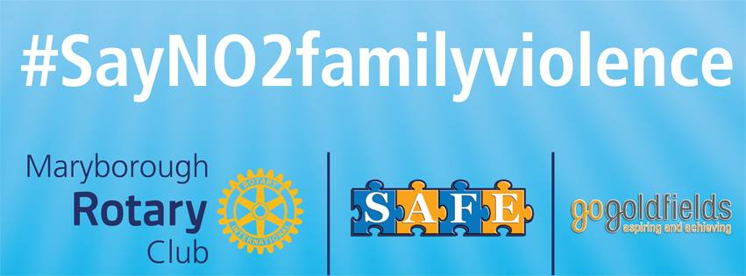#SayNo2famlyviolence January 2018

The Maryborough Rotary Club’s major project #SayNO2familyviolence continues to play a significant role in assisting with sending the message that family violence is unacceptable in our community. In addition, our program is being recognised by other communities and Rotary clubs as being a solution to addressing their issues around family violence.
Our Club’s working group consisting of Rotarians. Chris Frahn, Bob Butterfield, Thea Allan, Martin MacKay, Robert Rowe and Anthony Ohlsen continues to work on spreading the word and raising funds to further develop our project.
Our “Day at the Races” in conjunction with Maryborough Harness Racing Club (MHRC) not only raised approximately $2000, but also promoted our project to millions around the world. Many thanks to Rotarian. Bob Osborne, MHRC secretary, Les Chapman, Rotarians Chris, Bob and Martin and the business houses for sponsoring the event.
Maryborough Education Centre (MEC) has agreed to erect one of our signs, which is a major commitment and show of support for our project. Just as important is the debate that the school council had in making this decision, which enabled them to carefully consider, not only the issues around family violence, but the impact that family violence has within their school community. Well done MEC.
After our presentation at our Club’s Vocational Scholarship evening, Inspector Paul Gardiner invited the Club to erect one of our signs in the foyer of our local police station. This has been completed. It would be opportune to mention that of all those organisations involved in the campaign against family violence, our local police have made an outstanding cultural shift in the way that they are addressing family violence in our community.
In addition to this, a sign has been erected at the Maryborough Recreation Centre and we thank Gerard Murphy for his support.
Our contribution to the Energy Breakthrough was once again very prominent with a large sign on one of the walk overs and our signage on every vehicle that participated in the event. We thank Martin Mark and the RACV again, for their continued support.
Is our project working? A question that we continually ask.
We know it is working both locally and in other communities.
The Murdoch Institute is doing a major evaluation on the GoGoldfields project and is using a method called “The Most Significant Change story”. Service providers are asked to tell their story and the way they see projects having an impact. Each of the seven stories showed our Rotary project as having a significant impact on addressing family violence.
Senior Sergeant Paul Huggett, Maryborough Police Station Commander, credited our project as having a huge impact in the campaign against family violence. He was responding to the article regarding recently released crime statistics in the Maryborough Advertiser, December 15, 2017.
Although the figures had risen, SS Huggett was pleased, because the victims felt more confident that there was professional help available
As well as on the local scene, Maryborough Rotary is working with other Rotary Clubs. We have recently spoken to others Rotary Clubs within and outside District 9780
In collaboration with GoGoldfield and the Rotary clubs of Portland, Portland Bay, Horsham and Horsham East a website is being developed that can be used by all Rotary Clubs and communities anywhere in the world.
We had a teleconference with these Clubs in December and a brief will be available for presentation shortly.
We thank the Maryborough District Health Service for the use of their video conferencing facilities.
Well done Maryborough Rotary.

Garry Higgins PP

