Membership and Public Image
Members: Paul Atack (Chair), Ian Barratt, James Cowell, John Jehu, David Ryan, Mark Taylor, and Ray Welford.

Membership
This year the Club welcomed two new members.

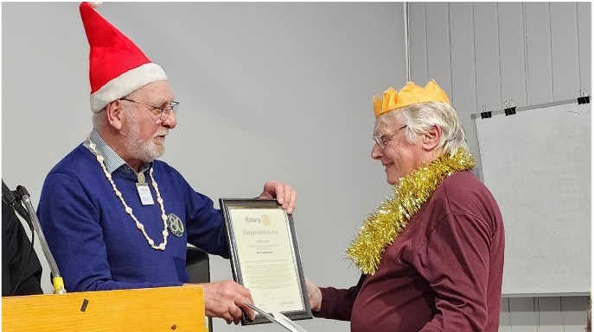 | 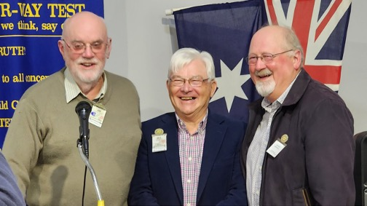
Geoff Covey inducted with Christmas spirit | President Jim, PP Bill Hewett and new member Peter Newell

Unfortunately, three members resigned due to ill health and job movement.

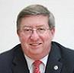 | 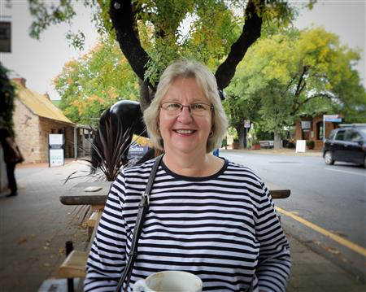 | 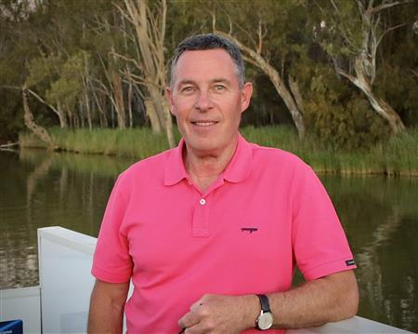
President Greg Wood | Di Hardy | Martin Hardy

Like many Rotary Clubs and other volunteer organisations, our Club is facing the twin problems of an aging and declining membership.

Membership is the life blood of the organisation, as the membership profile ages and the numbers decline, the capacity of the Club to achieve its goals becomes more challenging.

Several presentations were made to the club members, suggesting a range of recruitment opportunities, highlighting the turnover of member and how to introduce a new member.

Membership will remaining an ongoing challenge.

As part of Rotary education, information relevant to the Rotary monthly theme was regularly included in the Club Bulletin.

Public Image
Once again, the successful Hole in One event, provided a wealth of media opportunities, from television and radio advertisements, Facebook posts, the Club webpage and print media.

But other than the John Birrell Award, WD2 Road Safety Practioner of the Year Award, there was limited exposure in the local media.

As well as highlighting activities, projects and guest speakers on the webpage and Facebook, the Club is drawing attention to the use of funds raised through fund raising activities.

The Club pamphlet developed in the latter part of the previous Rotary year has been available and distributed at the Hole in One and BBQ’s, given to guest speakers and prospective members.

I would like to thank all members of the Membership and Public Image Committee for their ongoing support and work.

