osted on January 9, 2024
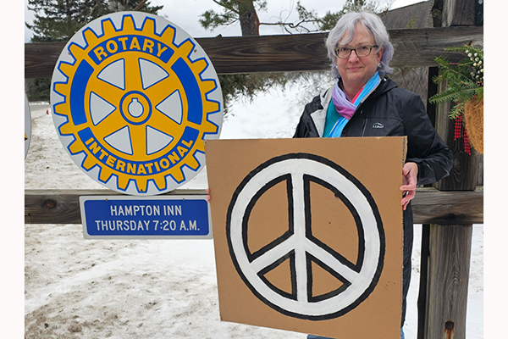Martha Pritchard Spear in front of the meeting sign for the Rotary Club of Lake Placid, New York, USA.
By Martha Pritchard Spear, assistant governor District 7040 and a member of the Rotary Club of Lake Placid, New York, USA
These are my own thoughts, not a statement of the Rotary Club of Lake Placid. I long for world peace, and I accept that there are those who will think I am naïve and a dreamer. Yet I am beginning to comprehend that the journey toward peace is sometimes reached by passing through violence. There are terrorists, fascists, and totalitarian leaders who scorn peace. Is there a nonviolent defense against people like that? I have faith that Rotary and other humanitarian organizations will continue to educate, advocate, mediate, and practice peace. I would like to think that peace will prevail. But my faith that it will has been shaken.
Living in Lake Placid, we have many ways to promote peace. As a travel destination, we get many tourists. When driving on Main Street, we can stop for people to cross the street, smile, and wave to reassure them it’s OK to walk. On a slushy day, we can stop and offer a ride to the person walking home with their heavy grocery bags or pushing a laden cart. When we are in line at the store, we can open our wallet and help someone who is short of money.
Being a Rotarian in Lake Placid means being a catalyst for peace, such as moving past social divisions. For us, it’s typical for a conservative Christian, an apolitical Jew, an atheist, and a liberal feminist to sit down together for breakfast. We wish each other Happy Holidays, Merry Christmas, Blessed Kwanzaa, and Happy Hannukah. We talk about the weather, our families, and the next Rotary volunteer project. We live by the credo of The Four-Way Test. Rotary International prioritizes peace as one of our core goals.
Peace is elusive. The 7 October terrorist attack by Hamas on Israel, followed by devastating “collateral” military consequences for Palestinians in Gaza, does not lend itself to peace. There is civil war in beautiful Ethiopia, my son’s country of birth. The entire continent of Africa is convulsing with civil wars, terrorist insurgencies, and ethnic violence.
“In spite of everything, I still believe that people are really good at heart.”
ANNE FRANK
The Russian war of aggression against Ukraine especially hits home for us in Lake Placid. Many of us know Ukrainian Dmitry Feld, respected for his work with USA Luge and as president of Shipman Youth Center. In 2022 Dmitry led an initiative to put up Ukrainian flags on light poles, inspiring business owners to put up their own Ukrainian flags. Dmitry has also organized supplies to be sent and traveled to Ukraine to assist pets in peril due to the war.
North Country School made it possible for a young Ukrainian boy named Yehor to leave his home in the great city of Kharkiv, where he was in grave danger, and come study in Lake Placid. Beth and Frank Brunner hosted a Ukrainian refugee family in their home for six weeks. There are many stories like these, of regular people advocating for peace by doing what’s morally right.
In this time of terrorism, wars, and deep, painful divisions among us Americans, peace is personal. Peace is complicated. By advocating for peace, I am acting in the hope that the words of Anne Frank are true: “In spite of everything, I still believe that people are really good at heart.”
Peace.
Contact RotaryLakePlacid@gmail.com to learn more about our club.

