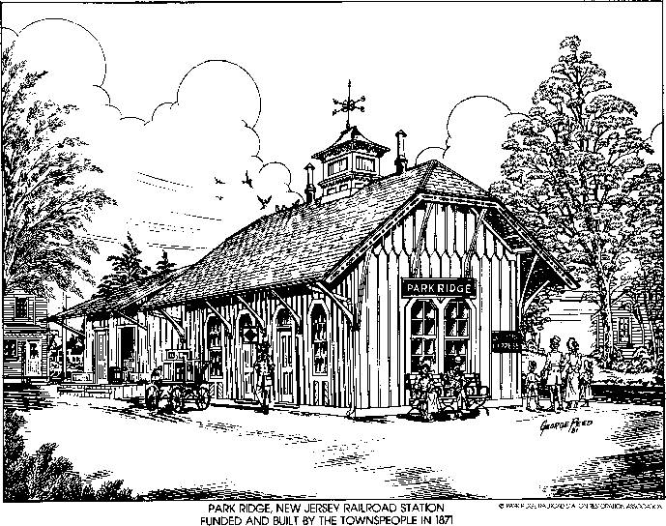



**PARK RIDGE ROTARY PAST PRESIDENTS**

|  |
| --- |
| 1928 – 30 DR. HARRY GARRETT |
| 1930 – 31 ROBERT SMITH |
| 1931 – 32 FRED WEBER |
| 1935 – 36 CHARLES ELLINGER |
| 1936 – 37 EDVIN L. NUSY |
| 1937 – 38 CHARLES GRAY |
| 1938 – 39 ELLERY SCOTT |
| 1939 – 40 PERRY SAUNDERS |
| 1940 – 41 JOHN FORLEE |
| 1941 – 42 DR. HYMEN ORON |
| 1942 – 43 J. FRED BRATT |
| 1943 – 44 BERNARD BRADFORD |
| 1944 – 45 DR. H. VANDER SLUICE |
| 1945 – 46 JESSE SAUNDERS |
| 1946 – 47 HENRY METLITZ |
| 1947 – 48 JOHN TOMASINNI |
| 1948 – 49 GEORGE HUFF |
| 1949 – 50 GUS BUIRKLE |
| 1950 – 51 DR. STEWART ALEXANDER |
| 1951 – 52 JOE KAPLOWITZ |
| 1952 – 53 SHEPARD CYNAMON |
| 1953 – 54 THOMAS WOOD |
| 1954 – 55 CHARLES GOODMAN |
| 1955 – 56 ROBERT SPEARING |
| 1956 – 57 HARRY BOWLES |
| 1957 – 58 CHARLES J. RONAN |
| 1958 – 59 MORRIS BERNARD |
| 1959 – 60 REV. JACK REYNOLDS |
| 1961 – 62 JACK HEALEY |
| 1962 – 63 DICK MAY |
| 1963 – 64 GUS BUIRKLE |
| 1964 – 65 GEORGE MOORE |
| 1965 – 66 RUDY FOLKENS |
| 1966 – 67 STAN FOLKENS |
| 1967 – 68 REV. JAMES OPSAL |
| 1968 – 69 VINCE FEDE |
| 1969 – 70 NELLO ETNA |
| 1970 – 71 NELLO ETNA |
| 1971 – 72 DR. GEORGE COHEN |
| 1972 – 73 WILLIS SWALES |
| 1973 – 74 AL WILKENS |
| 1974 – 75 DONALD PARRY |
| 1975 – 76 ANTHONY ANZALONE |
| |  | | --- | | 1976 – 77 H. ROGER ANDERSON | | 1977 – 78 PETER CHRISTENSEN | | 1978 – 79 BERT POSESS | | 1979 – 80 DR. ED MIKUS | | 1980 – 81 DICK SILVERMAN | | 1981 – 82 ROBERT KLEINBERG | | 1982 – 83 DR. ROBERT BALENTINE | |
| |  | | --- | | 1983 – 84 GEORGE APFEL | | 1984 – 85 MAX HAUSMANN | | 1985 – 86 DON TERRACE | | 1986 – 87 RAY JANOVIC | | 1987 – 88 KEN BIRDSALL | |
|  |
|  |
|  |
|  |
|  |

|  |  |  |  |  |  |  |  |  |  |  |  |  |  |  |  |  |  |  |  |  |  |  |  |  |  |  |  |  |  |  |  |  |  |
| --- | --- | --- | --- | --- | --- | --- | --- | --- | --- | --- | --- | --- | --- | --- | --- | --- | --- | --- | --- | --- | --- | --- | --- | --- | --- | --- | --- | --- | --- | --- | --- | --- | --- |
| |  | | --- | | 1988 – 89 FRED CHAPMAN | | 1989 – 90 RALPH PADOVANO | | 1990 – 91 DON RUSCHMAN | | 1991 – 92 ROBERT GALLAGER | | 1992 – 93 JAN DOORNBOSCH | | 1993 – 94 ROBERT DUELFER | | 1994 – 95 LINDA HANLON | | 1995 – 96 ELLEN DRAKE | | 1996 – 97 FAY LOGAN | | 1997 – 98 LAILA PARAGINI | | 1998 – 99 DAVID ACEVEDO | | 1999 – 00 STU GOLD | | 2000 – 01 ELISE GUILD | | 2001 – 02 DICK BEATTIE | | 2002 – 03 NANCY COLLENTINE | | 2003 - 04 STEVEN HOPPER | | 2004 - 05 ANN KILMARTIN | | 2005 - 06 PETER WELLS | | 2006 – 07 LINDA JONES | | 2007 - 08 RAY FALCON | | 2008 – 09 HARRIET KALLET | | 2009 - 10 STUART GOLD | | 2010 – 11 GEORGE SHERMAN | | 2011-12 FAY LOGAN | | 2012-13 JOEEN CIANNELLA | | 2013-14 ROBERT BUSTARD | | 2014-15 ROBERT BUSTARD | | 2015-16 VLAD ZHERENOVSKY | | 2016-17 PHILIP WELLS | | 2017-2018 RAY FALCON | | 2018-2019 JUNE BERTINI | | 2019-2020 STEVE HOPPER | | 2020-2021 STEVE FOX | |
|  |
|  |
|  |
|  |
|  |
|  |
|  |
|  |
|  |
|  |
|  |
|  |
|  |
|  |
|  |
|  |
|  |
|  |
|  |
|  |
|  |
|  |
|  |
|  |
|  |
|  |
|  |
|  |
|  |
|  |
|  |
|  |
|  |
|  |
|  |
|  |
|  |
|  |
|  |
|  |
|  |

PAST DISTRICT GOVERNORS

|  |
| --- |
| 1987 – 88 ROBERT KLEINBERG |
| 1991 – 92 RAY JANOVIC |

|  |
| --- |
| 2015-16 PETER WELLS |