CALLING ALL RUNNERS, WALKERS & DOGS!
PARK RIDGE ROTARY CLUB
VIRTUAL 5K RUN/WALK
SEPTEMBER 1, 2022 – SEPTEMBER 30, 2022
Our Annual 5K Run/Walk is back! As Covid continues to impact our communities, your safety is our priority

Everyone can participate. You can run/walk in your yard, your home, around the neighborhood, on a treadmill, with friends, with your dog or alone
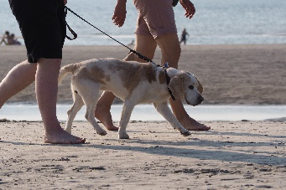
Wherever convient and safe.
Please join us to support Our HS student Scholarship program serving ParkRidge, Montvale, Woodcliff lake Schools allowing students who excel have an opportunity to obtain their dreams!
Participants can complete a 5K (3.1 miles) WHEREVER and WHENEVER they choose!
DATE: September 1 – September 30 , 2022

WHERE: Anywhere & Everywhere across the Globe! – walk /Run with Family, friends,
run on a treadmill, walk with your dog! Please post your pictures, your locations, miles completed & Time.
SIGN UP: https://runsignup.com/Race/Register/?raceId=19771

ON LINE ENTRY FEE: $10 through August 31 *SEPTEMBER 1- 30th PRICE $13*
BE A SPONSOR : https://portal.clubrunner.ca/2088/

Thank you to our Supporters & Sponsors!

