

# Highlights

**Happy New Year! The Leawood Rotary Club rang in the new year with a very moving presentation and movie from Honor Flight. The mission of Honor Flight is to celebrate America’s veterans by inviting them to share in a day of honor at our nation’s memorials. Awardees are flown to the nation’s capital for an all-expense-paid, one-day tour.**

**In other breaking news, Chuck Sipple was the winner of a drawing for FIVE free tickets to see the dance production, “**[The Underground](https://www.gounderground.org/)**.” Chuck’s name was drawn randomly from all the new monthly Unite KC supporters! Check out the video** [here](https://www.instagram.com/tv/Cm97xWDB4Tj/?igshid=YmMyMTA2M2Y=)**.**

**This iconic performance takes place every year at the Kauffman Center for the Performing Arts. The production is in its 16th year, and premiers on Feb 3rd and 4th. Our very own Lorna Jarrett is an original cast member in the production!**

**Upon hearing that he was the winner of the drawing, Chuck was overcome with joy, broke down in tears and exclaimed, “I never win anything!” Chuck’s newfound fortune spread throughout the Arts Community and he has a new cadre of friends…who want to get their hands on those tickets!**

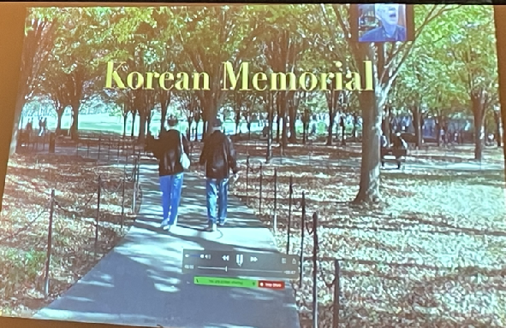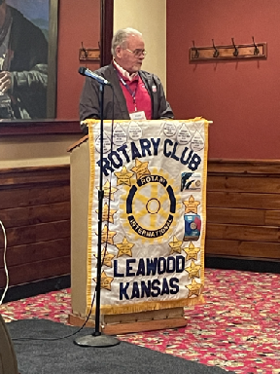

# **Picture 12**Leawood Rotary Other News and Upcoming Events

* Kirt Yoder presented the Leawood Rotary with a scholarship opportunity from the Greater KC Crime Commission.  This one-time $1000 scholarship is awarded based on a winning essay about public service.  Forward and encourage your high school seniors to take advantage of this opportunity.
* I would like to nominate someone from our Rotary Club to be Speaker of the House – we are on a winning streak. I make a motion that…
* How about a New Year’s [electronic jigsaw puzzle](https://www.morningbrew.com/daily/stories/2022/12/22/jigsaw-fun-with-new-year-s-eve-fireworks?utm_campaign=mb&utm_medium=newsletter&utm_source=morning_brew&mid=473976017c632f5d3c6e19b3cdb2698c) to round out the newsletter?
* Jim Arnett – thanks for the wonderful out-of-town Rotary Pictures!!!

**The next hybrid meeting at the Hereford House is Thursday, Jan 12th.**

|  |  |  |  |  |  |
| --- | --- | --- | --- | --- | --- |
| **DATE** | **SPEAKER** | **INVOCATION** | **VOCATIONAL** | **GREETERS ALL MONTH** | **TECH CREW** |
| Jan 12th | (C) Tyrone Evans- a career in the petroleum industry | Holland |  | J or D Schloegel, Ken S, Stu S, Chuck S, Ron S | Sara Nyland |
| Jan 19th | CLUB ASSEMBLY | N/A |  | J or D Schloegel, Ken S, Stu S, Chuck S, Ron S | David Bell |
| Jan 26th | Monthly Board Meeting | N/A |  | N/A | N/A |

ZOOM ACCESS **Can’t make it to the in-person meetings? Join Via ZOOM and keep up to date!**

ALL Meetings are hybrid - being held **in person** and **via Zoom**. If you can’t attend in person, please join us on Thursdays at 7:15 am.

<https://us06web.zoom.us/j/81310427816?pwd=RnpGRnY5dmd2dnl5WS9FaGQwVEhydz09>

**Meeting ID: 813 1042 7816 - Passcode: Rotary**