

# Highlights

**The Leawood Rotary honored members with Paul Harris pins. The recipients were:**

**Dave Anderson PH+8**

**Mike Best PH+2**

**Steve Black PH+2**

**Leigh Briggs PH+3**

**Mark Gibbens PHF**

**Mel Hawk PH+5**

**Ray Jarrett PH+1**

**Roger Newth PH+2**

**Jim Rawlings PH+4**

**Chuck Sipple PH+5**

**Dick Wetzler PH+3**

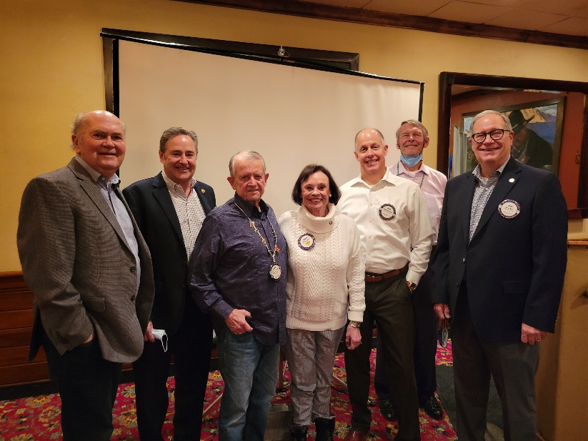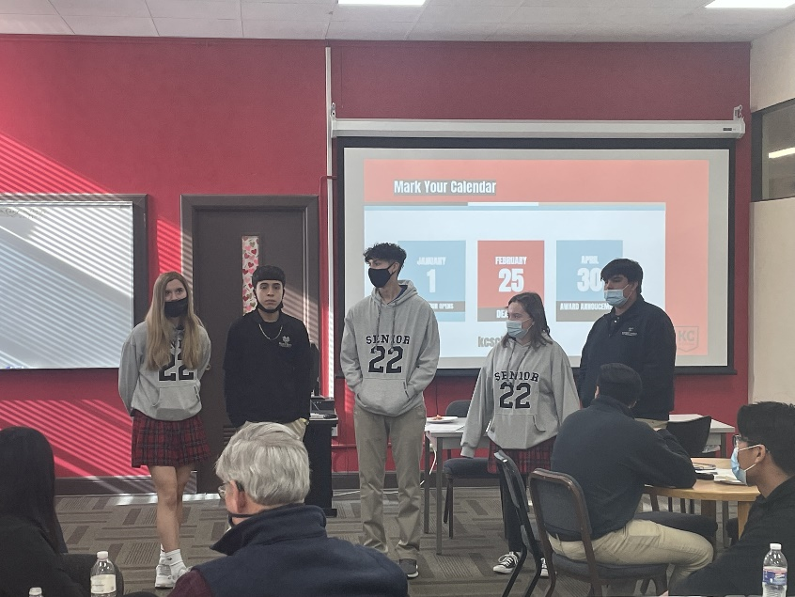**The Rotary also hosted its monthly Reach Luncheon with Bishop Ward students. Students learned about applying for scholarships and received guidance on forming a strategy and managing their time during the application season.**

# Rotary Fun Fact

The Rotary Club of Papeete, Tahiti, which is in the middle of the Pacific Ocean, is the club that is most remote from any other.

# Other Events and Reminders for the Week

* It takes effort to keep our village healthy. Please remember to please wear a mask when entering Hereford House, greeting others, when going through the food line, and after you eat. In other words---No mask, no bacon.
* The Wine Affinity Group get-together scheduled for Jan 19th at Chuck and Ester Udell's home is rescheduled for Mar 23rd.
* Leawood Rotary Club is a member in good standing of the Leawood Chamber of Commerce. As a member, Leawood members can attend Chamber events (ribbon cuttings, morning networking events, after hours networking events) FREE of charge. Only special events and monthly luncheons require a fee to attend.

# Leawood Rotary Upcoming Events

|  |  |
| --- | --- |
| Membership Committee Meeting | Jan 17th |
| Project Cure Workday | Jan 21st |
| Wine Affinity Group (Schloegel Residence) | Feb 9th |
| Happy Bottoms Work Session | Feb 22nd |
| Steve Knight Tree Planting Ceremony | Mar 31st |
| Gathering for Good Fundraiser – Prairie Band Casino | Mar 26th |
| Heartland P.E.T.S. Wichita | Mar 31st |

**The next meeting is on Thursday, Jan 20th, 2022, at the Herford House (Hybrid Meeting).**

**Please see the list of speakers and greeters in the table below.**

|  |  |  |  |
| --- | --- | --- | --- |
| **Date** | **Speaker** | **Invocation** | **Greeters** |
| Jan 20th, 2022 | Johnson County Multi-Service Centers | Chuck or Ester Udell | Kirk Nelson, Roger Newth, Sara Nylund, Jim Rawlings, Mary Reed, Rick Robinson |
| Jan 27th, 2022 | Board Meeting | n/a | Paul Rueschhoff, Jake or Debby Schloegel, Ken Selzer, Stu Sharp, Ron Slepitza, Wayne Starr |
| Feb 3rd, 2022 | Joy Wheeler, CEO Girl Scouts of America, Kansas and Missouri  “Today’s Girl Scouts.” | Hemi Vats | Same As Above |

ZOOM ACCESS **Can't make it to the in-person meetings? Join Via ZOOM and keep up to date!**

ALL Meetings are hybrid - being held **in person** and **via Zoom**. If you can't attend in person, please join us on Thursdays at 7:15 am.

**Check for Chuck Udell's email for the ZOOM Link**