

# Highlights

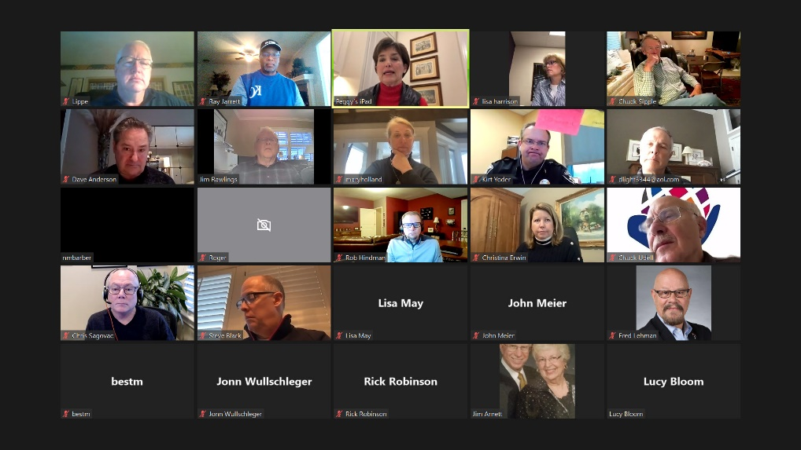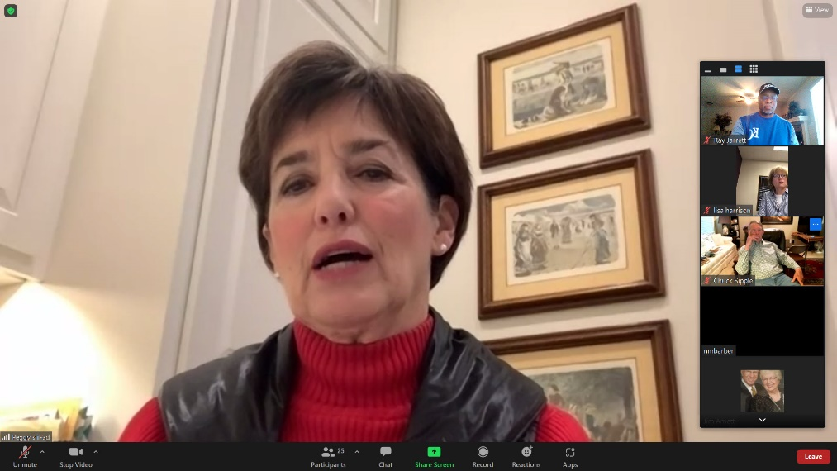**This week, the weather kept us up-to-date on our Zoom skills! Leawood Rotarians met online this past week and were treated to a comprehensive Leawood State of the City update. Mayor Peggy Dunn is an exceptional leader and gave us a great overview of the city’s programs and some of the stats that remind us that Leawood is a great place to live!**

Fun Rotary Facts

If you attend the El Aguilar club in Argentina, you are meeting with the highest club in the world at 16,000 feet (4,880 meters) above sea level. The lowest club meets at 40 feet (12.2 meters) below sea level at El Centro, California, USA.

# Leawood Rotary Upcoming Events

|  |  |
| --- | --- |
| Happy Bottoms Work Session | Feb 22nd |
| Wine Affinity Group – Udell | Mar 23rd |
| Gathering for Good Fundraiser – Prairie Band Casino | Mar 26th |
| Women's Social – Harrison | Mar 28th |
| Steve Knight Tree Planting Ceremony | Mar 31st |
| Heartland P.E.T.S. - Wichita | Mar 31st |
| Tomahawk Creek Trail Cleanup | Apr TBD |
| Annual Rotary Dinner – Vista 154 | Jun 23rd |

**Next week is the Board Meeting – Feb 24th . The next meeting is on Thursday, March 3rd , 2022, at the Herford House (Hybrid Meeting).**

**Please see the list of speakers and greeters in the table below.**

|  |  |  |  |
| --- | --- | --- | --- |
| **Date** | **Speaker** | **Invocation** | **Greeters** |
| Feb 24th, 2022 | Board Meeting | n/a |  |
| Mar 3rd, 2022 | Laura Hars & Shawnee Mission D.D. Students (Rox) | John Wullschleger | Tom Sullivan, Chuck or Ester Udell, Hemi Vats, Dick Welzer, Anita Williams, John Caton |
| Mar 10th, 2022 | Ron S – Jerusalem Farm Organization | Mary Holland | Same As Above |
| Mar 17th, 2022 | Editor Kyle Palmer (Lisa H.)  Shawnee Mission Post | Darren Lippe | Same As Above |

ZOOM ACCESS **Can't make it to the in-person meetings? Join Via ZOOM and keep up to date!**

ALL Meetings are hybrid - being held **in person** and **via Zoom**. If you can't attend in person, please join us on Thursdays at 7:15 am.

**Check for Chuck Udell's email for the ZOOM Link**