

# Highlights

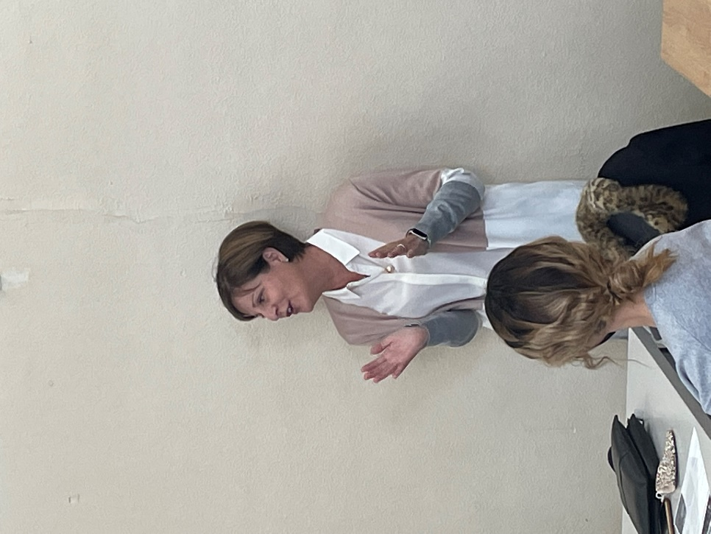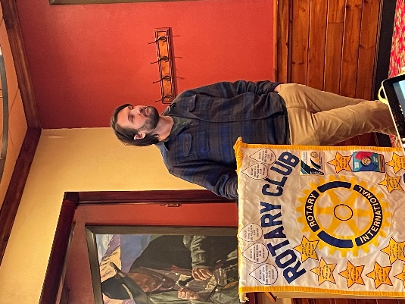**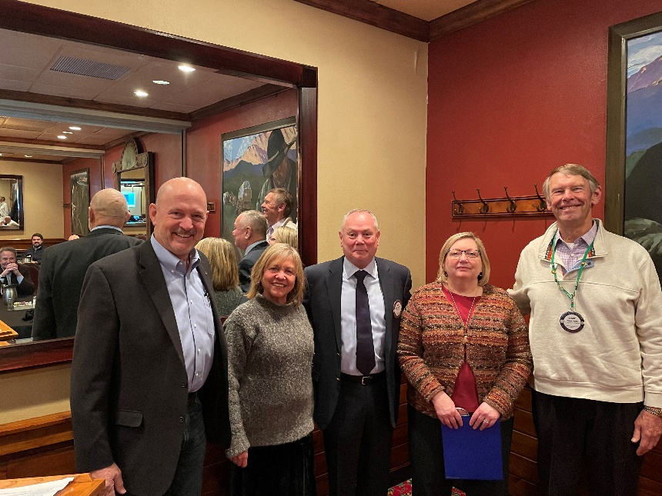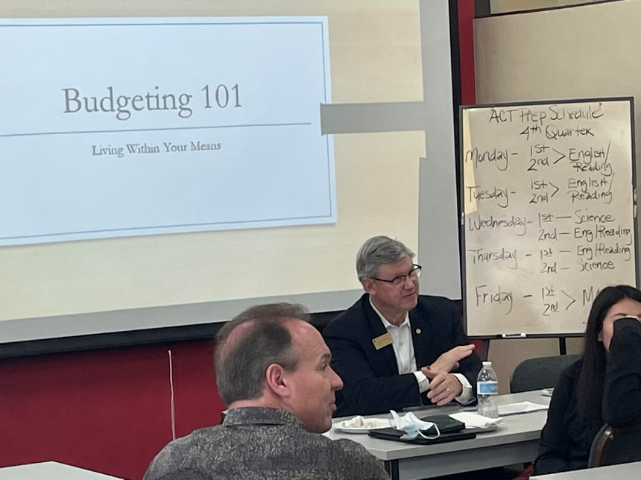This week was a busy week for the Leawood Rotary Club. Ron Slepitza taught REACH students how to budget as college students, and Roxanne gave an inspiring vocational speech. In our Thursday meeting, we welcomed new members Gail Weiss and Chris Sagovac! Jordan Schiele gave a very timely overview of the philanthropic activities of Jerusalem Farm. Jerusalem Farm is a Catholic non-profit organization located in Kansas City, Missouri, offering community-based solutions for residents facing code violations.**

Fun Rotary Facts

# In October 2020, Jennifer E. Jones became president-nominee, the first woman nominated as the Rotary International President. Her term as president will begin on July 1, 2022.

# Leawood Rotary Upcoming Events

|  |  |
| --- | --- |
| JOCO Library Shelves | TBD |
| Wine Affinity Group – Udell | March 23 |
| Gathering for Good Fundraiser – Prairie Band Casino | March 26 |
| Women’s Social – Harrison | March 29 |
| Steve Knight Tree Planting Ceremony | March 31 |
| Heartland P.E.T.S. - Wichita | March 31 |
| Tomahawk Creek Trail Cleanup | April TBD |
| Kentucky Derby Party | May 7 |

**The next meeting is on Thursday, Mar 17th, at the Herford House (Hybrid Meeting).**

**Please see the list of speakers and greeters in the table below.**

|  |  |  |  |
| --- | --- | --- | --- |
| **Date** | **Speaker** | **Invocation** | **Greeters** |
| Mar 17th | Editor Kyle Palmer (Lisa H.)  Shawnee Mission Post | Darren Lippe | Tom Sullivan, Chuck or Ester Udell, Hemi Vats, Dick Welzer, Anita Williams, John Caton |
| Mar 24th | Board Meeting | n/a | Same As Above |
| Mar 31st | NO MEETING  AFTERNOON SOCIAL | n/a | Same As Above |

ZOOM ACCESS **Can't make it to the in-person meetings? Join Via ZOOM and keep up to date!**

ALL Meetings are hybrid - being held **in person** and **via Zoom**. If you can't attend in person, please join us on Thursdays at 7:15 am.

**Check for Chuck Udell's email for the ZOOM Link**