

# Highlights

**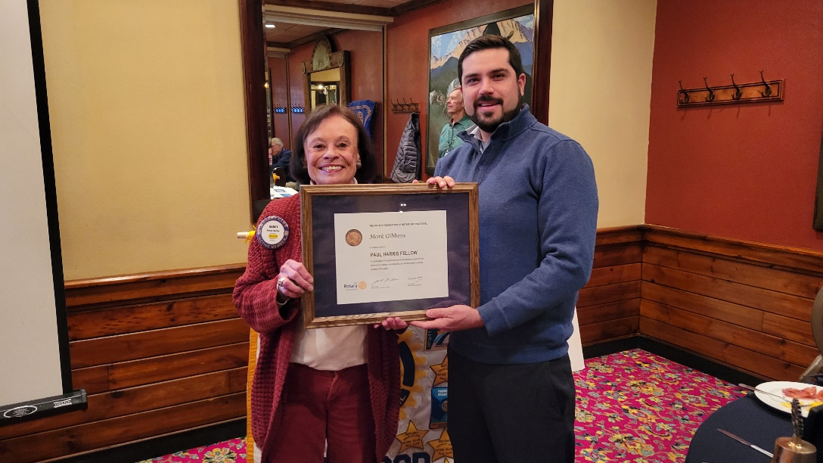****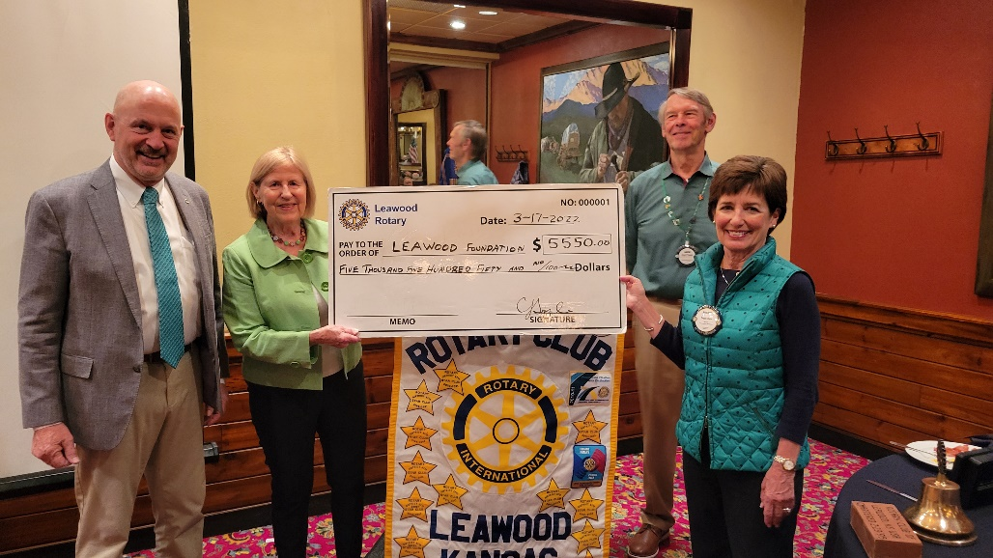This week, The Leawood Rotary Club presented Mayor Peggy Dunn with a check for the Leawood Trail restroom project. We’d also like to begin recognizing our Paul Harris Award winners. On Thursday, Mark Gibbens received his first award!**

**The Shawnee Mission Post’s Editor Kyle Palmer spoke to Rotary members about their email news service – you can subscribe here!** [**Subscribe**](https://pico.link/shawneemissionpost/offer?id=CheckoutWizard_shawneemissionpost)

Fun Rotary Facts

On Jul 1st, 1987, Sylvia Whitlock began her term as the first official woman President of a Rotary Club.

# Other Important Announcements

Fellow Rotarians,

We will have a Service Day at Project Cure on Mar 29th from 9 am - noon. This opportunity will help get aid to Ukraine. Project Cure’s overall national organization currently focuses most of its efforts on getting medical supplies to Ukraine and the surrounding countries taking in refugees. All seven distribution centers are contributing toward that end. Work will involve sorting medical supplies or warehouse work.

# Leawood Rotary Upcoming Events

|  |  |
| --- | --- |
| JOCO Library Shelves | TBD |
| Wine Affinity Group – Udell | Mar 23rd |
| Gathering for Good Fundraiser – Prairie Band Casino | March 26 |
| Women’s Social – Harrison | March 29 |
| Steve Knight Tree Planting Ceremony | March 31 |
| Heartland P.E.T.S. - Wichita | March 31 |
| Tomahawk Creek Trail Cleanup | April TBD |
| Kentucky Derby Party | May 7 |
| Rotary Youth Camp Workday | May 7 or 14 |
| Annual Rotary Dinner – Vista 154 | June 23 |

**There will be a Board Meeting on Mar 17th. The next in-person meeting at the Herford House (Hybrid Meeting) is on Thursday, Apr 7th.**

**Please see the list of speakers and greeters in the table below.**

|  |  |  |  |
| --- | --- | --- | --- |
| **Date** | **Speaker** | **Invocation** | **Greeters** |
| Mar 24th | Board Meeting | n/a | Tom Sullivan, Chuck or Ester Udell, Hemi Vats, Dick Welzer, Anita Williams, John Caton |
| Mar 31st | NO MEETING  AFTERNOON SOCIAL | n/a | Same As Above |

ZOOM ACCESS **Can’t make it to the in-person meetings? Join Via ZOOM and keep up to date!**

ALL Meetings are hybrid - being held **in person** and **via Zoom**. If you can’t attend in person, please join us on Thursdays at 7:15 am.

**Check for Chuck Udell’s email for the ZOOM Link**