

# Highlights

**This week, The Leawood Rotary Club had its Wine Affinity Event, which Chuck Udell hosted.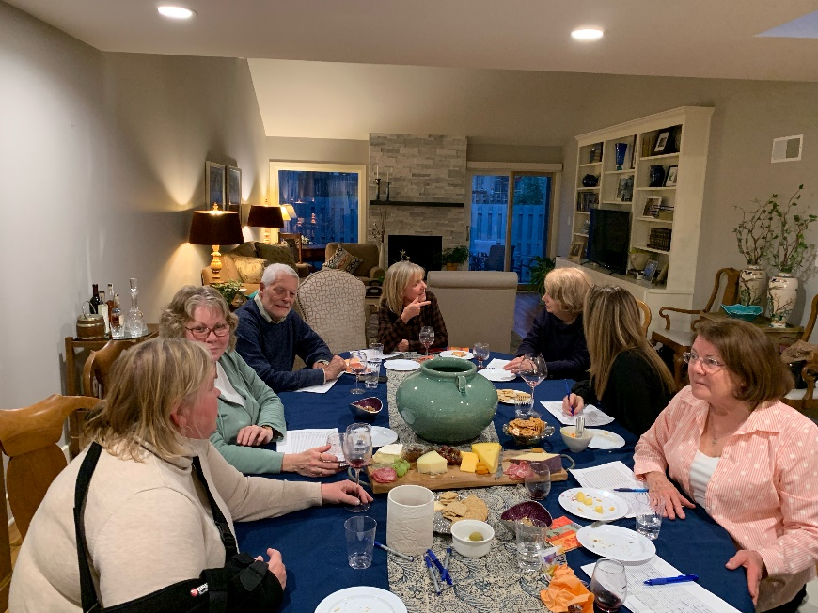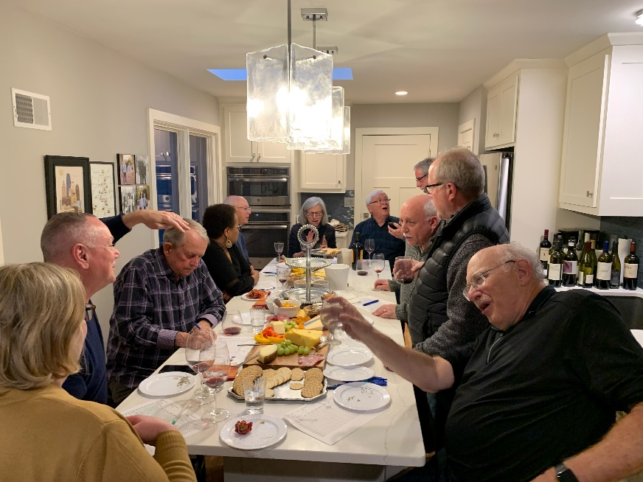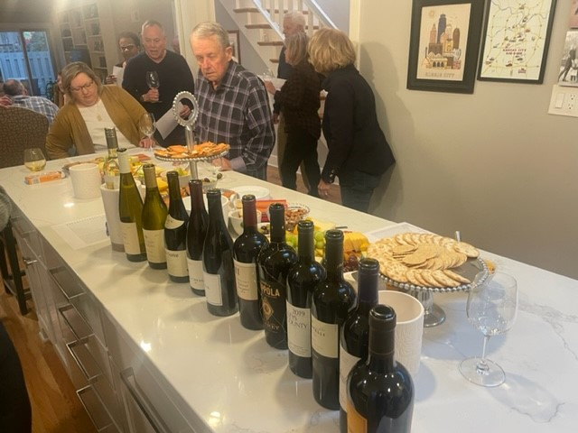 And a good time was had by all!**

Fun Rotary Facts

The name “Rotary” comes from the original practice of rotating meeting locations.

# Other Important Announcements

# The Kansas City Star shared the story of a resident of Veronica's Voice on march 20th. Lucy Bloom expressed her appreciation to The Star and Janet Jensen who authored the story and for using their voices to open up this difficult conversation.

# Leawood Rotary Upcoming Events

|  |  |
| --- | --- |
| JOCO Library Shelves | TBD |
| Women’s Social – Harrison | March 29 |
| Steve Knight Tree Planting Ceremony | March 31 |
| Heartland P.E.T.S. - Wichita | March 31 |
| Tomahawk Creek Trail Cleanup | April TBD |
| Kentucky Derby Party | May 7 |
| Rotary Youth Camp Workday | May 7 or 14 |
| Annual Rotary Dinner – Vista 154 | June 23 |

**There will be an Afternoon Social on Mar 31St. The next in-person meeting at the Herford House (Hybrid Meeting) is on Thursday, Apr 7th.**

**Please see the list of speakers and greeters in the table below.**

|  |  |  |  |
| --- | --- | --- | --- |
| **Date** | **Speaker** | **Invocation** | **Greeters** |
| Mar 24th | Board Meeting | n/a | Tom Sullivan, Chuck or Ester Udell, Hemi Vats, Dick Welzer, Anita Williams, John Caton |
| Mar 31st | NO MEETING  AFTERNOON SOCIAL | n/a | Same As Above |

ZOOM ACCESS **Can’t make it to the in-person meetings? Join Via ZOOM and keep up to date!**

ALL Meetings are hybrid - being held **in person** and **via Zoom**. If you can’t attend in person, please join us on Thursdays at 7:15 am.

**Check for Chuck Udell’s email for the ZOOM Link**