

# Highlights

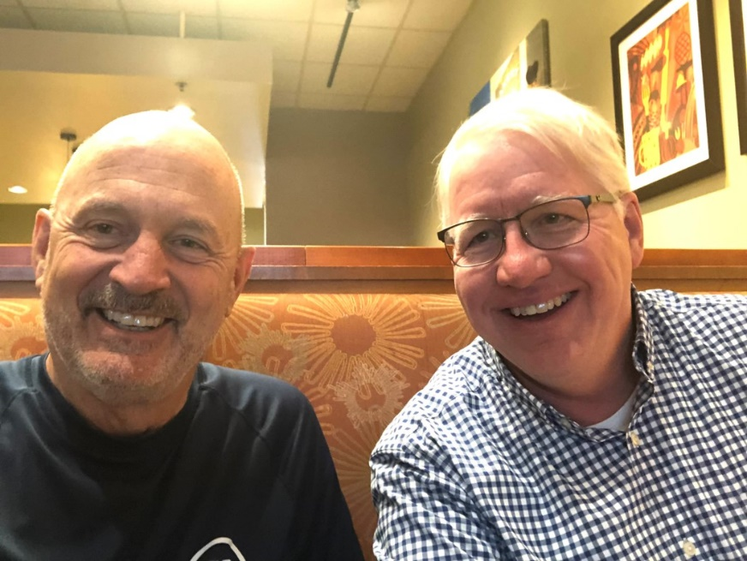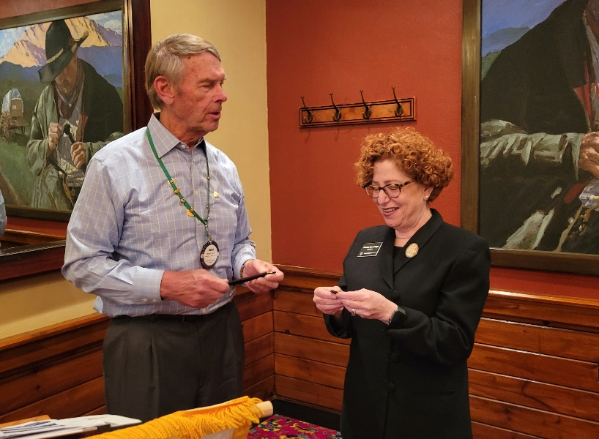**This week, the Leawood Rotary Club hosted a special guest; Kansas Supreme Court Justice Melissa Standridge. I can imagine her signing an important document with our Rotary Pen. I love this picture of Ken, but I have no idea what it’s about! Lastly, Kirt Yoder sent an important reminder about a presentation on Human Trafficking awareness at Johnson County Community College next week.**



Rotary Humor

* The rotation of Earth really makes my day.
* My favorite exercise is a combination of a lunge and a crunch. It’s called lunch.

# Leawood Rotary Upcoming Events

* A quick reminder about Rotary Youth Leadership Award - June will be here before you know it; delegate applications are due no later than Apr 30. If you have already selected your delegates, you may send your applications in early --- no need to wait until Apr 30!!!
* The next Wine Affinity Group meeting will be Monday, Apr 25 at 5:30 pm. The hostess is Kathy Dull, and the wine theme is your favorite summer patio sipping wine. The event will be at Kathy’s office. The address is Better Homes and Gardens Real Estate, 3740 W. 106th St, Leawood, KS.
* We are asking our Rotary members wishing to join the Polio Plus Society to agree to donate at least $100 to Polio Plus during this Rotary Year. Please complete the attached Commitment form information and send it to Jim Arnett (scan image to maajca@gmail or mail to: 2608 W. 118th St. Leawood, KS ).
* Please make your donation by check sent to the Club’s Charitable Account for Polio Plus OR by logging in to My.Rotary.Org/Donate, and clicking on Polio Fund.

|  |  |
| --- | --- |
| Tomahawk Creek Trail Cleanup | April TBD |
| Kentucky Derby Party (Lisa Katz) | May 7 |
| Wine Affinity Group | Apr 25 |
| Rotary Youth Camp Workday | May 7 or 14 |
| Rotary Day at Monarchs Park | Jun 9 |
| Annual Rotary Dinner – Vista 154 | Jun 23 |

**The next in-person meeting at the Herford House (Hybrid Meeting) is on Thursday, Apr 21.**

**Please see the list of speakers and greeters in the table below.**

|  |  |  |  |
| --- | --- | --- | --- |
| **Date** | **Speaker** | **Invocation** | **Greeters** |
| Apr 21, 2022 | Johnson County Multi-Service Center | Nancy Barber | Kyle Wisecarver, Jonn Wullschleger, Dave Anderson, Jim Arnett, Nancy Barber, Roger Barbieri |
| Apr 28, 2022 | Board Meeting | n/a | Same As Above |

ZOOM ACCESS **Can’t make it to the in-person meetings? Join Via ZOOM and keep up to date!**

ALL Meetings are hybrid - being held **in person** and **via Zoom**. If you can’t attend in person, please join us on Thursdays at 7:15 am.

**Check for Chuck Udell’s email for the ZOOM Link**