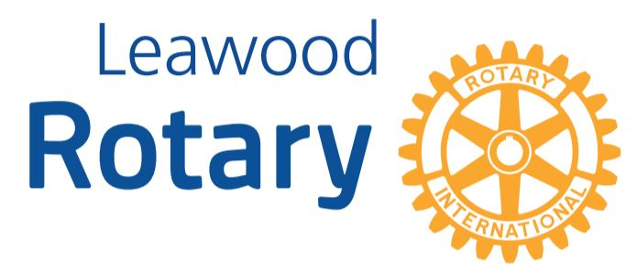

# Highlights

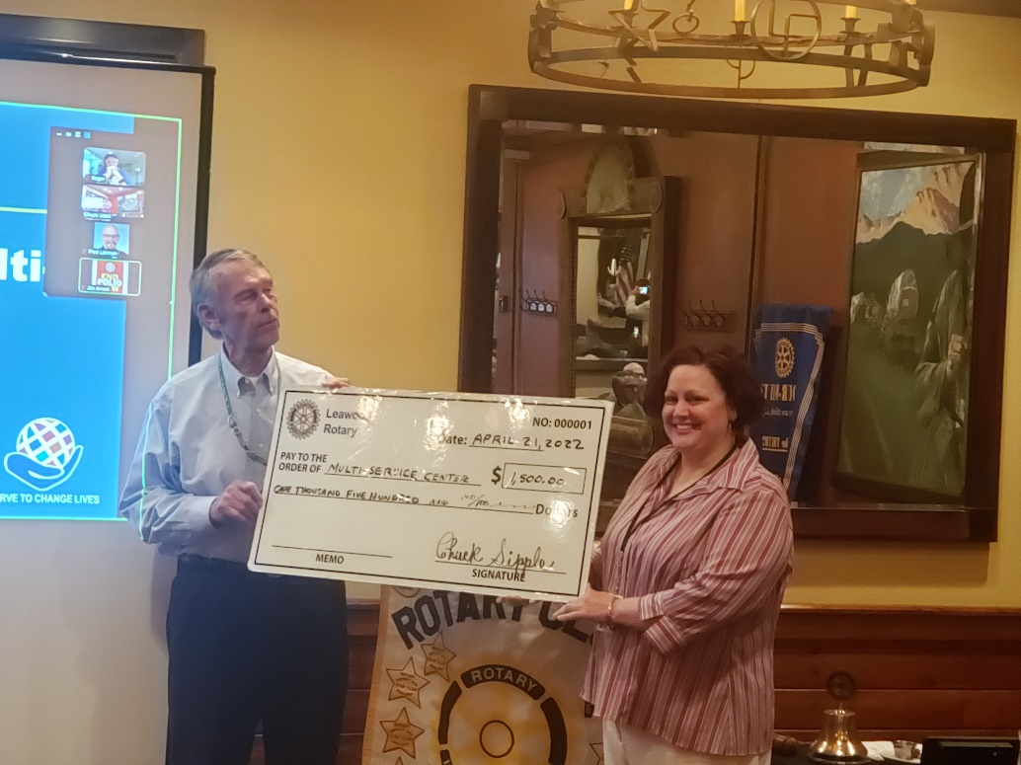**This week, the Leawood Rotary Club hosted a special guest; Johnson County Multi-Service Center Beth Johnson - New Member Induction Andrew Catherwood**

**Leawood Rotary Club engaged in many amazing activities this week. We welcomed a new member, Andrew Catherwood! Lorna Jarrett invited our Rotarians to help inspire and plant seeds into the students’ lives at New Chelsea Elementary School on Monday, May 16th. Look who got a Paul Harris Award – Tom Koch!! Congratulations! Lastly, we heard from Beth Johnson, a Johnson County MultiService Center representative, and presented her organization with a generous donation!**

**

Rotary Quiz – Do you know your Rotary History?

The first person to email back with the answer will get a $5 donation to Polio Plus in their name. We will continue to do this until we have donated $100!

Question: During its 1988 convention in Philadelphia, Rotary announces it has raised how much money?

# Leawood Rotary Upcoming Events

* A quick reminder about Rotary Youth Leadership Award - June will be here before you know it; delegate applications are due no later than Apr 30th. If you have already selected your delegates, you may send your applications in early --- no need to wait until Apr 30th!!!
* Unite KC is sponsoring a Career Week through the Health Care Domain from May 16-20. Rotary owns Monday, May 16th. Please get in touch with Lorna at [jarrett.lorna@gmail.com](mailto:jarrett.lorna@gmail.com) volunteer to come out and make an indelible mark in the lives and hearts of these kids.
* We are asking our Rotary members wishing to join the Polio Plus Society to agree to donate at least $100 to Polio Plus during this Rotary Year. Please make your donation by check sent to the Club’s Charitable Account for Polio Plus OR by logging in to My.Rotary.Org/Donate, and clicking on Polio Fund.

|  |  |
| --- | --- |
| Kentucky Derby Party (Lisa Katz) | May 7th |
| Wine Affinity Group - K. Dull’s Office | Apr 26th |
| Rotary Youth Camp Workday | May 7 or 14 |
| Rotary Day at Monarchs Park | Jun 9th |
| Unite KC Career Week | May 13th |
| Annual Rotary Dinner – Vista 154 | Jun 23rd |

**The next meeting will be the Board Meeting on Apr 28th. The next in-person meeting at the Herford House (Hybrid Meeting) is Thursday, May 5th.**

**Please see the list of speakers and greeters in the table below.**

|  |  |  |  |
| --- | --- | --- | --- |
| **Date** | **Speaker** | **Invocation** | **Greeters** |
| Apr 28th, 2022 | Board Meeting | n/a | Same As Above |
| May 5th, 2022 | John Harrington & Dave Pickhardt – Mr. Kauffman’s Legacy Project | John Caton | Sally Barchman, Gene or Agnes Bartholf, Kevin Berman, Mike Best, Steve Black, Lucy Bloom |
| May 12th, 2002 | Bill & Kathy Musgrave Tusange Update (Tom K & Chuck U) | Gene or Agnes Bartholf | Same As Above |
| May 19th, 2022 | Jim Cosgrove Ripple-McGonigal book (Lisa H) | Kevin Berman | Same As Above |
| May 26th, 2022 | Board Meeting | n/a | n/a |

ZOOM ACCESS **Can’t make it to the in-person meetings? Join Via ZOOM and keep up to date!**

ALL Meetings are hybrid - being held **in person** and **via Zoom**. If you can’t attend in person, please join us on Thursdays at 7:15 am.

**Check for Chuck Udell’s email for the ZOOM Link**