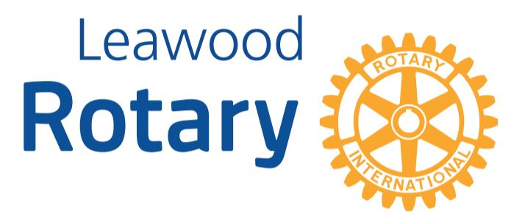

# Highlights

**This week, the Leawood Rotary Club hosted a Wine Affinity Group Event at Kathy Dull’s Office – isn’t that a beautiful bottle of Riesling? Leawood Rotary Club’s REACH volunteers celebrated the end of another year. The two REACH Scholarship winners were Juan Vasquez (pictured) and Seth Lyons. Additionally, Juan is graduating as the Valedictorian of his class, and Seth’s ACT scores were higher than anyone else in the 2022 class. Oh, and by the way, the board made some fantastic decisions this week!**

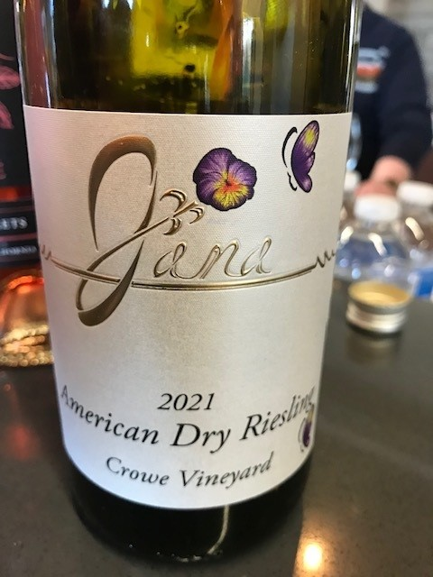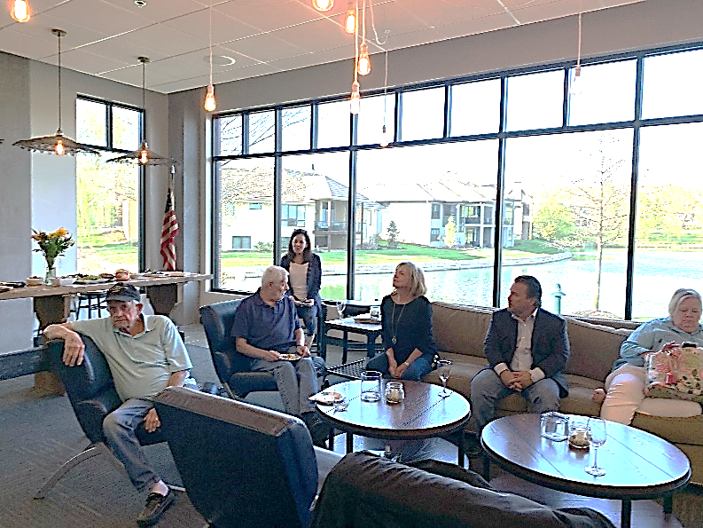

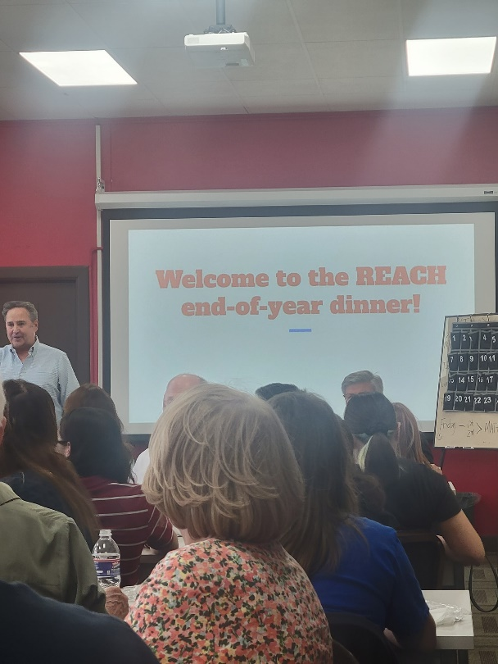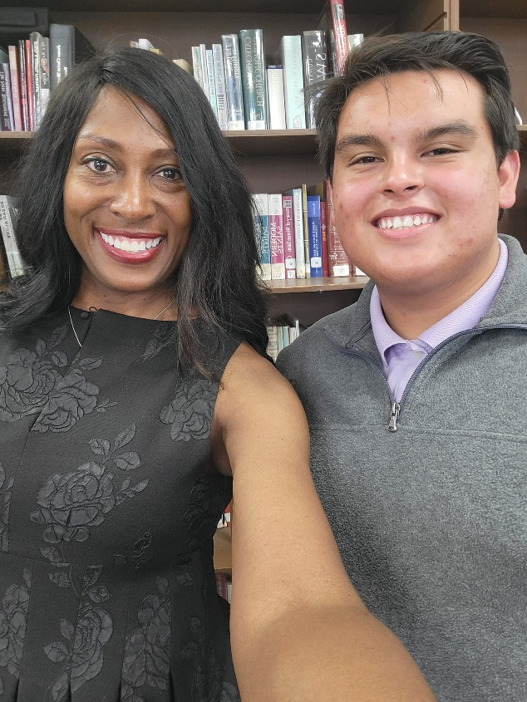

Rotary Quiz – Do you know your Rotary History?

Our first winner is… Sara Nyland!!! On Monday, Apr 25th, 2022, she answered correctly at 3:26:32 PM. The Jarrett Foundation will donate $5 this week to Polio Plus in her name! Ninety-Five more to go!

Question #2: Today, Polio remains endemic in only two countries — down from how many? (in 1988)

# Leawood Rotary Upcoming Events

* A quick reminder about Rotary Youth Leadership Award - June will be here before you know it; delegate applications are due no later than Apr 30th. If you have already selected your delegates, you may send your applications in early --- no need to wait until Apr 30th!!!
* Unite KC is sponsoring a Career Week through the Health Care Domain from May 16-20. Rotary owns Monday, May 16th. Please get in touch with Lorna at [jarrett.lorna@gmail.com](mailto:jarrett.lorna@gmail.com) volunteer to come out and make an indelible mark in the lives and hearts of these kids.
* We are asking our Rotary members wishing to join the Polio Plus Society to agree to donate at least $100 to Polio Plus during this Rotary Year. See page three of this newsletter.

|  |  |
| --- | --- |
| Kentucky Derby Party (Lisa Katz) | May 7th |
| Rotary Youth Camp Workday | May 7 or 14 |
| Unite KC Career Week | May 13th |
| Rotary Day at Monarchs Park | Jun 9th |
| Annual Rotary Dinner – Vista 154 | Jun 23rd |

**The next in-person meeting at the Herford House (Hybrid Meeting) is Thursday, May 5th.**

**Please see the list of speakers and greeters in the table below.**

|  |  |  |  |
| --- | --- | --- | --- |
| **Date** | **Speaker** | **Invocation** | **Greeters** |
| May 5th, 2022 | John Harrington & Dave Pickhardt – Mr. Kauffman’s Legacy Project | John Caton | Sally Barchman, Gene or Agnes Bartholf, Kevin Berman, Mike Best, Steve Black, Lucy Bloom |
| May 12th, 2002 | Bill & Kathy Musgrave Tusange Update (Tom K & Chuck U) | Gene or Agnes Bartholf | Same As Above |
| May 19th, 2022 | Jim Cosgrove Ripple-McGonigal book (Lisa H) | Kevin Berman | Same As Above |
| May 26th, 2022 | Board Meeting | n/a | n/a |

ZOOM ACCESS **Can’t make it to the in-person meetings? Join Via ZOOM and keep up to date!**

ALL Meetings are hybrid - being held **in person** and **via Zoom**. If you can’t attend in person, please join us on Thursdays at 7:15 am.

**Check for Chuck Udell’s email for the ZOOM Link**

**The PolioPlus Society**

As a Rotarian and supporter of Polio Eradication, **Rotary’s Number One Priority**, I wish to participate in the Countdown to History as a member of the

**PolioPlus Society of District 5710**

I hereby commit to making an annual donation to the PolioPlus Fund of The Rotary Foundation as follows (select one):

* $100 USD per year (minimum amount to become a society member)
* A contribution of $_____________ per year to PolioPlus (more than $100)

Optional Lapel Pin: Yes ___ No ____

Optional End Polio Now Wristband: Yes ___ No ____

I pledge to help Rotary make history by continuing to contribute the above amount each year until the World Health Organization certifies that polio has been fully eradicated because …

***Until the world is polio-free, every child is at risk.***

Society members will receive a PolioPlus Society Membership Certificate and, if requested, the Society Lapel Pin and an End Polio Now wristband…and your contribution qualifies for Paul Harris Recognition Points credit.

To make your tax-deductible donation write a check to the Rotary Foundation with Polio Fund noted. Or go to [my.rotary.org/donate](https://my.rotary.org/en/donate) and click on “Polio Fund”. You can choose a one-time donation of $100 or more, or a recurring donation in the amount and frequency of your choice (We suggest $10/month as the “easy way” to become a PolioPlus Society member.)

Name (please print)_____________________________Member ID: ________________

Email Address ____________________________Club Name_____________________

Signature ______________________________________Date____________________

Please provide a copy of this form to your club’s Foundation Chair. Then scan & email form to **(Jim Arnett, 5710 Polio Chair,** [**maajca@gmail.com**](mailto:maajca@gmail.com)**)** or mail to **(2608 W. 118th St., Leawood, KS 66211).** Your PolioPlus Society certificate, pin and wristband will be presented at a club meeting to make sure you are recognized for your commitment to polio eradication.

**Sign up today!**