

# Highlights

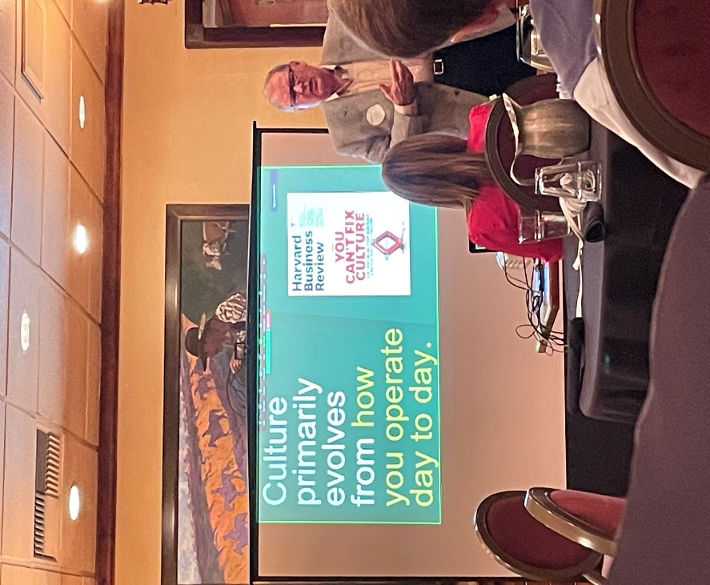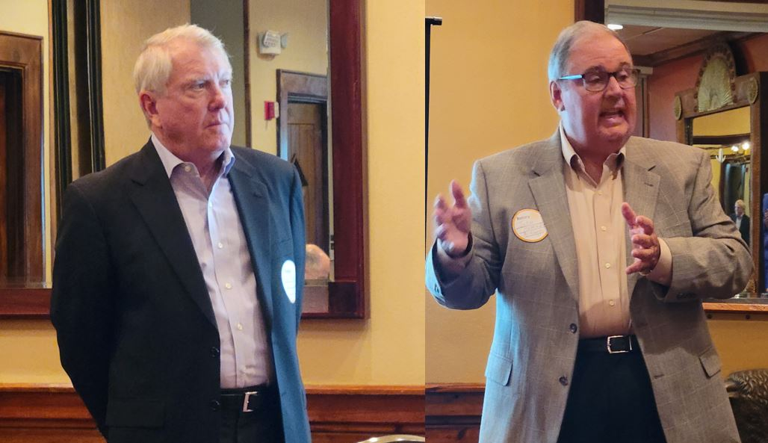**The Leawood Rotary Club featured two riveting speakers from Mr. K’s Legacy Project, John Harrington and Dave Pickhardt. Ewing Marion Kauffman was an entrepreneur and humanitarian whose innovative and long-lasting contributions have benefited millions of people in his hometown of Kansas City and beyond. We also “re-inducted” Larry Hawks! Welcome back, Larry!**

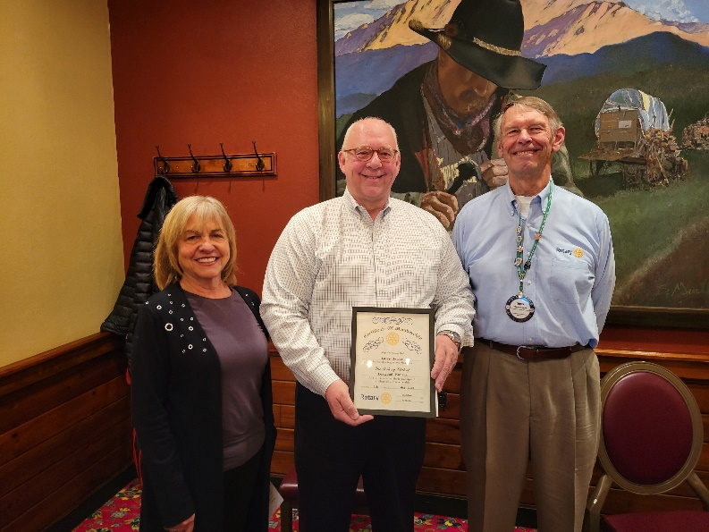

# Qr code Description automatically generatedLeawood Rotary Upcoming Events

* Don’t forget to use the QR code to the right to help Topeka win a grant that helps women re-establish themselves after incarceration and reduce recidivism. You can vote up to ten times a day!
* We are asking our Rotary members wishing to join the Polio Plus Society to agree to donate at least $100 to Polio Plus during this Rotary Year. See page three of this newsletter.

|  |  |
| --- | --- |
| Kentucky Derby Party (Lisa Katz) | May 7th |
| Final Days of Polio Plus Drive |  |
| Rotary Youth Camp Workday | May 7 or 14 |
| Unite KC Career Week | May 13th |
| Wine Tasting Event – May House | TBD |
| Rotary Day at Monarchs Park | Jun 9th |
| Annual Rotary Dinner – Vista 154 | Jun 23rd |

**The next in-person meeting at the Herford House (Hybrid Meeting) is Thursday, May 12th.**

**Please see the list of speakers and greeters in the table below.**

|  |  |  |  |
| --- | --- | --- | --- |
| **Date** | **Speaker** | **Invocation** | **Greeters** |
| May 12th, 2002 | Bill & Kathy Musgrave Tusange Update (Tom K & Chuck U) | Gene or Agnes Bartholf | Sally Barchman, Gene or Agnes Bartholf, Kevin Berman, Mike Best, Steve Black, Lucy Bloom |
| May 19th, 2022 | Jim Cosgrove Ripple-McGonigal book (Lisa H) | Kevin Berman | Same As Above |
| May 26th, 2022 | Board Meeting | n/a | n/a |

ZOOM ACCESS **Can’t make it to the in-person meetings? Join Via ZOOM and keep up to date!**

ALL Meetings are hybrid - being held **in person** and **via Zoom**. If you can’t attend in person, please join us on Thursdays at 7:15 am.

**Check for Chuck Udell’s email for the ZOOM Link**

**The PolioPlus Society**

As a Rotarian and supporter of Polio Eradication, **Rotary’s Number One Priority**, I wish to participate in the Countdown to History as a member of the

**PolioPlus Society of District 5710**

I commit to making an annual donation to the PolioPlus Fund of The Rotary Foundation as follows (select one):

* $100 per year (minimum amount to become a society member)
* A contribution of $_____________ per year to PolioPlus (more than $100)

Optional Lapel Pin: Yes ___ No ____

Optional End Polio Now Wristband: Yes ___ No ____

I pledge to help Rotary make history by continuing to contribute the above amount each year until the World Health Organization certifies that polio has been fully eradicated because …

***Until the world is polio-free, every child is at risk.***

Society members will receive a PolioPlus Society Membership Certificate and, if requested, the Society Lapel Pin and an End Polio Now wristband…and your contribution qualifies for Paul Harris Recognition Points credit.

To make your tax-deductible donation write a check to the Rotary Foundation with Polio Fund. Or go to [my.rotary.org/donate](https://my.rotary.org/en/donate) and click on “Polio Fund.” You can choose a one-time donation of $100 or more or a recurring donation in the amount and frequency of your choice (We suggest $10/month as the “easy way” to become a PolioPlus Society member.)

Name (please print)_____________________________Member ID: ________________

Email Address ____________________________Club Name_____________________

Signature ______________________________________Date____________________

Please provide a copy of this form to your club’s Foundation Chair. Then scan & email the form to **(Jim Arnett, 5710 Polio Chair,** [**maajca@gmail.com**](mailto:maajca@gmail.com)**)** or mail to **(2608 W. 118th St., Leawood, KS 66211).** Your PolioPlus Society certificate, pin and wristband will be presented at a club meeting to make sure you are recognized for your commitment to polio eradication.

**Sign up today!**