

# Highlights

**Wow! The Leawood Rotary Club added another new member! Welcome, Sonya Evans! Sonya has already made her presence felt. On Thursday, we received an update from Bill & Kathy Musgrave on the Tusange Children’s Ministry. What a fantastic contribution! The Leawood Rotarians also participated in a Youth Camp Workday – this looks like a complex operation – only Lego experts allowed!**

**The Leawood Club witnessed one of the most stunning upsets in Kentuck Derby History at the Kentucky Derby party on May 7th. Hats off to Lisa Katz and Mission Chateau for hosting a fantastic event. Be sure to check out all of the amazing pictures from Chuck Udell and Sara Nylund!**

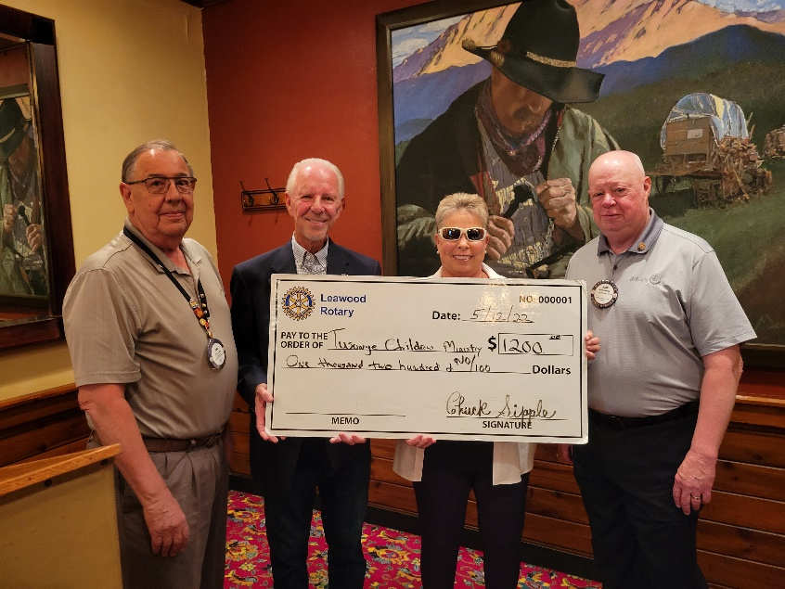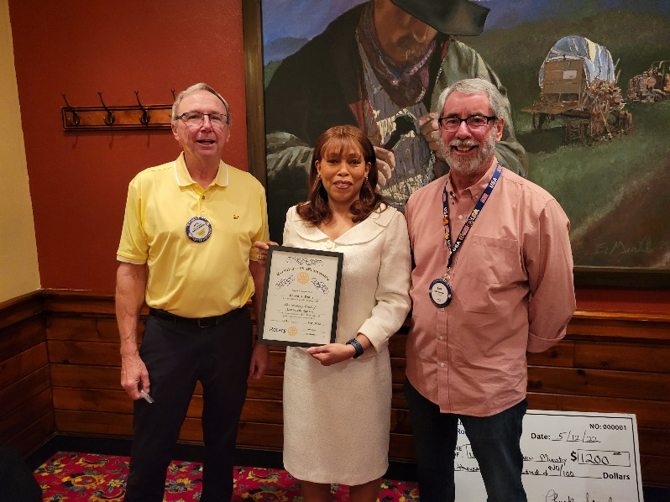

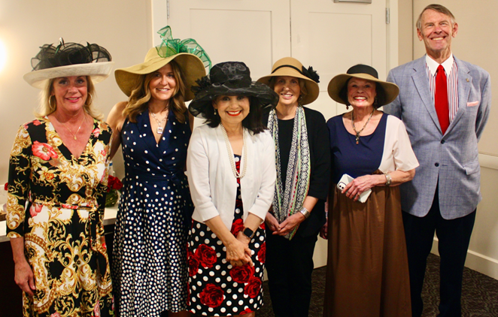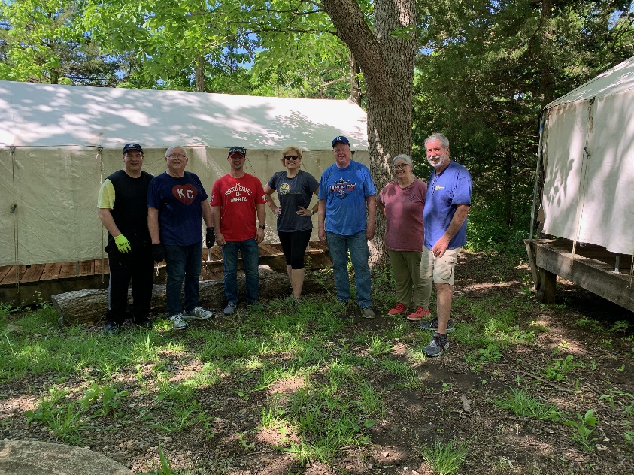

# Leawood Rotary Upcoming Events

* A big “Thank you to all of the Rotarians who volunteered to be a part of Unite KC’s invitation at New Chelsea’s Career Week.
* We are asking our Rotary members wishing to join the Polio Plus Society to agree to donate at least $100 to Polio Plus during this Rotary Year. See the new form on page three of this newsletter.

|  |  |
| --- | --- |
| Final Days of Polio Plus Drive |  |
| Unite KC Career Week | May 13th |
| Wine Tasting Event – May House | TBD |
| Rotary Day at Monarchs Park | Jun 9th |
| Annual Rotary Dinner – Vista 154 | Jun 23rd |

**The next in-person meeting at the Herford House (Hybrid Meeting) is Thursday, May 19th.**

**Please see the list of speakers and greeters in the table below.**

|  |  |  |  |
| --- | --- | --- | --- |
| **Date** | **Speaker** | **Invocation** | **Greeters** |
| May 19th, 2022 | Jim Cosgrove Ripple-McGonigal book (Lisa H) | Kevin Berman | Sally Barchman, Gene or Agnes Bartholf, Kevin Berman, Mike Best, Steve Black, Lucy Bloom |
| May 26th, 2022 | Board Meeting | n/a | n/a |

ZOOM ACCESS **Can’t make it to the in-person meetings? Join Via ZOOM and keep up to date!**

ALL Meetings are hybrid - being held **in person** and **via Zoom**. If you can’t attend in person, please join us on Thursdays at 7:15 am.

**Check for Chuck Udell’s email for the ZOOM Link**

**The Polio Plus Society**

As a Rotarian and supporter of Polio Eradication, **Rotary’s Number One Priority**, I wish to participate in the Countdown to History as a member of the

**PolioPlus Society of District 5710**

I hereby commit to making an annual donation to the PolioPlus Fund of The Rotary Foundation as follows (select one):

* $100 USD per year (minimum amount to become a society member)
* A contribution of $_____________ per year to PolioPlus (more than $100)

Optional Lapel Pin: Yes ___ No ____

Optional End Polio Now Wristband: Yes ___ No ____

I pledge to help Rotary make history by continuing to contribute the above amount each year until the World Health Organization certifies that polio has been fully eradicated because …

***Until the world is polio-free, every child is at risk.***

Society members will receive a PolioPlus Society Membership Certificate and, if requested, the Society Lapel Pin and an End Polio Now wristband…and your contribution qualifies for Paul Harris Recognition Points credit.

To make your tax-deductible donation write a check to the your Club’s Foundation with Polio Fund noted. Or go to [my.rotary.org/donate](https://my.rotary.org/en/donate) and click on “Polio Fund”. You can choose a one-time donation of $100 or more, or a recurring donation in the amount and frequency of your choice (We suggest $10/month as the “easy way” to become a PolioPlus Society member.)

Name (please print)_____________________________Member ID: ________________

Email Address ____________________________Club Name_____________________

Signature ______________________________________Date____________________

Please provide a copy of this form to your club’s Foundation Chair. Then scan & email form to **(Jim Arnett, 5710 Polio Chair,** [**maajca@gmail.com**](mailto:maajca@gmail.com)**)** or mail to **(2608 W. 118th St., Leawood, KS 66211).** Your PolioPlus Society certificate, pin and wristband will be presented at a club meeting to make sure you are recognized for your commitment to polio eradication. 