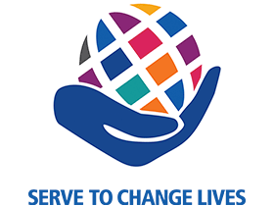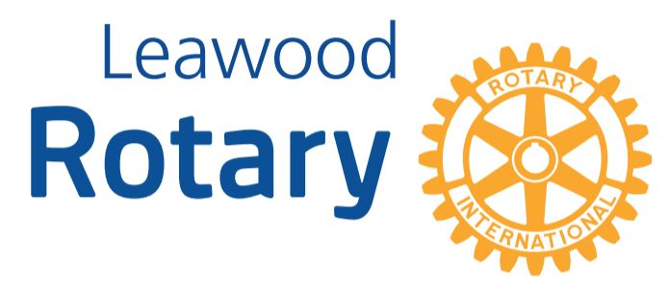

# Highlights

**The Leawood Rotary Club got a real treat this past Thursday – our guest speaker was an author! Jim Cosgrove gave us a detailed account of his research experiences while writing the book “Ripple,” an account of the disappearance of Frank McGonigal.**

**The Leawood Rotarians also partnered with Unite KC at New Chelsea Elementary School’s Career Week. What a fantastic opportunity to spark the imagination and inspiration of young minds! John Meier and Chuck Udell also shared their life’s vocations and passions.**

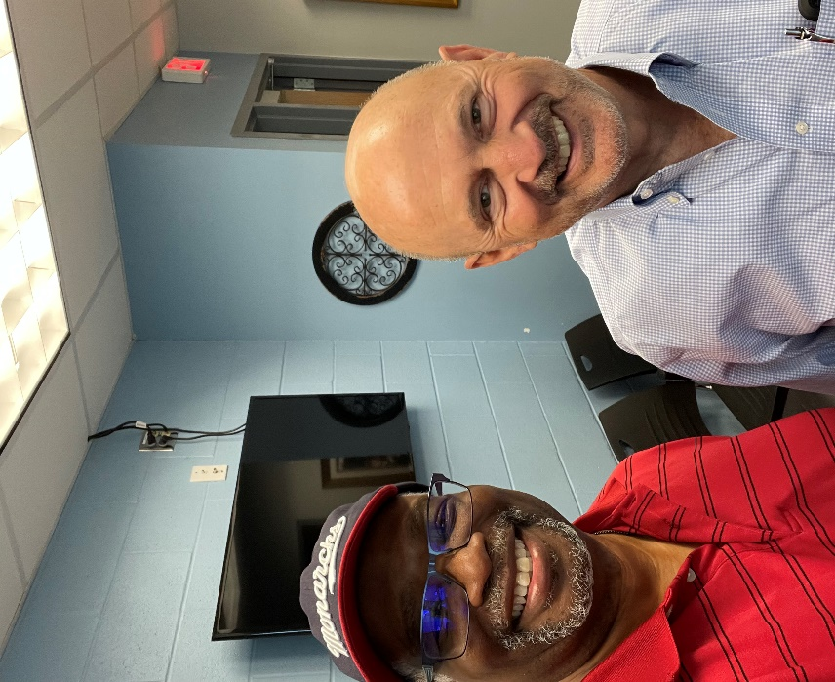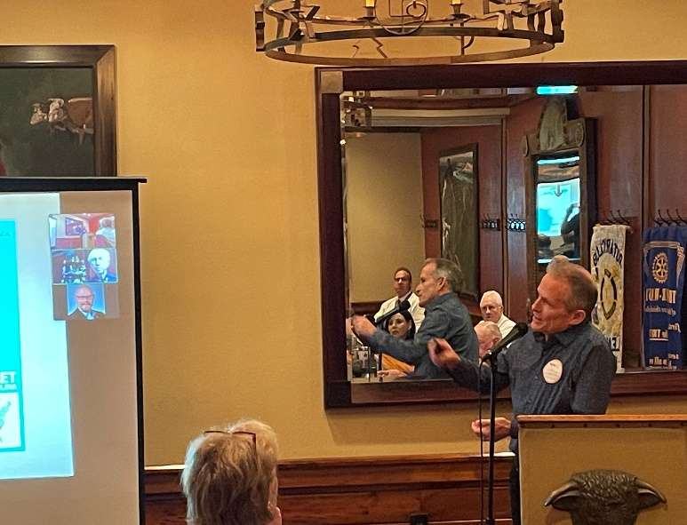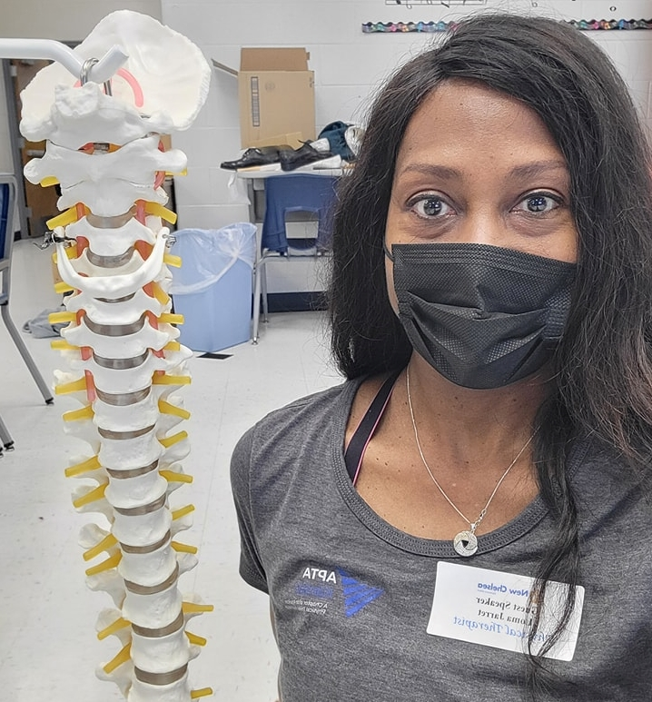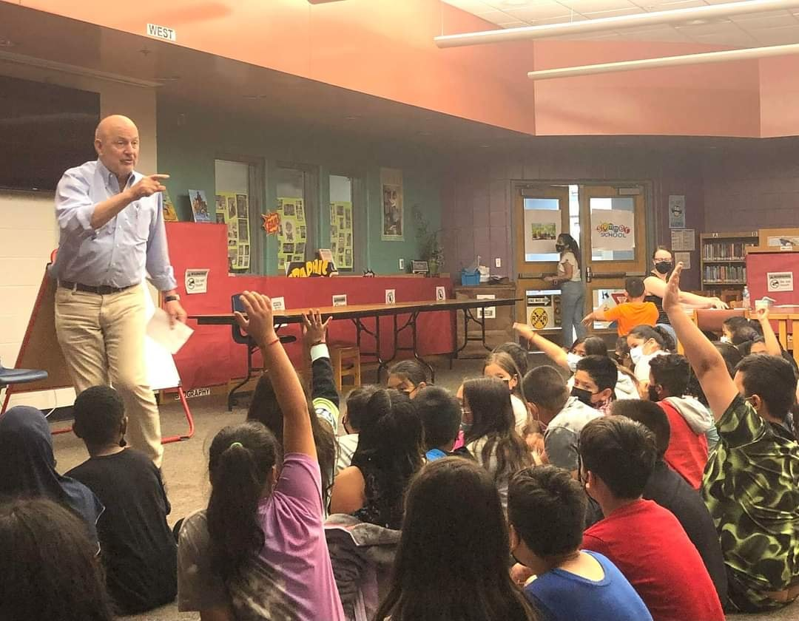

# A picture containing cloud, night sky Description automatically generatedA red moon in the sky Description automatically generated with low confidenceLeawood Rotary Other News

* A big “Thank you to all of the Rotarians who volunteered to be a part of Unite KC’s invitation at New Chelsea’s Career Week.
* My son and I got some excellent photos of the May 14 lunar eclipse/blood moon. Enjoy these pictures if you missed the event.

|  |  |
| --- | --- |
| Jerusalem Farm | TBD |
| Wine Tasting Event – May House | TBD |
| Rotary Day at Monarchs Park | Jun 9th |
| Annual Rotary Dinner – Vista 154 | Jun 23rd |

**This Thursday, May 26th, is the Rotary Business meeting. The next in-person meeting at the Herford House (Hybrid Meeting) is Thursday, Jun 2nd.**

**Please see the list of speakers and greeters in the table below.**

|  |  |  |  |
| --- | --- | --- | --- |
| **Date** | **Speaker** | **Invocation** | **Greeters** |
| May 26th, 2022 | Board Meeting | n/a | n/a |

ZOOM ACCESS **Can’t make it to the in-person meetings? Join Via ZOOM and keep up to date!**

ALL Meetings are hybrid - being held **in person** and **via Zoom**. If you can’t attend in person, please join us on Thursdays at 7:15 am.

**Check for Chuck Udell’s email for the ZOOM Link**