

# Highlights

**Jake and Debbie gave an outstanding presentation on their Caminos de Santiago tour. The Camino de Santiago, known in English as the Way of St James, is a network of pilgrims' ways or pilgrimages leading to the shrine of the apostle Saint James the Great.**

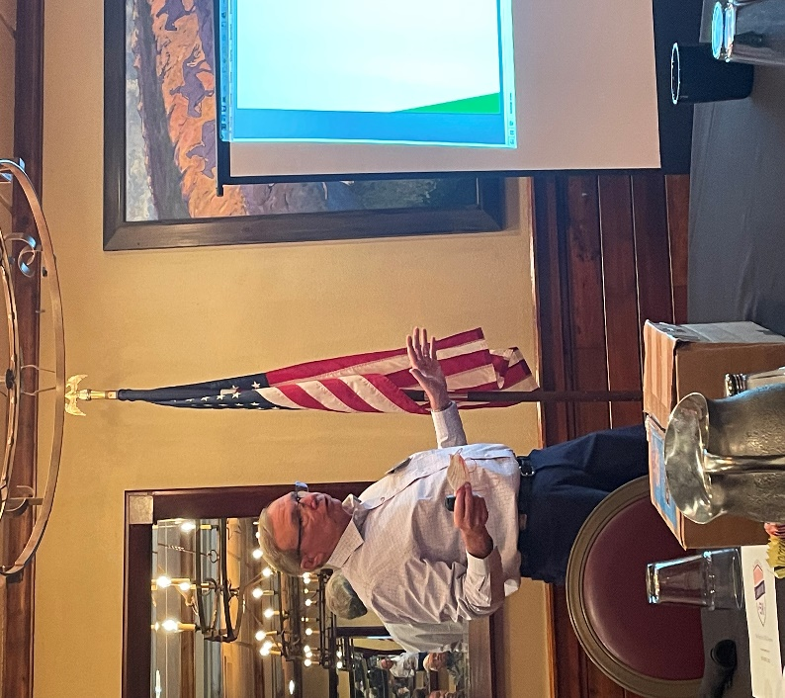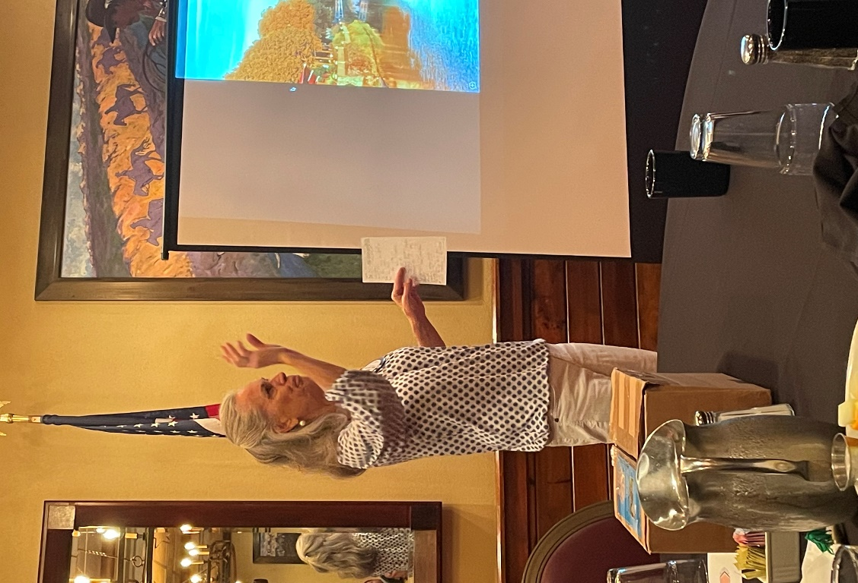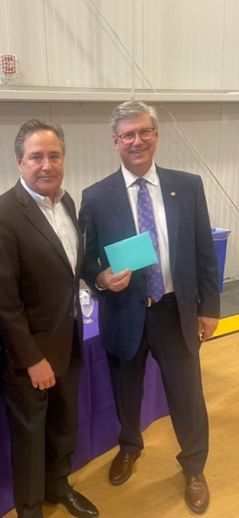 **Dave Anderson presented a gift from the REACH Team to Ron Slepitza at his retirement reception at Avila University - celebrating his Avila presidency. The envelope contains millions of dollars. Congrats Ron!**

# Leawood Rotary Other News

* We'll be collecting food at our annual dinner. The cans will be used for centerpieces and then donated to the Village Church Food Pantry, serving thousands of our neighbors in JoCo. Times are tough for many, so thank you for giving generously.
* The next Wine Affinity Group meeting will be Monday, Jun 6th at 5:30 pm. The hosts are Paul and Denise Rueschhoff, and the wine theme is any wine with the words Pinot or Noir in the name. The event will be at Paul and Denise's home. The address is 12008 Cherokee Lane, Leawood, KS 66209.

|  |  |
| --- | --- |
| Jerusalem Farm | TBD |
| Wine Tasting Event – Rueschhofff House | Jun 6th |
| Rotary Day at Monarchs Park | Jun 9th |
| Annual Rotary Dinner – Vista 154 | Jun 23rd |
| Unite KC Walk for Unity | Jul 9th |

**The next in-person meeting at the Herford House (Hybrid Meeting) is Thursday, Jun 9th.**

**Please see the list of speakers and greeters in the table below.**

|  |  |  |  |
| --- | --- | --- | --- |
| **Date** | **Speaker** | **Invocation** | **Greeters** |
| Jun 9th | Amy Pollen – KC Scholars | Steve Black | Leigh Briggs, John Brown, Gary Bussing, Taylor Coker, Keith Drinkard, Kathy Dull |
| Jun 16th | Club Assembly | n/a |  |
| Jun 23rd | Board Meeting | n/a |  |

ZOOM ACCESS **Can't make it to the in-person meetings? Join Via ZOOM and keep up to date!**

ALL Meetings are hybrid - being held **in person** and **via Zoom**. If you can't attend in person, please join us on Thursdays at 7:15 am.

**Check for Chuck Udell's email for the ZOOM Link**

Keep Scrolling…

**Bonus Pics**

