

# Highlights

**This week in Rotary news, Amy Pollen and the KC Scholars team made a fantastic presentation to the Leawood Rotary Club. They reminded us how important the scholarship award process is to families – we are so happy that young Amy will be able to pursue her college career.**

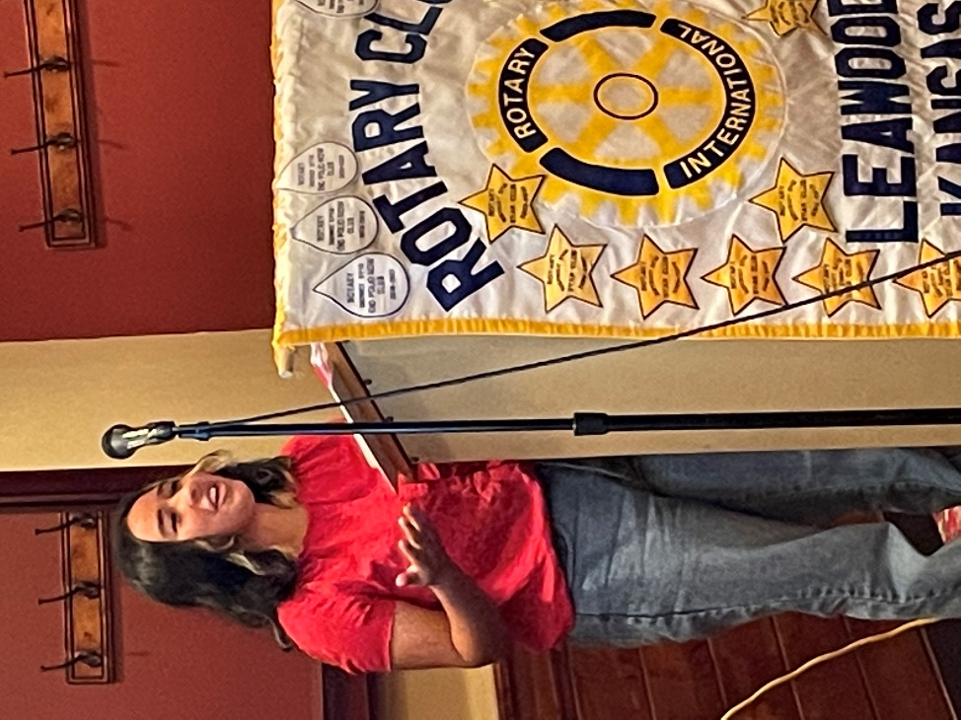**…And of course, there was more wine tasting!!! Many thanks to Rueschhofffs for hosting!**

# Leawood Rotary Other News and Upcoming Events

It’s always fantastic seeing Leawood Rotarians in the news and making an impact all over the city and the world. Thank you, John, Chuck, and Lucy, for shining the light on our club!

|  |  |
| --- | --- |
| Happy Bottoms Project Day | TBD |
| Rotary Day at Monarchs Park | Jun 9th |
| Check Presentation to Heart to Heart | Jun 16th |
| Annual Rotary Dinner – Vista 154 | Jun 23rd |
| Unite KC Walk for Unity | Jul 9th |

**The next in-person meeting at the Herford House (Hybrid Meeting) is Thursday, Jun 16th.**

**Please see the list of speakers and greeters in the table below.**

|  |  |  |  |
| --- | --- | --- | --- |
| **Date** | **Speaker** | **Invocation** | **Greeters** |
| Jun 16th | Club Assembly | n/a | Leigh Briggs, John Brown, Gary Bussing, Taylor Coker, Keith Drinkard, Kathy Dull |
| Jun 23rd | Board Meeting | n/a |  |

ZOOM ACCESS **Can’t make it to the in-person meetings? Join Via ZOOM and keep up to date!**

ALL Meetings are hybrid - being held **in person** and **via Zoom**. If you can’t attend in person, please join us on Thursdays at 7:15 am.

**Check for Chuck Udell’s email for the ZOOM Link**