

# Highlights

**This week Rotarians shared information at our Club Assembly. We hosted a Heart to Heart International visitor this past Thursday morning and presented them with a $1000 check for their work in Ukraine.**

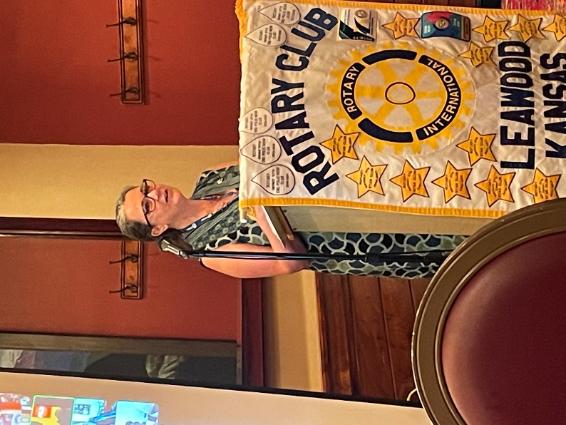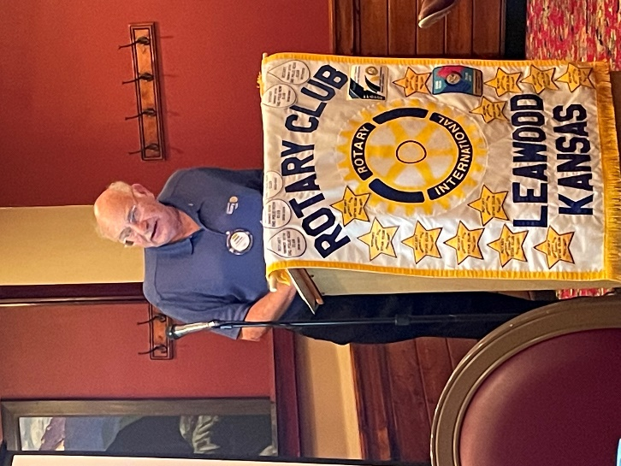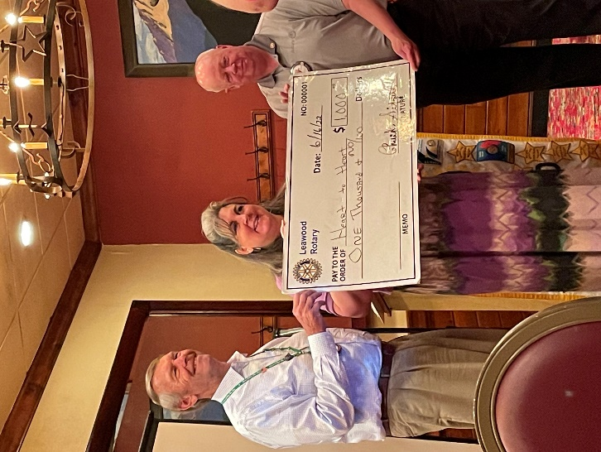**The Club also got updates from Jonn Wullschleger, Lucy Bloom, and Chuck Udell on the International Convention in Houston.**

# Leawood Rotary Other News and Upcoming Events

* Don’t forget to sign up for the Labor Day Run. Here’s the link to sign: <https://runsignup.com/Race/KS/Leawood/LeawoodLaborDay5K?remMeAttempt=>!
* We all notice rising food prices. Imagine how hard it must be for some to feed their families. Please bring food cans and other items to our annual dinner. We will give the donations to the food pantry at Village Church on Antioch.
* Are you ready for another reason to celebrate? July is designated as “Reach out to a Rotarian you haven’t seen in a while” month! Let’s get our absent members and friends involved!

|  |  |
| --- | --- |
| Happy Bottoms Project Day | TBD |
| Annual Rotary Dinner – Vista 154 | Jun 23rd |
| Unite KC Walk for Unity | Jul 9th |

**Our next meeting is our Board Meeting (Jun 23rd). The next in-person meeting at the Herford House (Hybrid Meeting) is Thursday, Jul 1st.**

**Please see the list of speakers and greeters in the table below.**

|  |  |  |  |  |
| --- | --- | --- | --- | --- |
| **Date** | **Speaker** | **Invocation** |  | **Greeters** |
| Jun 23rd | Board Meeting | n/a |  | n/a |

ZOOM ACCESS **Can’t make it to the in-person meetings? Join Via ZOOM and keep up to date!**

ALL Meetings are hybrid - being held **in person** and **via Zoom**. If you can’t attend in person, please join us on Thursdays at 7:15 am.

**Check for Chuck Udell’s email for the ZOOM Link**