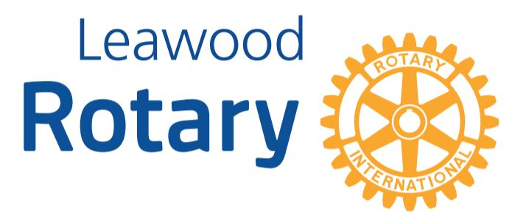

# Special “Catch Up” Edition - Highlights

**Leawood Rotarians have been busy the past few weeks, so we have lots of news to cover in this Special Edition! Enjoy the pictures!**

Chuck presents “Rotarian of the Year” award (clock) to Gary Bussing

Chuck Sipple presents “Newcomer of the Year” award to Kirt Yoder

John Meier - First Meeting as new President

Juan Vazquez, Juan Marron and Seth Lyons receive their Reach Scholarship Funding

Ray Jarrett with Dayton Moore

Q: "Hey Chuck, does it hurt to be President?" A: "Naaa, but you will feel a slight pinch..."

Leawood Rotary at the Walk for Unity

Stephen Powell’s induction into Leawood Rotary

Wine Affinity Event hosted by Chris Sagovac and Gail Weiss

# Leawood Rotary Other News and Upcoming Events

* Don’t forget to sign up for the Labor Day Run. Here’s the link: <https://runsignup.com/Race/KS/Leawood/LeawoodLaborDay5K?remMeAttempt=>!
* Are you ready for another reason to celebrate? July is designated as “***Reach out to a Rotarian you haven’t seen in a while***” month! Let’s get our absent members and friends involved!

# Did You Know?

* Did you know that our very own Jim Arnett worked with Mike Farrell and Gene Roddenberry to provide technical advice for several Star Trek movies? He gets additional cool Rotarian points for that fact!

**The next in-person meeting at the Herford House (Hybrid Meeting) is Thursday, Jul 21st.**

|  |  |  |  |  |  |
| --- | --- | --- | --- | --- | --- |
| July 21, 2022 | Morgan Henderson  Ripple Glass (C) | John Brown | Rod Pemberton |  | Rick Robinson |
| July 28, 2022 | Board Meeting | N/A | N/A |  | Andrew Catherwood |

ZOOM ACCESS **Can’t make it to the in-person meetings? Join Via ZOOM and keep up to date!**

ALL Meetings are hybrid - being held **in person** and **via Zoom**. If you can’t attend in person, please join us on Thursdays at 7:15 am.

**Check for Chuck Udell’s email for the ZOOM Link**