

# Highlights

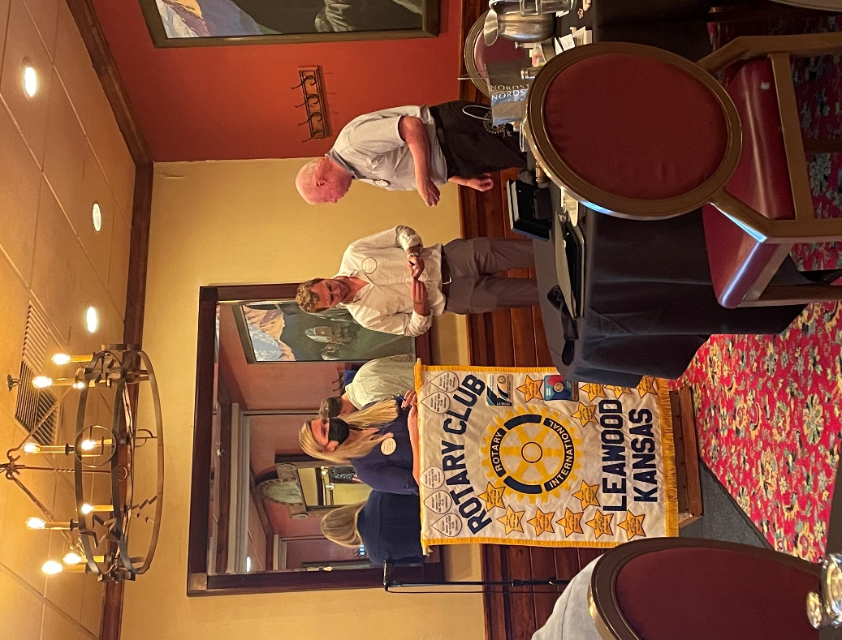**Leawood Rotarians hosted Ripple Glass at its last meeting; Morgan and Piercyn retold the story of how glass recycling is transforming our landscape. Last week (sorry for the inadvertent omission), our own Brad Moore gave us a look at the Overland Park Historical Society’s artifacts and stories.**

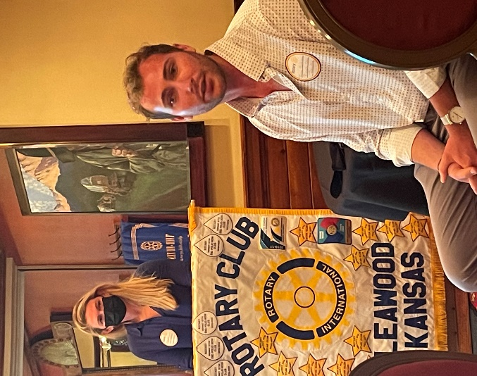

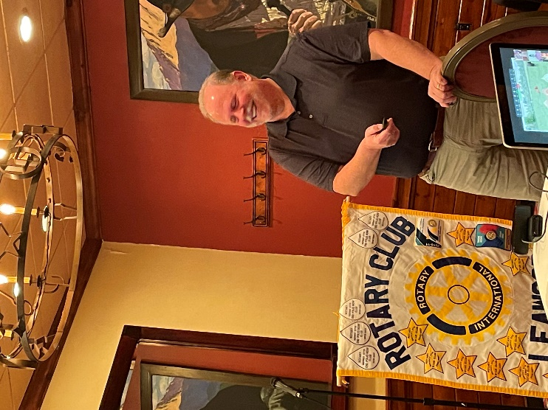

Brad Moore - OP Historical Society Presentation

Morgan and Piercyn from Ripple Glass

John Meier – Presents Ripple Glass with Leawood Rotarty gifts

# Leawood Rotary Other News and Upcoming Events

* Don’t forget to sign up for the Labor Day Run. Here’s the link: <https://runsignup.com/Race/KS/Leawood/LeawoodLaborDay5K?remMeAttempt=>!
* Rotary Happy Hour is coming up on Aug 12th. $15 Reservations are required and include reserved seating and your first beverage. Click Here for Reservations: [Reservation Link](https://checkout.xola.com/index.html#seller/5fab0050fe09ed788500c4d5/experiences/62d5b9f2d8dedd2f5526c3b2?openExternal=trueHi)

**Thursday, Jul 28th, is the Board Meeting. The next in-person meeting at the Herford House (Hybrid Meeting) is Thursday, Aug 11th.**

|  |  |  |  |  |  |
| --- | --- | --- | --- | --- | --- |
| **Date** | **Guest Speaker** | **Invocation** | **Vocational** | **Greeters** | **Tech Crew** |
| Jul 28th, 2022 | Board Meeting | N/A | N/A |  | Andrew Catherwood |
| Aug 4th, 2022 | Field Trip: The New Wave Event Space @ Leawood City Pool | Gary Bussing | Darren Lippe | Teri G., Lisa H., Mel H., Rob H., Larry H., Mike H. | Sara Nyland |
| Aug 11th, 2022 | David Bell – Defending the Indefensible | Andrew Catherwood |  | Same as Above | David Bell |
| Aug 18th, 2022 | Offered to Dan Brown – Volunteering in Ukraine | John Caton | Mary Holland | Same as Above | Rick Robinson |
| Aug 25th, 2022 | Board Meeting | N/A | N/A | Same as Above | Andrew Catherwood |

ZOOM ACCESS **Can’t make it to the in-person meetings? Join Via ZOOM and keep up to date!**

ALL Meetings are hybrid - being held **in person** and **via Zoom**. If you can’t attend in person, please join us on Thursdays at 7:15 am.

**Check for Chuck Udell’s email for the ZOOM Link**