

# Highlights

**This past week, the Leawood Rotary Club had the week off for its monthly business meeting; however, we have some important news!!**

**First, we will not be at the Herford House this Thursday; our meeting will be at a remote location. Our next meeting will find us at The Wave 106, Leawood's brand new event space gem, located at City Park, next to the pool.**

**We'll hear all the latest from our Leawood Parks & Rec team members, and they'll answer all your questions about current and planned Parks & Rec projects. We will serve coffee, juice, and a yummy boxed breakfast.**

**If you didn't see the August 2022 Edition of the Rotary magazine, make sure you pick up a copy and read the President's message on page 1. Jennifer Jones wrote an inspirational article that sets the tone for advancing the role of the Rotary.**

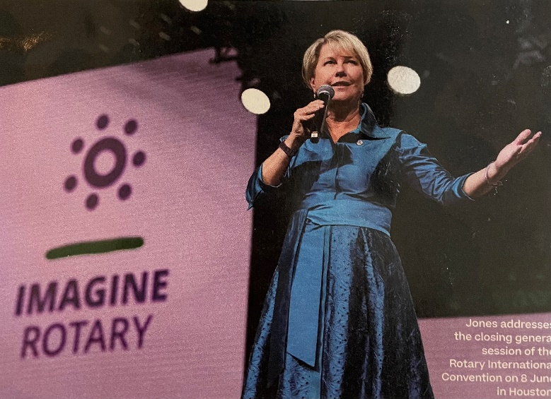

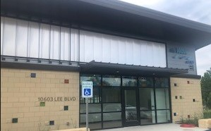

“An invitation that unlocks our imaginations and allows us to know that everything and anything is possible. Each one of us has that same opportunity the honor to extend an invitation.”

The official address is 10603 Lee Blvd.

# Leawood Rotary Other News and Upcoming Events

* Don't forget to sign up for the Labor Day Run. Here's the link: <https://runsignup.com/Race/KS/Leawood/LeawoodLaborDay5K?remMeAttempt=>!
* Rotary Happy Hour is coming up on Aug 12th. $15 Reservations are required and include reserved seating and your first beverage. Click Here for Reservations: [Reservation Link](https://checkout.xola.com/index.html#seller/5fab0050fe09ed788500c4d5/experiences/62d5b9f2d8dedd2f5526c3b2?openExternal=trueHi)

**Thursday, Aug 4th, is a Field Trip. The next in-person meeting at the Herford House (Hybrid Meeting) is Thursday, Aug 11th.**

|  |  |  |  |  |  |
| --- | --- | --- | --- | --- | --- |
| **Date** | **Guest Speaker** | **Invocation** | **Vocational** | **Greeters** | **Tech Crew** |
| Aug 4th, 2022 | Field Trip: The New Wave Event Space @ Leawood City Pool | Gary Bussing | Darren Lippe | Teri G., Lisa H., Mel H., Rob H., Larry H., Mike H. | Sara Nyland |
| Aug 11th, 2022 | David Bell – Defending the Indefensible | Andrew Catherwood |  | Same as Above | David Bell |
| Aug 18th, 2022 | Offered to Dan Brown – Volunteering in Ukraine | John Caton | Mary Holland | Same as Above | Rick Robinson |
| Aug 25th, 2022 | Board Meeting | N/A | N/A | Same as Above | Andrew Catherwood |

ZOOM ACCESS **Can't make it to the in-person meetings? Join Via ZOOM and keep up to date!**

ALL Meetings are hybrid - being held **in person** and **via Zoom**. If you can't attend in person, please join us on Thursdays at 7:15 am.

**Check for Chuck Udell's email for the ZOOM Link**