

# Highlights

**This past week, the Leawood Club took its Rotary show on the road thanks to the coordination of our multi-talented member, Lisa Harrison! Rotarians met at “The Wave,” Leawood’s new event space in City Park. We were able to tour the space and received an update on projects from Brian Anderson, Leawood Parks and Recreation.**

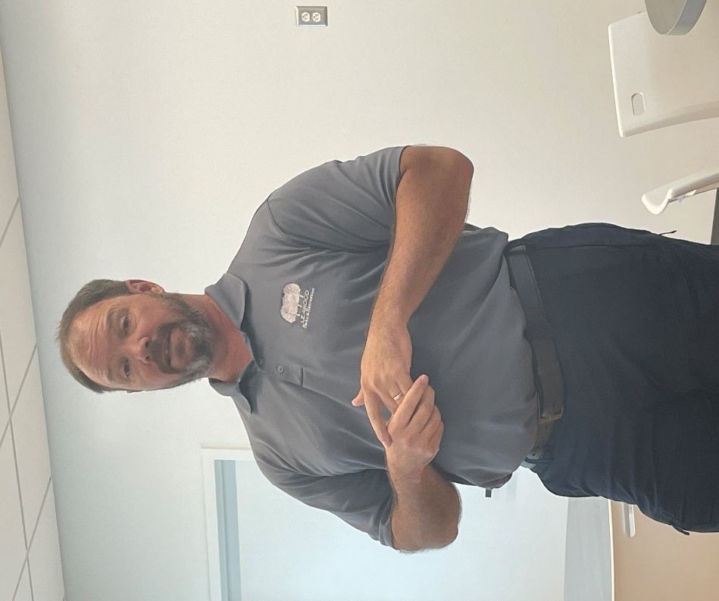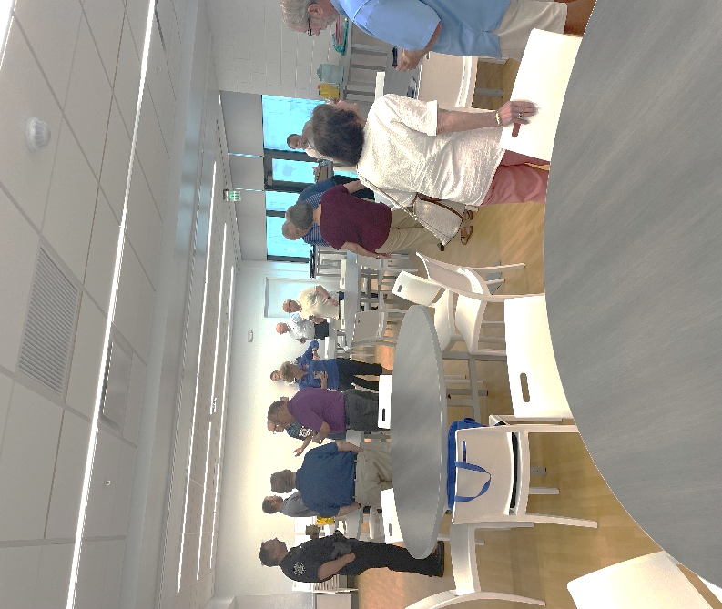**Rotarians also donated their time to volunteer at Project C.U.R.E., an organization that provides humanitarian assistance to the people of Ukraine and is the world’s largest distributor of medical supplies to resource-limited communities across the globe.**

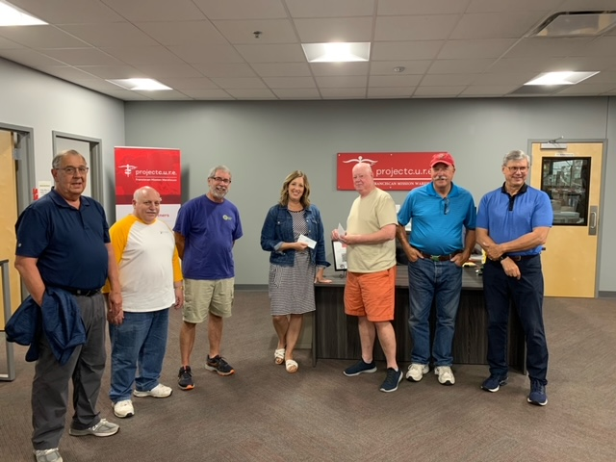

Rotarians Gathering at “The Wave”

Rotarians at Project C.U.R.E.

Brian Anderson from Leawood Parks and Recreation

# Leawood Rotary Other News and Upcoming Events

* Don’t forget to sign up for the Labor Day Run. Here’s the link: <https://runsignup.com/Race/KS/Leawood/LeawoodLaborDay5K?remMeAttempt=>!
* Each of you should have received an email from Signup Genius. We are using this program to sign up for working the 5k. You can sign up for different areas (water station, course monitor, photography, etc.). Please create your login and sign up for a spot.
* The next Wine Affinity Group meeting will be Tuesday, Aug 23rd at 5:30 pm. The wine theme is “Wines from the Tuscany region of Italy.” Mary and John will host the event at their home. The address is 12357 Long St, Overland Park, KS.
* Rotary Happy Hour is coming up on Aug 12th. $15 Reservations are required and include reserved seating and your first beverage. Click Here for Reservations: [Reservation Link](https://checkout.xola.com/index.html#seller/5fab0050fe09ed788500c4d5/experiences/62d5b9f2d8dedd2f5526c3b2?openExternal=trueHi)

**The next in-person meeting at the Herford House (Hybrid Meeting) is Thursday, Aug 11th.**

|  |  |  |  |  |  |
| --- | --- | --- | --- | --- | --- |
| **Date** | **Guest Speaker** | **Invocation** | **Vocational** | **Greeters** | **Tech Crew** |
| Aug 11th, 2022 | David Bell – Defending the Indefensible | Andrew Catherwood |  | Teri G., Lisa H., Mel H., Rob H., Larry H., Mike H. | David Bell |
| Aug 18th, 2022 | Offered to Dan Brown – Volunteering in Ukraine | John Caton | Mary Holland | Same as Above | Rick Robinson |
| Aug 25th, 2022 | Board Meeting | N/A | N/A | Same as Above | Andrew Catherwood |

ZOOM ACCESS **Can’t make it to the in-person meetings? Join Via ZOOM and keep up to date!**

ALL Meetings are hybrid - being held **in person** and **via Zoom**. If you can’t attend in person, please join us on Thursdays at 7:15 am.

**Check for Chuck Udell’s email for the ZOOM Link**