

# Highlights

**This past week, the Leawood Club’s guest speaker was Dan Brown, the son of Rotarian John Brown! (pictured seated)**

**Dan retold story after story of his time as a volunteer firefighter in Ukraine. We heard first-hand accounts of the dangers, the shelling, and the heroic efforts of Ukrainians fighting to keep their country free. We are so glad you returned safely!**

**Dan’s selflessness in volunteering certainly brings home the need to support organizations like “Habitat for Humanity” A little-known fact about Ukraine, located in eastern Europe, is that it is the second largest country on the continent after Russia.**

**Rotarians also came to a consensus on a new Leawood Rotary Flag!!! Thanks, Sara, for all of your hard work!**

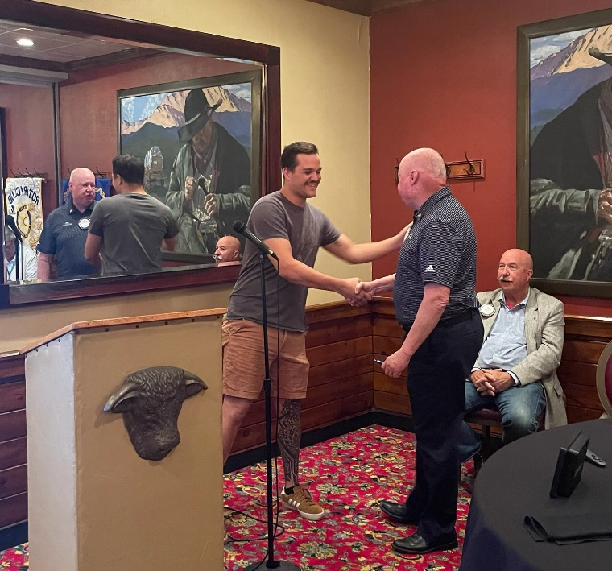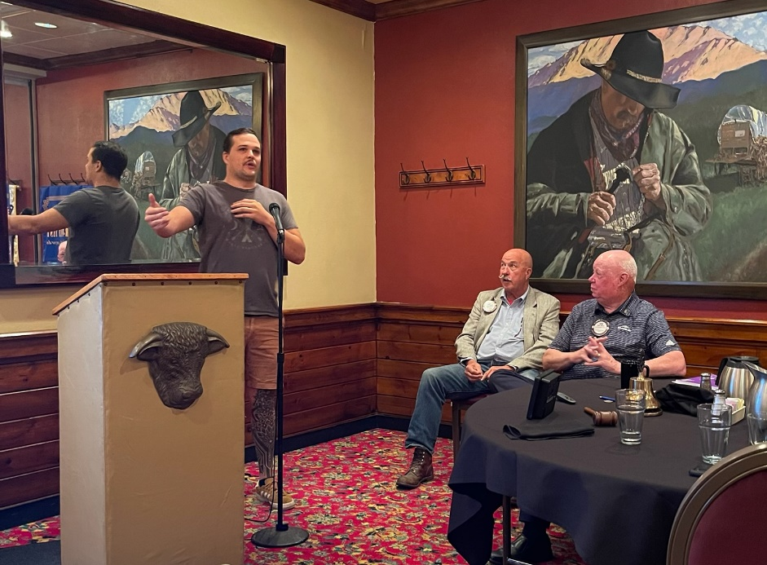

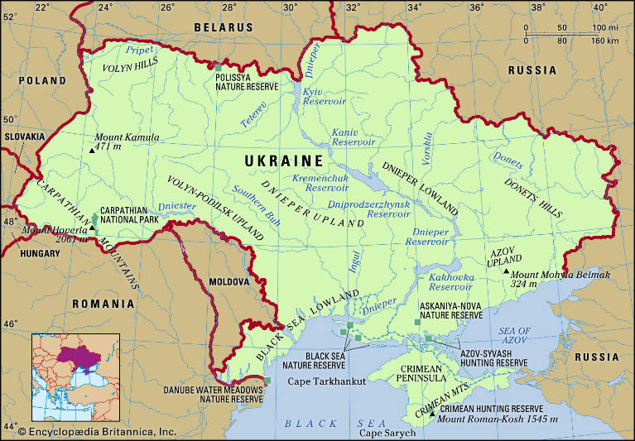

# Leawood Rotary Other News and Upcoming Events

* Don’t forget to sign up for the Labor Day Run. Here’s the link: <https://runsignup.com/Race/KS/Leawood/LeawoodLaborDay5K?remMeAttempt=>!
* Each of you should have received an email from Signup Genius. We are using this program to sign up for working the 5k. You can sign up for different areas (water station, course monitor, photography, etc.). Please create your log-in and sign up for a spot.
* The next Wine Affinity Group meeting will be Tuesday, Aug 23rd at 5:30 pm. The wine theme is “Wines from the Tuscany region of Italy.” Mary and John will host the event at their home. The address is 12357 Long St, Overland Park, KS.

**The next meeting at the Herford House is our Board Meeting on Thursday, Aug 25th.**

|  |  |  |  |  |  |
| --- | --- | --- | --- | --- | --- |
| **Date** | **Guest Speaker** | **Invocation** | **Vocational** | **Greeters** | **Tech Crew** |
| Aug 25th, 2022 | Board Meeting | N/A | N/A | Teri G., Lisa H., Mel H., Rob H., Larry H., Mike H. | Andrew Catherwood |

ZOOM ACCESS **Can’t make it to the in-person meetings? Join Via ZOOM and keep up to date!**

ALL Meetings are hybrid - being held **in person** and **via Zoom**. If you can’t attend in person, please join us on Thursdays at 7:15 am.

[**https://us06web.zoom.us/j/81310427816?pwd=RnpGRnY5dmd2dnl5WS9FaGQwVEhydz09**](https://us06web.zoom.us/j/81310427816?pwd=RnpGRnY5dmd2dnl5WS9FaGQwVEhydz09)

**Meeting ID: 813 1042 7816**

**Passcode: Rotary**