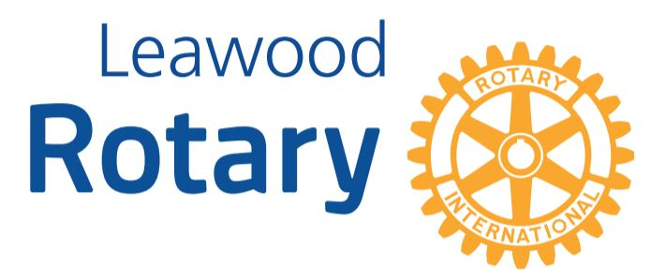

# Highlights

**The Leawood Rotary Club knows how to have fun! On September 18, the club hosted its Annual Picnic at the Sharp’s Homestead!!! A big thanks to everyone who worked to make this event a total SUCCESS! A trivial question came out of this event: Can you name the Rotarians who decided to climb onto the roof of the barn???? Sara – thanks again for the excellent photography work! Click here to see all the pictures ->** [**Picnic 2021**](https://www.icloud.com/sharedalbum/#B0i53qWtHJHzx6G)

# Leawood Rotary Upcoming Events

**\*\* ALERT ** We WILL NOT have a meeting next Thursday, September 30.**

* **Women’s Social September 30**
* **Christmas in October October 9**
* **District 5710 Conference Oct 22-23**
* **New Member Orientation October 27**
* **Tomahawk Trail Cleanup November 6**

**

## Meet Leawood Rotary’s newest Member

## *Rod PemBerton*



**WELCOME, Rod!!! Rod is a Financial Professional and helps individuals, couples, and families grow their assets for the long term. His story will be featured in Ken Selzer’s new book, “Believing Again, Rising Above.” Rod is open to coffee and GOLF dates!!! Please make him feel welcome!**



**Can’t make it to the in-person meetings? Join Via ZOOM and keep up to date!**

ALL Meetings are hybrid - being held **in person** and **via Zoom**. If you can’t attend in person, please join us on Thursdays at 7:15 a.m. via the Zoom Information below.

Zoom Meeting - [Zoom Link](https://us02web.zoom.us/j/86135437131?pwd=cUNGUUMxTCtTeHAybDRIS2JLRm41UT09)  
Meeting ID: 861 3543 7131   
Passcode: Rotary