

# Highlights

**Leawood Rotarians keep making a difference!! Our Christmas in October event saw Rotarians provide a much-needed facelift for a grateful KC resident – Rita Smith. Check out the “before” and “after”’ pictures below. Even the little dog in the first picture was excited!**

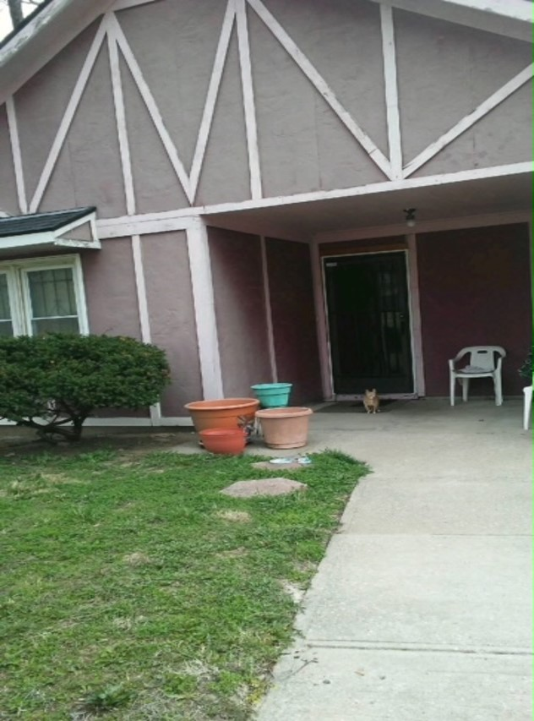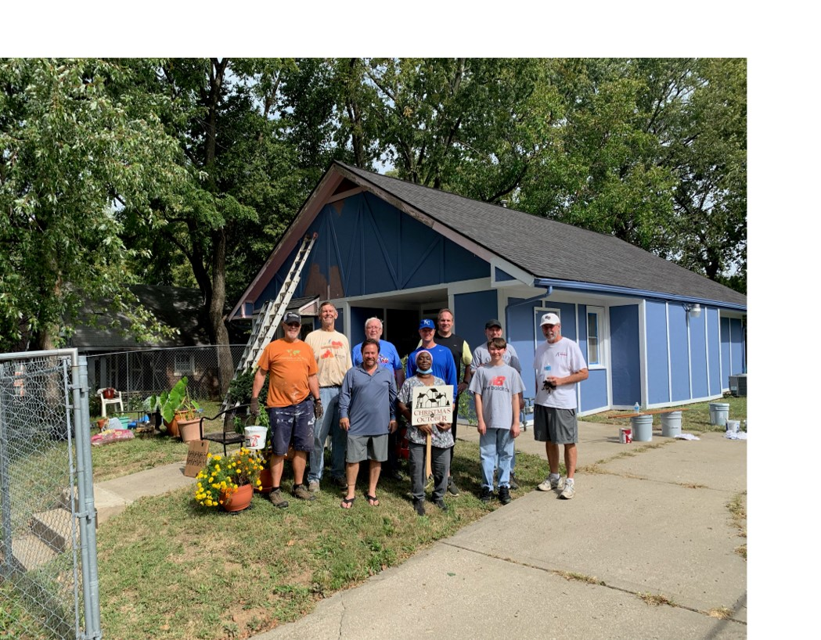

# Rotarian Fact of the Week

The Rotary International Club 29 of Oklahoma City, also known as Downtown Rotary,has 600+ members and is the largest Rotary club in the world.

# Important Reminders and Announcements

* Please welcome our newest member, Kirt Yoder! Captain Kirt Yoder is the Operations Division Commander with the Leawood Police force and will be a great addition to our club! John Meier will be his mentor. Would you please welcome Kirt to our club? His induction will be next week, Oct 21st.
* Oops! Please do not park by the Hereford House trash dumpsters when attending the Rotary Meetings. We’ve learned that the Waste Management trucks have great difficulty getting to the dumpsters when we park near them.

# Leawood Rotary Upcoming Events

On October 21- 23, 2021, at the Hilton Convention Center in Manhattan, Kansas, we are thrilled to unite District 5710 Rotarians in a celebration of all our District has accomplished this past year!

Important Dates

# **JCCB Dinner & Auction Oct 22nd**

# **District 5710 Conference Oct 21-23rd**

# **Wine Group – Terri Gimlin Oct 26th**

# **New Member Orientation Oct 27th**

# **Tomahawk Trail Cleanup Nov 6th**

# **Rise Against Hunger Nov 26th**

# **Happy Hour Mission Chateau Dec 8th**

# **JCCB Work Day Dec 11th**

**The next meeting is Thursday, Oct 21st, 2021, at the Herford House (Hybrid Meeting)**

**Please see the list of speakers and greeters in the table below.**

|  |  |  |  |
| --- | --- | --- | --- |
| **Date** | **Speaker** | **Invocation** | **Greeters** |
| Oct 21, 2021 | Nancy Barber  PHF/Foundation | Rick Robinson | Terri Gimlin , **Lisa Harrison** , Mel Hawk , Rob Hindman , Mike Hoefer , Russ Johnson |
| Oct 28, 2021 | Board Meeting | n/a | Same as Above |
| Nov 4, 2021 | HANDWASH Rotary Grant Program (Chuck U.) | n/a | Lorna or Ray Jarrett , **David Johnston**  Del Karmeier , Lisa Katz , Roxann Kerr Lindsey , Tom Koch |
| Nov 11, 2021 | Leawood Rotary Veterans | Paul Rueschhoff | Same as Above |
| Nov 18, 2021 | Chuck Green – retired Secret Service (John M) | Jake or Debby Schloegel | Same as Above |

ZOOM ACCESS **Can’t make it to the in-person meetings? Join Via ZOOM and keep up to date!**

ALL Meetings are hybrid - being held **in person** and **via Zoom**. If you can’t attend in person, please join us on Thursdays at 7:15 am via the Zoom Information below.

Zoom Meeting - [Zoom Link](https://us02web.zoom.us/j/86135437131?pwd=cUNGUUMxTCtTeHAybDRIS2JLRm41UT09)  
Meeting ID: 861 3543 7131   
Passcode: Rotary