

# Highlights

**Leawood Rotarians continued their legacy of service with their latest trip to Bishop Ward High School to engage students in the Reach Program. The Reach committee planned and executed a masterful meeting that involved leading students through an exploration of careers using various online and mentor-led tools. Ken Selzer gave an inspirational vocational talk about being a first-generational college graduate and his success as a CPA.**

# 

Rotarian Fact of the Week

The four founder Rotarians (from left) were: Gustavus Loehr, Silvester Schiele, Hiram Shorey, and Paul P. Harris.

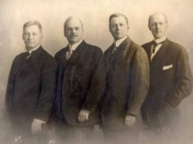

# Other Events of the Week

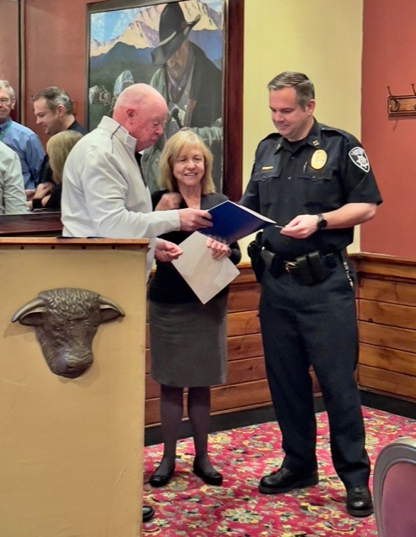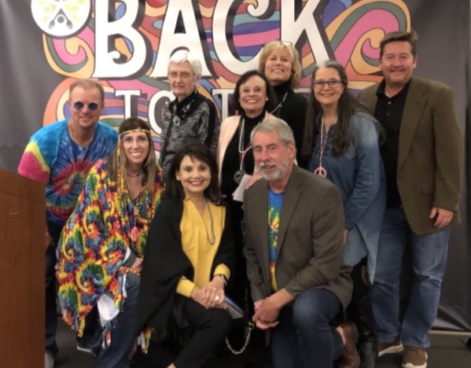The Leawood Rotary inducted Kirt Yoder this week! Captain Kirt Yoder is the Operations Division Commander with the Leawood Police force. Looking Groovy! Leawood Rotarians at the JCCB Holiday of Hope Benefit, where the theme was “Back to the ’60s.”

# Leawood Rotary Upcoming Events

* Wine Group – Terri Gimlin Oct 26th
* New Member Orientation Oct 27th
* Tomahawk Trail Cleanup Nov 6th
* Rise Against Hunger Nov 26th
* Happy Hour Mission Chateau Dec 8th
* JCCB Work Day Dec 11th

**The next meeting is the BOARD MEETING on Thursday, Oct 28st, 2021, at the Herford House (Hybrid Meeting).**

**Please see the list of speakers and greeters in the table below.**

|  |  |  |  |
| --- | --- | --- | --- |
| **Date** | **Speaker** | **Invocation** | **Greeters** |
| Oct 28, 2021 | Board Meeting | n/a |  |
| Nov 4, 2021 | HANDWASH Rotary Grant Program (Chuck U.) | n/a | Lorna or Ray Jarrett, **David Johnston**  Del Karmeier , Lisa Katz , Roxann Kerr Lindsey , Tom Koch |
| Nov 11, 2021 | Leawood Rotary Veterans | Paul Rueschhoff | Same as Above |
| Nov 18, 2021 | Chuck Green – retired Secret Service (John M) | Jake or Debby Schloegel | Same as Above |

ZOOM ACCESS **Can’t make it to the in-person meetings? Join Via ZOOM and keep up to date!**

ALL Meetings are hybrid - being held **in person** and **via Zoom**. If you can’t attend in person, please join us on Thursdays at 7:15 am via the Zoom Information below.

Zoom Meeting - [Zoom Link](https://us02web.zoom.us/j/86135437131?pwd=cUNGUUMxTCtTeHAybDRIS2JLRm41UT09)  
Meeting ID: 861 3543 7131   
Passcode: Rotary