

# Highlights

**The Leawood Rotary Club honored several new Paul Harris recipients this past week. From left to right and top to bottom are Fred Lehman, Lucy Bloom, Kirk Nelsen, and Sara Nylund. Not pictured – Lorna Jarrett.**

# Speaker Profile: Kathryn Fahy – HANWASH

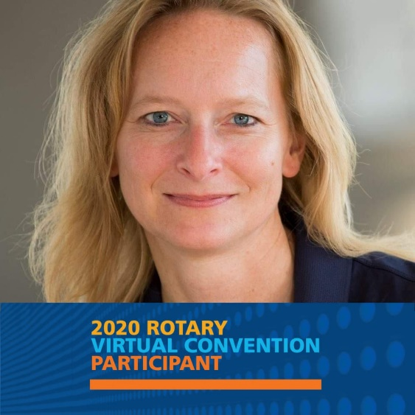Kathryn has been a Rotarian since 2006 and is a member and Past President of the Iowa Great Lakes Rotary Club in Spirit Lake, Iowa.

She is a former Rotary Ambassadorial Scholar (1997 Canberra, Australia).

She has also been the Marketing Chair for HANWASH (Haiti National Clean Water, Sanitation and Hygiene Initiative). Kathy owns and operates K Brand Marketing, a marketing consulting business, and is an active partner in her family grain farm in North-Central Iowa.

Kathryn, thank you for your outstanding presentation on HANWASH and your dedication to making a difference. Check out more of her work on <https://www.facebook.com/kathryn.heldorferfahy>

# A group of men holding a trophy Description automatically generated with low confidenceOther Events of the Week

### Seizing the Prize – Way to Go Leawood!!!

# Leawood Rotary Upcoming Events

* Rise Against Hunger Nov 26th
* Happy Hour Mission Chateau Dec 8th
* JCCB Workday Dec 11th
* Happy Bottoms Work Session Feb 22
* Lisa Harrison has some wonderful yard signs – ask her how you can give one of these signs a new home!

**The next meeting is on Thursday, Nov 11th, 2021, at the Herford House (Hybrid Meeting).**

**Please see the list of speakers and greeters in the table below.**

|  |  |  |  |
| --- | --- | --- | --- |
| **Date** | **Speaker** | **Invocation** | **Greeters** |
| Nov 11, 2021 | Leawood Rotary Veterans | Paul Rueschhoff | Lorna or Ray Jarrett, **David Johnston**  Del Karmeier , Lisa Katz , Roxann Kerr Lindsey , Tom Koch |
| Nov 18, 2021 | Chuck Green – retired Secret Service (John M) | Jake or Debby Schloegel | Same as Above |
| Nov 25, 2021 | NO MEETING | Nov 25, 2021 | NO MEETING |