

# Highlights

**The Leawood Rotary Club held a special Veteran’s Day meeting this past Thursday. Several members of our club are veterans, and all were proud to serve our great country. In addition, Rick Robinson secured a compelling speaker for the Veteran’s Day Program.**

**Mel Carney is a Vietnam vet and the author of “Command At Dawn.” His book wonderfully narrates the real-life story of a young Midwestern man’s efforts to deal with issues during his service in the Vietnam War.**

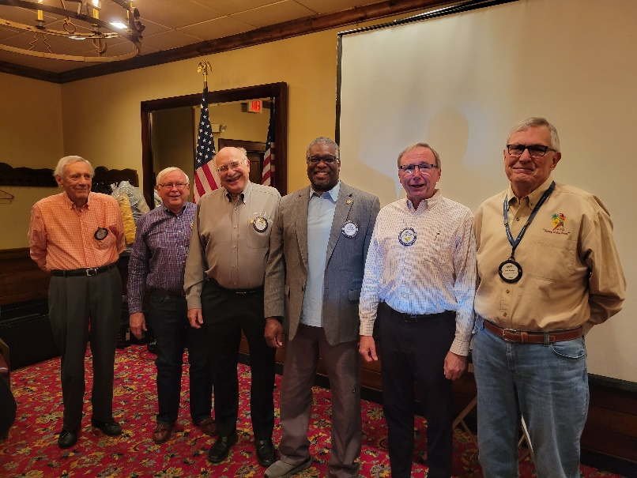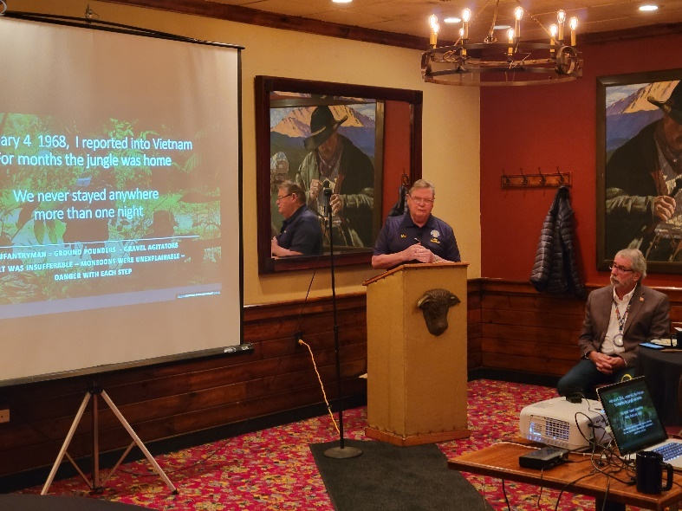

# Rotary Fact of the Week

# *In 1968, the first Rotary Club banner to orbit the moon was carried by astronaut Frank Borman, a Houston Space Center Rotary Club member.*

# Other Events of the Week

* JCCB has a shop location! Now they need volunteers! Would you please join our December 11th Service Team at the Holiday Shop and think about any other day you are free to help?
* A reminder that next Wednesday is our November REACH meeting.

# Leawood Rotary Upcoming Events

* Rise Against Hunger Nov 26th
* Happy Hour Mission Chateau Dec 8th
* JCCB Workday Dec 11th
* Happy Bottoms Work Session Feb 22
* ***Lisa Harrison has some wonderful yard signs – ask her how you can give one of these signs a new home!***

**The next meeting is on Thursday, Nov 18th, 2021, at the Herford House (Hybrid Meeting).**

**Please see the list of speakers and greeters in the table below.**

|  |  |  |  |
| --- | --- | --- | --- |
| **Date** | **Speaker** | **Invocation** | **Greeters** |
| Nov 18, 2021 | Chuck Green – retired Secret Service (John M) | Jake or Debby Schloegel | Lorna or Ray Jarrett, David Johnston  Del Karmeier, Lisa Katz, Roxann Kerr Lindsey, Tom Koch |
| Nov 25, 2021 | NO MEETING | NO MEETING | NO MEETING |
| Dec 2, 2021 | OPEN | Ken Selzer | Ross Kurz, Fred Lehman, David Lightner, Lisa May, John Meier, **Brad Moore** |
| Dec 9, 2021 | Holiday Auction  Part 1 | Stu Sharp | Same as Above |

ZOOM ACCESS **Can’t make it to the in-person meetings? Join Via ZOOM and keep up to date!**

ALL Meetings are hybrid - being held **in person** and **via Zoom**. If you can’t attend in person, please join us on Thursdays at 7:15 am via the Zoom Information below. **This is a recurring meeting.**

Zoom Meeting - [Zoom Link - Updated Weekly](https://us02web.zoom.us/j/85716228327?pwd=YlpIaUtmeE1VMk1yRXdya0xNeWEzdz09)   
Meeting ID: 857 1622 8327 - Passcode: Rotary