

# Highlights

**The Leawood Rotary Club welcomed Chuck Green, retired Secret Service in Charge of the Kansas City Field Office District. Chuck’s presentation on “Protecting People, Places, and Things” gave us valuable insight into the work that goes into upholding the laws of our city.**

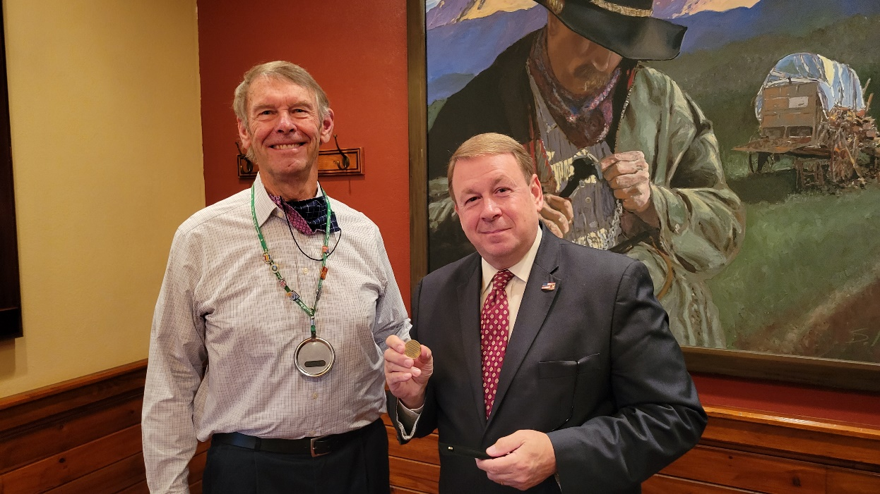

# Rotary Fact of the Week

# *The first head of state to address a Rotary convention was President Warren G. Harding in 1923, in St. Louis.*

# Other Events of the Week

* The Rise Against Hunger event is Friday (after Thanksgiving Day), Nov 26th. The start time is 8:30 am until 10:30 am. Please sign up at this link: <http://events.riseagainsthunger.org/LeawoodRotary21A>
* Due to scheduling conflicts and the holidays, the Wine Affinity Group will not meet in November and December. The Udell’s will host the next event in January. The date and wine varietal are TBD.
* Bring your auction items to the Dec. 9 meeting, ready to be auctioned. A note explaining the value of the article would be helpful for Santa and his elves.

# Leawood Rotary Upcoming Events

* JCCB Coat Drive Continues
* Rise Against Hunger Nov 26
* Happy Hour Mission Chateau Dec 8
* JCCB Club Work Day Dec 11
* Happy Bottoms Work Session Feb 22

**The next meeting is on Thursday, Dec 2nd, 2021, at the Herford House (Hybrid Meeting).**

**Please see the list of speakers and greeters in the table below.**

|  |  |  |  |
| --- | --- | --- | --- |
| **Date** | **Speaker** | **Invocation** | **Greeters** |
| Nov 25, 2021 | NO MEETING - Thanksgiving Holiday | n/a | n/a |
| Dec 2, 2021 | Ray, Ken, Amanda & Rod’s book  (Lisa H.) | Stu Sharp | Kirt Yoder – Vocational Talk  Ross Kurz, Fred Lehman, David Lightner, Lisa May, John Meier, Kirt Yoder, **Brad Moore** |
| Dec 9, 2021 | Holiday Auction - Part 1 | Ron Slepitza | Same as Above |
| Dec 16, 2021 | Holiday Auction – Part 2 | Kirt Yoder | Same as Above |
| Dec 23, 2021 | NO MEETING - Holiday | n/a |  |

ZOOM ACCESS **Can’t make it to the in-person meetings? Join Via ZOOM and keep up to date!**

ALL Meetings are hybrid - being held **in person** and **via Zoom**. If you can’t attend in person, please join us on Thursdays at 7:15 am.

**Check for Chuck Udell’s email for the ZOOM Link**