

# Highlights

**The Leawood Rotary Club held the first of two auctions on Dec 9th. If there was any doubt that we love to have a good time, this laugh-filled event dispelled all rumors! We raised $2250!! Jake, next auction, we bid on the pants!!!**

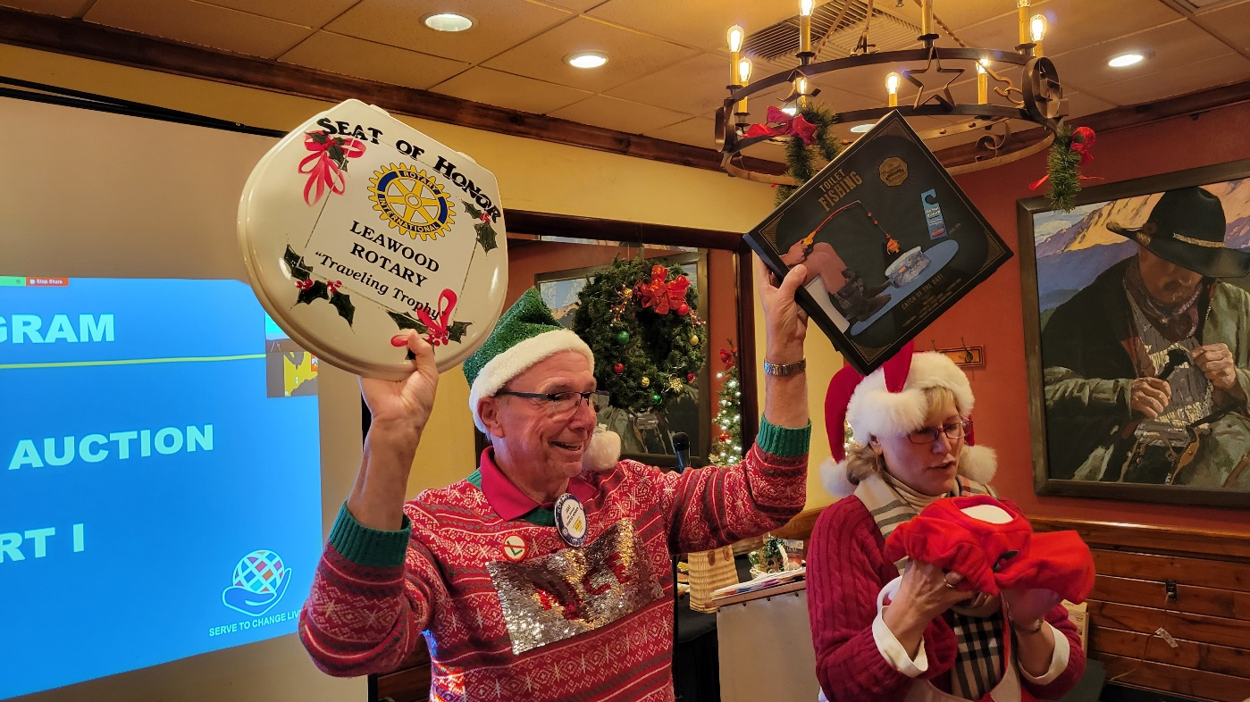

# 

# Other Events of the Week

# The Wine Affinity Group will have a get-together on Jan 19th, 2022, at Chuck and Esther Udell’s place. The wine theme is “Wines from Sonoma.”

# We are excited to announce that funds raised will support the Leawood Foundation’s fundraising efforts to build a permanent restroom facility along the Tomahawk Creek Trail.

* On Dec 8th, Rotarians got together for a fun social!! Notice that the ladies are talking, and the guys are drinking!
* Last week, some of our REACH students participated in a school play titled “The Lion, the Witch, and the Wardrobe.” Talent and Brains!!!
* 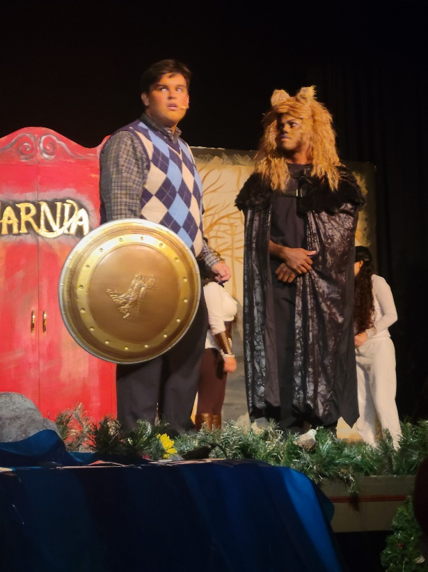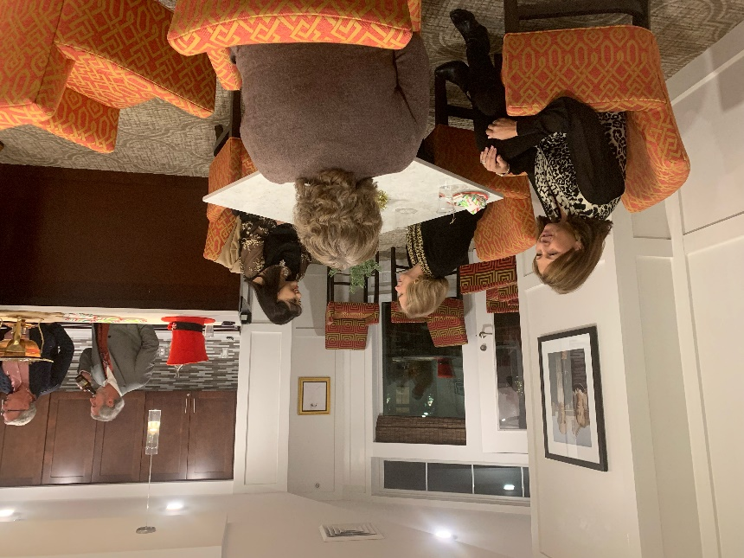🎁THIS MONTH ONLY - Barton Street Books is excited to announce a partnership with Rotary Club (Leawood Rotary Club) to help fight the war against Polio. All profits from “*The Power of You*” will go directly back to The Club this month, so scan and order your copy today! Thanks Roger Barbieri!!

# Leawood Rotary Upcoming Events

|  |  |
| --- | --- |
| JCCB Coat Drive Continues |  |
| Happy Hour Mission Chateau | Dec 8th |
| JCCB Individual Help Days |  |
| Holiday Auction | Dec 16th |
| JCCB Club Workday | Dec 11th |
| Board Meeting | Dec 16th @ 5:30 PM |
| Steve Knight Tree Planting Ceremony | TBD |
| Happy Bottoms Work Session | Feb 22nd |

**The next meeting is on Thursday, Dec 16th, 2021, at the Herford House (Hybrid Meeting).**

**Please see the list of speakers and greeters in the table below.**

|  |  |  |  |
| --- | --- | --- | --- |
| **Date** | **Speaker** | **Invocation** | **Greeters** |
| Dec 9, 2021 | Holiday Auction - Part 1 | Ron Slepitza | Ross Kurz, Fred Lehman, David Lightner, Lisa May, John Meier, Kirt Yoder, Brad Moore |
| Dec 16th, 2021 | Holiday Auction – Part 2 | Kirt Yoder | Same as Above |
| Dec 23rd, 2021 | NO MEETING - Holiday | n/a |  |
| Dec 30th, 2021 | NO MEETING - Holiday | n/a |  |
| Jan 6th, 2022 | Club Assembly | Wayne Starr | Kirk Nelson, Roger Newth, Sara Nylund, Jim Rawlings, Mary Reed, Rick Robinson |

ZOOM ACCESS **Can’t make it to the in-person meetings? Join Via ZOOM and keep up to date!**

ALL Meetings are hybrid - being held **in person** and **via Zoom**. If you can’t attend in person, please join us on Thursdays at 7:15 am.

**Check for Chuck Udell’s email for the ZOOM Link**