

# Highlights

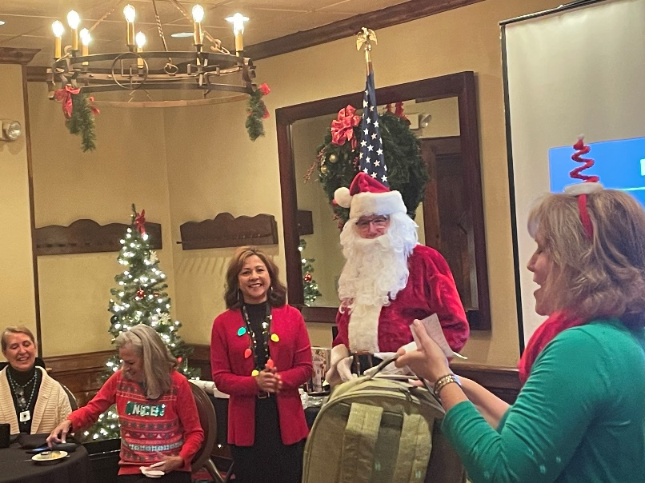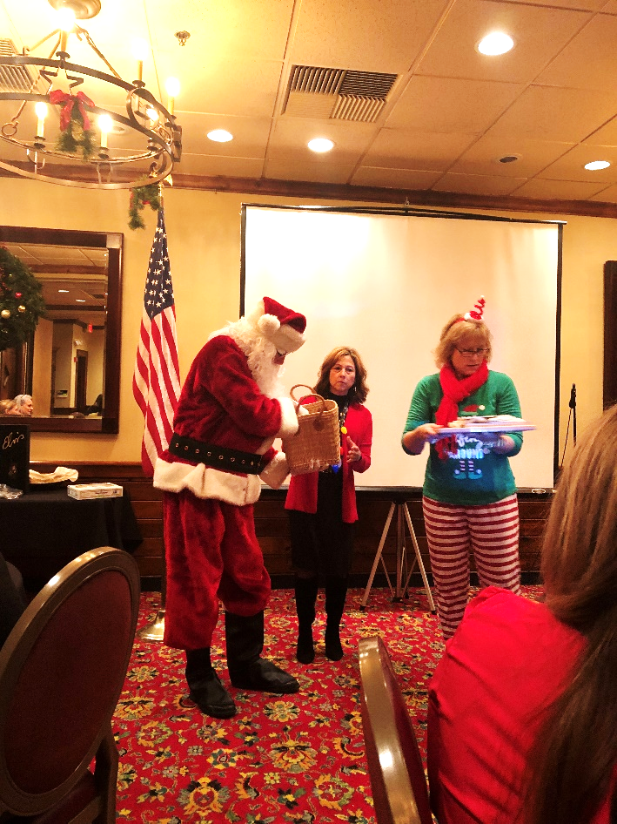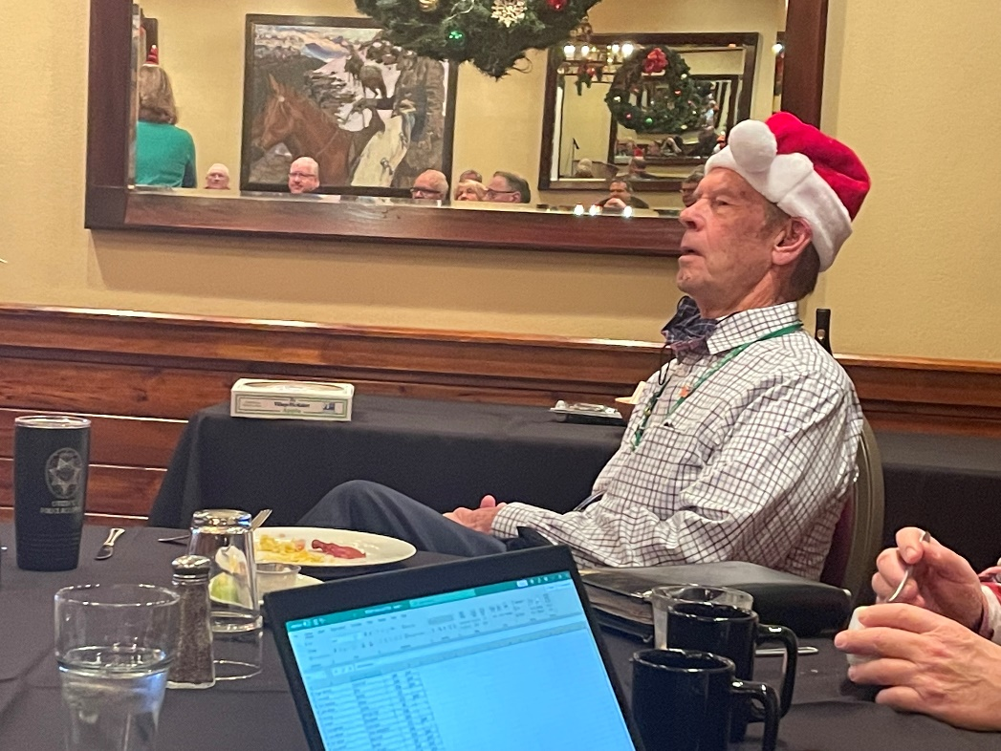**The Leawood Rotary Club held the second of two auctions on Dec 16th. In total, we raised $5,000!! Who knew we could have that much fun bidding on a pen and a pie? Who ended up with that pie, anyway? Hey Boss, don’t forget to clean your plate and finish that bacon!**

# Other Events of the Week

# The Wine Affinity Group will have a get-together on Jan 19th, 2022, at Chuck and Esther Udell’s place. The wine theme is “Wines from Sonoma.”

# We are excited to announce that funds raised will support the Leawood Foundation’s fundraising efforts to build a permanent restroom facility along the Tomahawk Creek Trail.

* On Dec 15th (yes, the night of the windstorm!), REACH hosted a dinner where past REACH students came to talk to our current students about college life! It was very informative and enlightening!
* 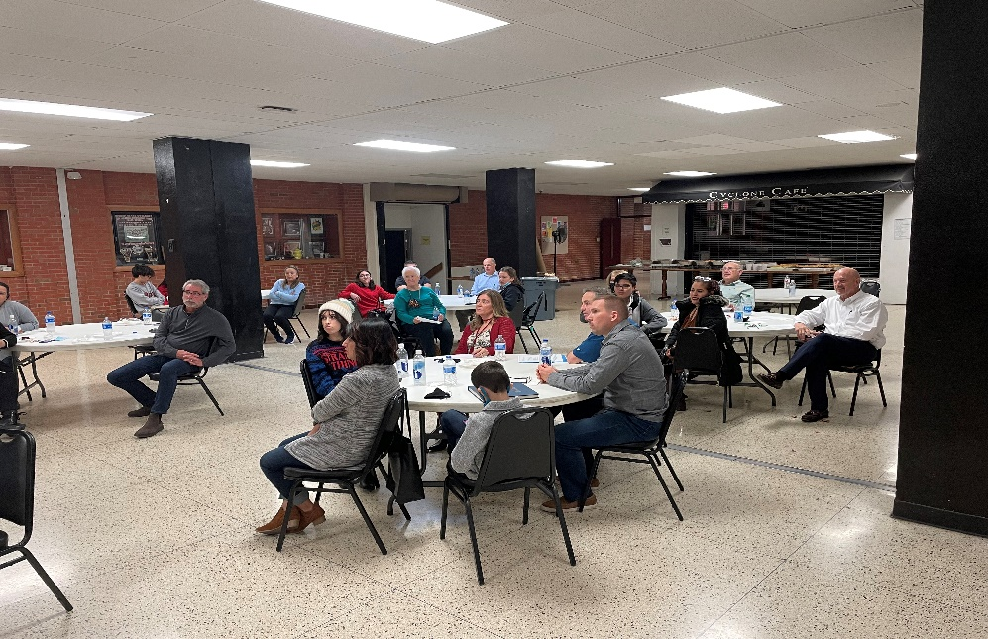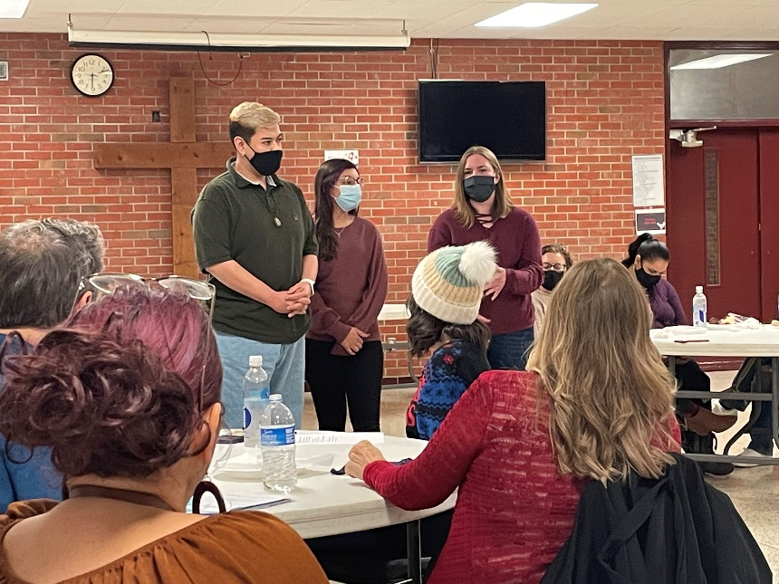🎁THIS MONTH ONLY - Barton Street Books is excited to announce a partnership with Rotary Club (Leawood Rotary Club) to help fight the war against Polio. All profits from “*The Power of You*” will go directly back to The Club this month, so scan and order your copy today! Thanks Roger Barbieri!!

# Leawood Rotary Upcoming Events

|  |  |
| --- | --- |
| JCCB Individual Help Days |  |
| Steve Knight Tree Planting Ceremony | TBD |
| Happy Bottoms Work Session | Feb 22nd |

**The next meeting is on Thursday, Jan 6th, 2022, at the Herford House (Hybrid Meeting).**

**Please see the list of speakers and greeters in the table below.**

|  |  |  |  |
| --- | --- | --- | --- |
| **Date** | **Speaker** | **Invocation** | **Greeters** |
| Dec 23rd, 2021 | NO MEETING - Holiday | n/a |  |
| Dec 30th, 2021 | NO MEETING - Holiday | n/a |  |
| Jan 6th, 2022 | Club Assembly | Wayne Starr | Kirk Nelson, Roger Newth, Sara Nylund, Jim Rawlings, Mary Reed, Rick Robinson |
| Jan 13th, 2022 | OPEN  Roxanne’s SMSD speaker? | Tom Sullivan | Same As Above |
| Jan 20th, 2022 | OPEN  Roxanne’s SMSD speaker? | Chuck or Ester Udell | Same As Above |

ZOOM ACCESS **Can’t make it to the in-person meetings? Join Via ZOOM and keep up to date!**

ALL Meetings are hybrid - being held **in person** and **via Zoom**. If you can’t attend in person, please join us on Thursdays at 7:15 am.

**Check for Chuck Udell’s email for the ZOOM Link**