

# Highlights

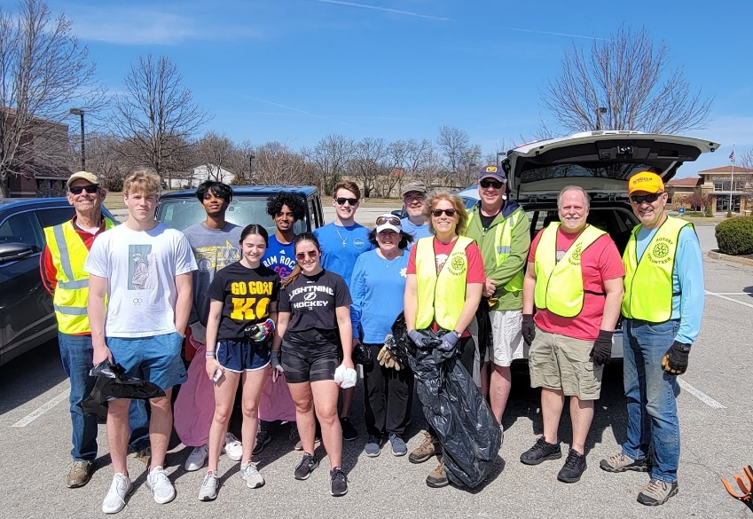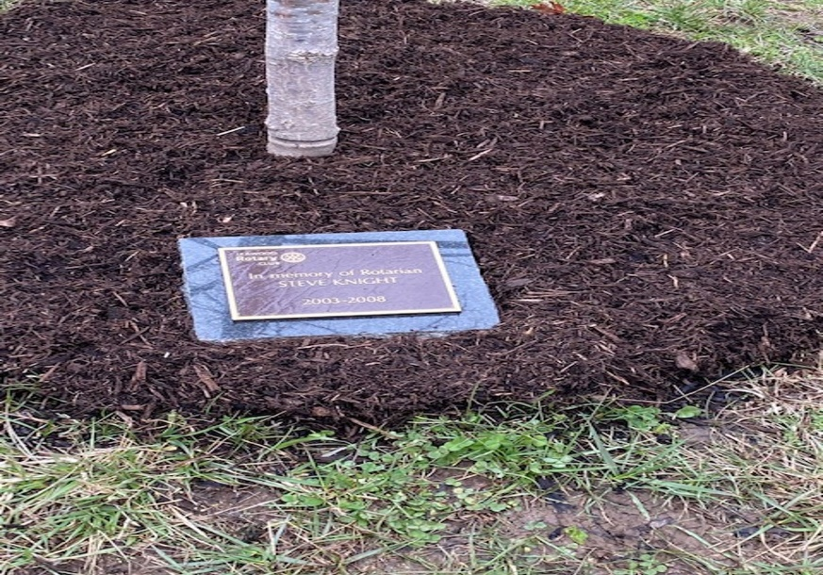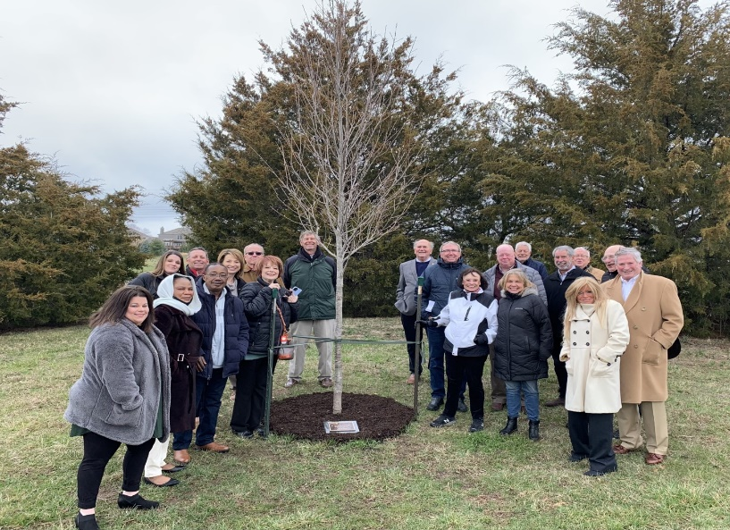**This week’s activities included a beautiful tree planting ceremony for Steve Knight. We also had a pop-up trash pickup – I hear there was some “interesting trash” this time out! Our recent meeting was a Club Assembly meeting with updates on South Africa and Hydroponics (Udell), Polio Initiative (Arnett), Website Update (Schloegel), Treasurer’s Report (Bussing), and Rotary Swarm (Bloom).**

Rotary Humor

# Entertain your friends with this one in the upcoming week!

A wife asked her husband what he wanted for his birthday. “I’d like something silver and shiny and goes from 0 to 120k in three seconds!”

So she went out and bought him a set of bathroom scales!

# Leawood Rotary Upcoming Events

* A quick reminder about Rotary Youth Leadership Award - June will be here before you know it; delegate applications are due no later than Apr 30. If you have already selected your delegates, you may send your applications in early --- no need to wait until Apr 30!!!
* Lisa Katz is hosting a Derby party on May 7. That should be fun!

|  |  |
| --- | --- |
| JOCO Library Shelves | TBD |
| Tomahawk Creek Trail Cleanup | April TBD |
| Rotary Youth Camp Workday | May 7 or 14 |
| Annual Rotary Dinner – Vista 154 | June 23 |

**The next in-person meeting at the Herford House (Hybrid Meeting) is on Thursday, Apr 14.**

**Please see the list of speakers and greeters in the table below.**

|  |  |  |  |
| --- | --- | --- | --- |
| **Date** | **Speaker** | **Invocation** | **Greeters** |
| Apr 7, 2022 | Club Assembly | Dave Anderson | Kyle Wisecarver, Jonn Wullschleger, Dave Anderson, Jim Arnett, Nancy Barber, Roger Barbieri |
| Apr 14, 2022 | Kansas Supreme Court Justice  Melissa Standridge | Jim Arnett | Same As Above |
| Apr 21, 2022 |  | Nancy Barber | Same As Above |
| Apr 28, 2022 | Board Meeting | n/a | Same As Above |

ZOOM ACCESS **Can’t make it to the in-person meetings? Join Via ZOOM and keep up to date!**

ALL Meetings are hybrid - being held **in person** and **via Zoom**. If you can’t attend in person, please join us on Thursdays at 7:15 am.

**Check for Chuck Udell’s email for the ZOOM Link**