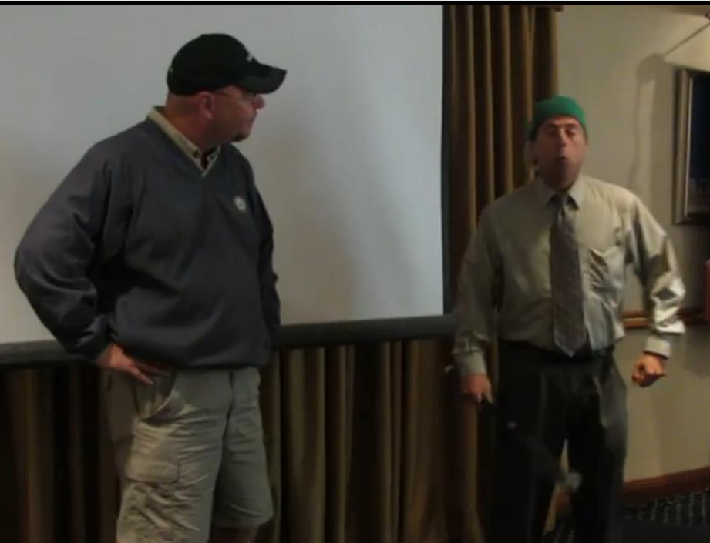
Our own Glenn Krazny
giving his rendition of
the classic "Who"s on First"
Click Link below.
http://youtu.be/AeQy-ygYC28
- See more at: http://indialanticrotary.org/#sthash.cfd5Ch1X.dpuf

