15th Annual
Bowling for Literacy
Saturday, August 14th, 2021
11:45 a.m. to 3:45 p.m.
Sunshine Bowling Center
595 E. International Speedway Blvd., DeLand

Registration ends July 15th
1st Paid, 1st Reserved! Payment must be received to reserve your lane.
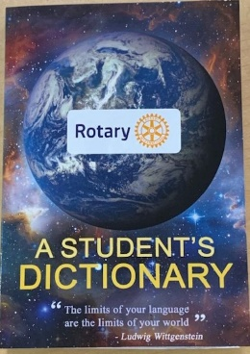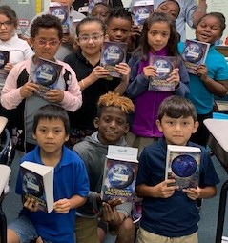
1—$300 for a team of 5 bowlers, includes buffet lunch
OR
2—Be a Sponsor! Just $200 includes:
One month display of business logo on rotating digital monitors at Sunshine Bowling Center; business name on Rum Cups sold at Bowling Center while supplies last; acknowledgment in Facebook promotions and day of the event; and your company banner or sign may be displayed at the Bowling Center!

3—OR do BOTH and enter a team of 5 bowlers and purchase a sponsorship for just $450!

For more information or to RSVP contact:
Leanne Elliott at 386-747-7900, lmelliott115@gmail.com or
Brian Rothwell at 386-527-3097, brothwell42@att.net

Please complete the registration form and email it to brothwell42@att.net and pay online at www.delandrotary.org.
OR mail the form with payment to: Rotary Club of DeLand, PO Box 704, DeLand, FL 32721

