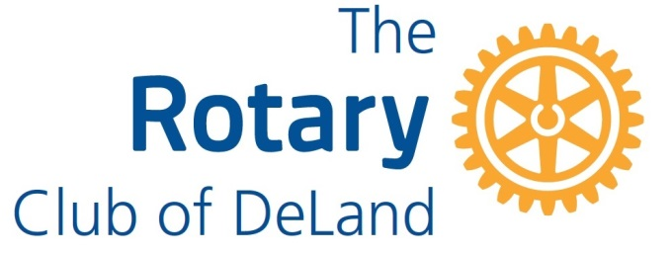

2021-2022 Donation Request

The Rotary Club of DeLand has limited grant funding available to local non-profit organizations that provide a significant level of service in the greater DeLand area. This year’s fundraisers were our Florida in February BBQ Event, Bowling for Literacy, Pickleball Tournament, Mini-Golf Tournament, We DeLand Raffle, and Golf Tournament. The application deadline is April 1, 2022 and all applications must be made in the name of a non-profit organization (no individuals) and must be sponsored by a member of the Rotary Club DeLand. Incomplete or late applications will NOT be considered.

The Rotary Club of DeLand will fund programs which provide services to our community’s citizens with the following areas of focus: (1) emergency assistance (2) improving health and education (3) strengthening individuals and families (4) youth development and (5) enhancement of the cultural and historical foundation of our community.

Applications may be submitted by mail to: Rotary Club of DeLand, PO Box 704, DeLand, FL 32721-0704, or they may be emailed to rotaryclubofdeland@gmail.com. Applications must be RECEIVED BY April 1, 2022. Please request acknowledgement of your application’s receipt before the deadline.

Donation Request

Organization:

Address:

Telephone: Website:

Executive Director: Email:

Contact Person/Title:

Telephone: Email:

Date of Organization Establishment:
Mission statement or purpose of the organization:

Our organization will help promote one or more of the Rotary Club of DeLand’s fundraising events: (please check all that apply)
Promotion on website and/or newsletter

Displaying posters

Assist by selling tickets and/or sponsorships

Volunteering

We are unable to do any of the above because:

If you have received funds in prior years please give an example how your organization has promoted or supported our fundraising or service events:

___________________________________________________________________________________

Project Information:

- Please describe the program for which the monies are being requested, including substantiation of need, client group served, geographic area served, and size of group served. (Please attach a narrative of no more than one page.)

- How will the money be used? (Please describe in attached one-page narrative.)

- Total project cost:

- Amount requested:

- What funding sources in what amounts do you already have for this program (including internal resources)? (Please describe in attached one-page narrative.)

- What other funding sources (and amounts) have applications been or will be made concerning this program? (Please describe in attached one-page narrative.)

- Will you accept partial funding?

If yes, will you be able to obtain additional monies from other sources?

- Please tell us how you will measure the success of the clients in your program.

- If you were funded by the Rotary Club of DeLand for a program last year, please give a brief summary of the program, which includes the amount of last year’s funding, how the funding was utilized and the program’s results. (Please describe in attached one-page narrative.)

__________________________ ________________________________ _____________

Print Name Executive Director Signature Date

Print Name Board President Signature Date

_____________________________ ___________________________________ ____________
Print Name Signature of Sponsoring DeLand Rotarian Date

Please include the required materials with this application, as applicable:
- A copy of your 501c(3) IRS authorization letter (if applicable)

- List of names and addresses of your Board of Directors

- A copy of your organization’s current budget and most recent year’s financials, including comparison of actual to budget.

PLEASE DO NOT SUBMIT EXCESSIVE ATTACHMENTS

