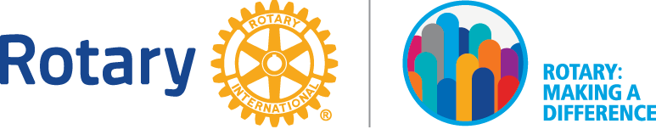
Club of DeLand
Accomplishments in 2017-2018

TOTAL GIVING - $109,875+

Major Community Donation Recipients: $60,500
- Barberville Pioneer Settlement | - Grace House Pregnancy Resource Ctr.
- Boys & Girls Club of Volusia | - Greater Union Life Center
- Catalyst Global Youth Initiatives | - Guardian ad Litem Foundation
- Childhood Cancer Foundation | - ME Strong, Inc.
- City of DeLand Homeless Center | - Museum of Art
- Creating Jobs | - Naval Air Station
- Cystic Fibrosis Foundation | - Neighborhood Ctr. of West Volusia
- DeLand Family YMCA | - Police Athletic League (PAL)
- FUTURES Taking Stock in Children | - Rotary Achievers
- Girls on the Run | - Volusia Stock Show Syndicate
- Good Samaritan Clinic
Financial Assistance: $26,725
- Alzheimer’s Association | - Rotary Foundation
- DeLand Fire Fighters | - St. Barnabas
- Mainstreet DeLand Veteran’s Parade | - Starke Elementary
- Roatan Honduras Water Project | - UFLEF
Scholarships: $4,750
- DeLand High School | - Youth Exchange Program
- Taylor High School
Service Projects: $17,900
- Bowling for Literacy/Dictionary Project | - Feeding Local Kids
- DHS Flag Pole Circle Beautification | - YMCA Pool Area Beautification

