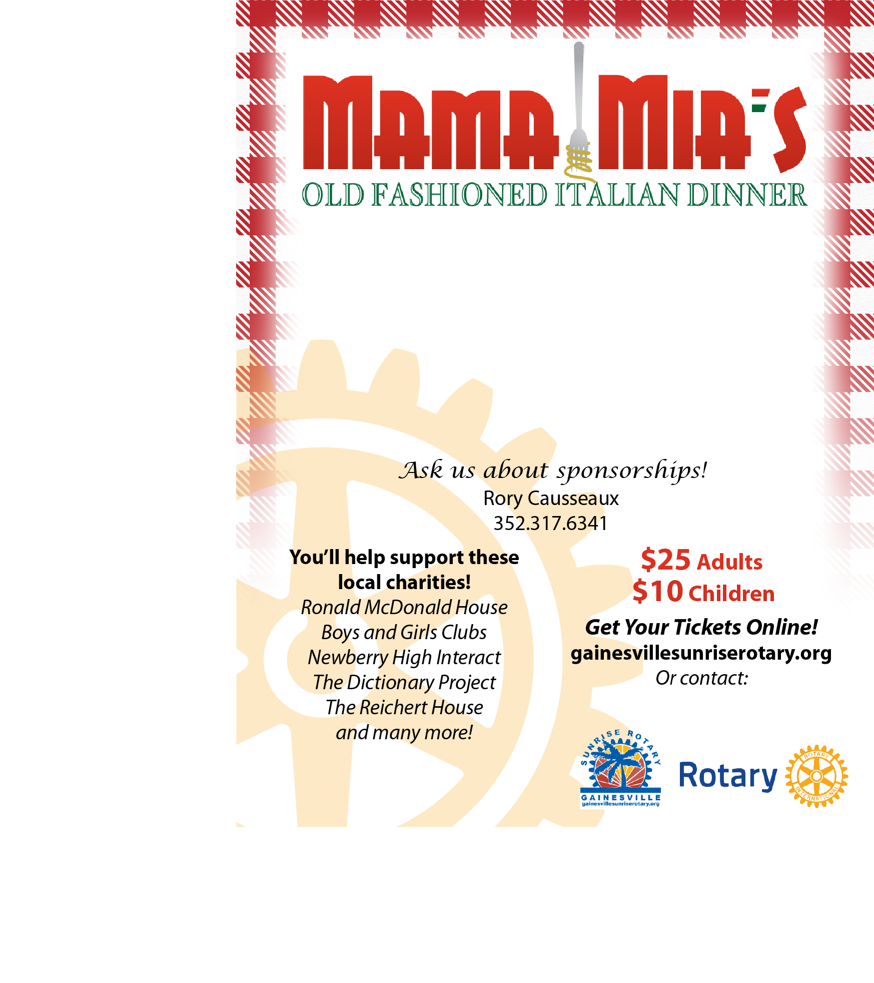

Join us for a fun evening

of delicious homemade Italian food,

served up by Sunrise Rotary!

**Sunday, Nov. 1, 2015 • 5-8pm**

Northwest Grille • 5115 NW 39th Ave

Take Out Available || Drawings and Raffles

Rotarian Name and Number

**Sunday, Nov. 2, 2014 • 5-8pm**

Northwest Grille • 5115 NW 39th Ave

Take Out Available || Drawings and Raffles

Rotarian Name and Number

***Sunrise Rotary of Gainesville presents***

Join us for a fun evening

of delicious homemade Italian food,

served up by Sunrise Rotary!