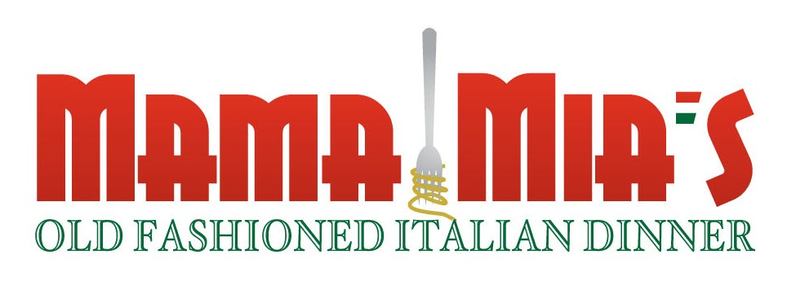
RE: Mama Mia – Sunday, November 1, 2015
Sunrise Rotary of Gainesville Annual Major Fundraiser

On behalf of the Sunrise Rotary of Gainesville, we would like to invite you to be a sponsor of the Mama Mia Old Fashioned Italian Dinner, our Club’s annual fund raising event. The funds raised by the dinner helps the Sunrise Rotary of Gainesville support a number of community projects. As a sponsor, your name will be on posters around town, on a sign-board that greets our guests, on the menu describing dinner and on our website / Facebook page. Last year, we served nearly 400 dinners and expect greater things this year.
This event is our club’s major form of raising funds to then, in turn, benefit our community. Our entire club gets engaged in all the many aspects of an event like this. Members seek sponsorships and raffle prizes, procure food, prepare food, serve on the night of the event, sell tickets, and invest their personal financial commitment as well.
We continually update our portfolio of service in keeping with the Rotary motto of “Service above Self”; therefore we are always open to suggestions of other ways that would better serve people in our community.
Again, thank you so much for considering being supportive of our community by helping the Sunrise Rotary of Gainesville with its Mama Mia event. I would ask that you complete the enclosed sponsorship form and return it to Rory Causseaux using the sponsorship form address with a check matching your chosen level of participation. Checks should be payable to the “Rotary Club of Gainesville Foundation, Inc.” which is a 501(c)(3) tax exempt organization (Fed. ID Number 59-2914025). Credit cards (except American Express) can be used for payment for a small credit card fee. If you wish to pay by credit card, please provide me with your card number, expiration date, 3 digit code, billing zip code, card type, and name shown on the card. You may also fax or email the form ahead of mailing the original and the check or when you supply the credit card information. We need your sponsorship form prior to October 11, 2015, in order for your sponsorship information to be published on the posters. Also, email Dorothy Zimmerman (dozimmer@bellsouth.net) your company logo/name for use to display your sponsorship on all forms of advertising.

The amount of the contribution that is deductible for federal income tax purposes is limited to the excess of any money contributed over the fair market value of meals provided. The value of the meals is estimated to be ten dollars ($10) a ticket.

Should you have any questions or comments, please call me on my cell phone at (352)317-6341.
Sincerely,
Sunrise Rotary of Gainesville

Rory P. Causseaux
Mama Mia Steering Committee, Sponsorship Chairman

