FY26 Silent Auction Item - Google Form

https://forms.gle/cAsYsBEU5YLznYzw8
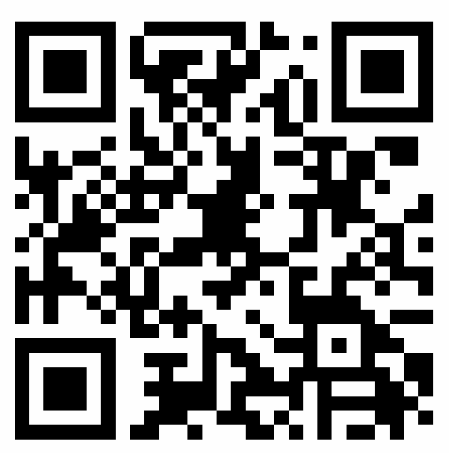
The above link or QR code will take you to the RCMG Google Form we’ve set up so you can input information on Silent Auction items being donated.

If you have any trouble with the form, let me know.

Tim Deets
codeets@gmail.com or 763-710-0351

