Greenville, New York Rotary Club
Peace Boat Scholarship Application Deadline Extended to February 29, 2024
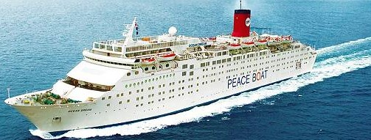

The Greenville, NY Rotary Club announces a new scholarship program. We will choose one young Greenville area scholar, age 18-30 to sail with the Peace Boat as a member of the Youth for the SDGs Program, interacting and learning peace-building skills with other scholars from around the world. Peace Boat works in partnership with the United Nations and aims to promote and strengthen youth engagement through the United Nations Sustainable Development Goals Action Campaign.

We ask that you research these links and learn about the important work the Peace Boat and the United Nations have done for the world. Programs onboard the Peace Boat combines learning, activism, advocacy, and travel.

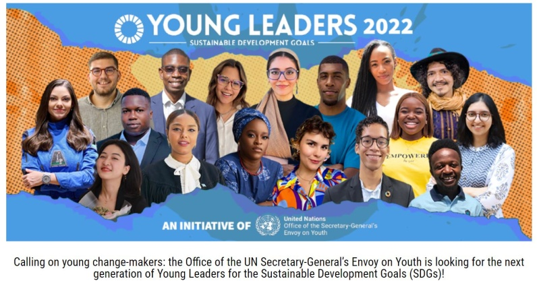

The Peace Boat visits 200 countries per year as it travels around the globe promoting and teaching peace and sustainability. The next youth scholarship program will be traveling in July, 2024, the revised travel date of this scholarship. The Peace Boat confirms that the destination of the July scholarship will be either the Arctic or Latin America. A passport is required. The extended application deadline allows additional time to apply for and receive an international passport.

The goal of the Peace Boat is to promote peace, human rights, and sustainability. How do these three pillars relate to your life and your passions? What do you hope to achieve as the first young scholar and representative of Greenville, NY onboard the Peace Boat?

If you would like to be considered for this scholarship, we ask that you to share your enthusiasm and creativity with us in the form of a multi-media video. The video must be a one to three minute presentation responding to the above questions, and can take any creative form - an animation, music, poetry, art, storytelling, a play, a narrative. We would like to see your passion for peace through this video. Questions? Please email peaceboatapplications@gmail.com.

Please submit the video through a Wetransfer link. We recommend that you are certain that the video link will open by sending it to a friend or family member first. Along with your video, please submit a written resume, which includes your community service activities, travel history and education background.

Please send your application to: peaceboatapplications@gmail.com by February 29, 2024. We look forward to learning about you.

