Rotary Club of Westlake Village
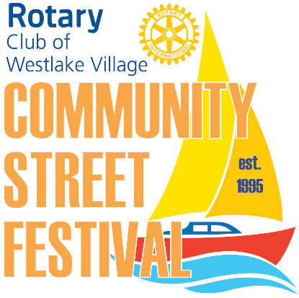
26th Annual Community Street Festival
Sunday – April 26, 2020; 11:00 a.m. – 5:00 p.m.

VENDOR REQUIREMENTS AND RULES
LOCATION:
Lakeview Canyon Road, between Agoura Road and Watergate Road VENDOR CATEGORY:
Please fully describe the items you intend to sell.
DISPLAY REQUIREMENTS:
The Westlake Village Rotary Club does not provide canopies, tables or chairs, and all vendors must provide their own. Booth spaces are approximately 10'x10'. Displays must be well-constructed and booths must fit within their assigned space. All vendors are required to stay in their booth space and are not allowed to stray into the street to sell items or hand out literature.
Food truck vendors must be permitted by the Los Angeles County Health Department.
APPLICATION AND FEES:
All vendors and organizations will be placed in booth space on a first-come, first-served basis after their completed application and fees have been received. Payment for your booth is made by PayPal. A PayPal link can be found on the Rotary website. Vendors may select up to three booth space locations on their application after reviewing the space availability on the Street Fest event site at www.rotarywlv.org. All final decisions on placement will be made by the Rotary Street Festival Committee. Consideration will be given to returning vendors who submit their applications early.
All completed applications, payment, and required insurance certificates must be emailed to RCWVStreetfest@gmail.com by April 10, 2020 in order to participate in the event. As we are limited to approximately 150 spaces, we highly recommend emailing the required paperwork and paying your fees early. Final instructions about the day-of-event check-in, location and more will be available on the website approximately two weeks before the event. www.rotarywlv.org. Please make sure that SPAM does not block emails from rotarywlv.org. If you have any questions, email Vendor Chair at RCWVStreetfest@gmail.com. Please include "Street Fair 2020" in the subject line.

BRING YOUR OWN ITEMS:
You must bring your own canopy, tables, chairs, shade, and water. Certain sponsorship levels may include these items. No electricity is available in the booth spaces. Generators are not allowed.
VEHICLES:
Vendors must park their vehicles where specified in the final instructions you will receive prior to the event. Vendors will be allowed to drive into the vendor area usually beginning at 6:30 a.m. to unload and then must park in the designated parking area before setting up your booth. Street access will close at 10:00 a.m. Due to restricted room in the festival area, large, oversize vehicles such as motor homes cannot be accommodated during loading and unloading. If you have no other choice but to use such a vehicle, please come prepared to cart your materials in from the nearest available parking areas.
Arrival and set-up times will be provided to you two weeks prior to the event. Disassembly must start immediately at 5:00 p.m. with loading completed by 6:30 p.m. and the street cleared by 7:00 p.m. or risk a traffic violation.
FAMILY FRIENDLY EVENT:
The Rotary Club of Westlake Village is committed to maintaining a family friendly environment during the Street Festival Event. Therefore, possession, sale, or use of drugs, illegal substances, or weapons of any kind are expressly prohibited. The Rotary Club of Westlake Village reserves the right to eject vendors who do not comply with event rules or use loud or vulgar music or language in promoting their booths. If any vendor is found to be in breach of the above rules, the vendor may be required to leave the Street Festival immediately, forfeit the booth space fee, and be barred from future registrations.
CANCELLATIONS:
The event will not be cancelled due to weather and no refunds will be made. Should the Rotary Club of Westlake Village be forced to cancel the event for other reasons, a refund amounting to fifty percent of the vendor booth space will be made.

CONTACT INFORMATION:
Rotary Club of Westlake Village
c/o Community West Bank
951 S. Westlake Blvd., #100
Westlake Village, CA 91359
www.rotarywlv.org
RCWVStreetfest@gmail.com (If you send an email, please include "Street Fair 2020" in the subject line.)

