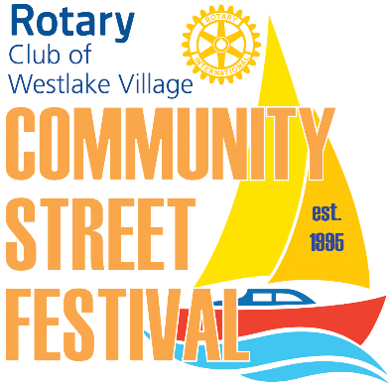
Rotary Club of Westlake Village
26th Annual Community Street Festival
Sunday – April 26, 2020; 11:00 am -5:00 pm
Greetings to our Valued Vendors,
The Rotary Club of Westlake Village will be holding their 26th annual Community Street Festival on Sunday, April 26, 2020, at the corner of Lakeview Canyon and Agoura Roads in Westlake Village, from 11:00 am to 5:00 pm.
The 2020 Street Festival will offer an expanded vendor area, a beer and wine garden featuring local brewers and Stonehaus wine, a classic car show, Kids Zone, entertainment and more. Vendors will again have the opportunity to request up to three choices for booth spaces.
We are looking forward to celebrating our 26th year with another successful Street Festival, and encourage you to join us. On behalf of the entire team, we appreciate your continuing support.
Vendor application, terms and conditions, space map and availability are available on our website at www.rotarywlv.org. Click the 2020 Street Festival web page tab for complete event information. Vendor spaces are awarded on a first-come, first-served basis.
Thank you,
Rotary Club of Westlake Village
c/o Community West Bank
951 S. Westlake Blvd, #100
Westlake Village, CA 91361
For additional information, email Vendor Chair at RCWVStreetfest@gmail.com. Please include "Street Fair 2020" in the subject line.

