Posted by Kate Collinson
on Jun 03, 2014

The Evanston Lighthouse Rotary Club distributed $17,400 in grants to 10 local organizations at its June 3rd meeting. The ELRC's Community Service Committee sought to support local organizations and programs that help improve the quality of life for those Evanston residents most in need. Proposals in the areas of education, hunger, homelessness, employment and health received priority consideration.
Funds for the grants, which ranged from $800 to $3000, were raised by club members through sales of poinsettias and other florals, citrus, nuts and hams at holiday time, as well as donations from members and other supporters.
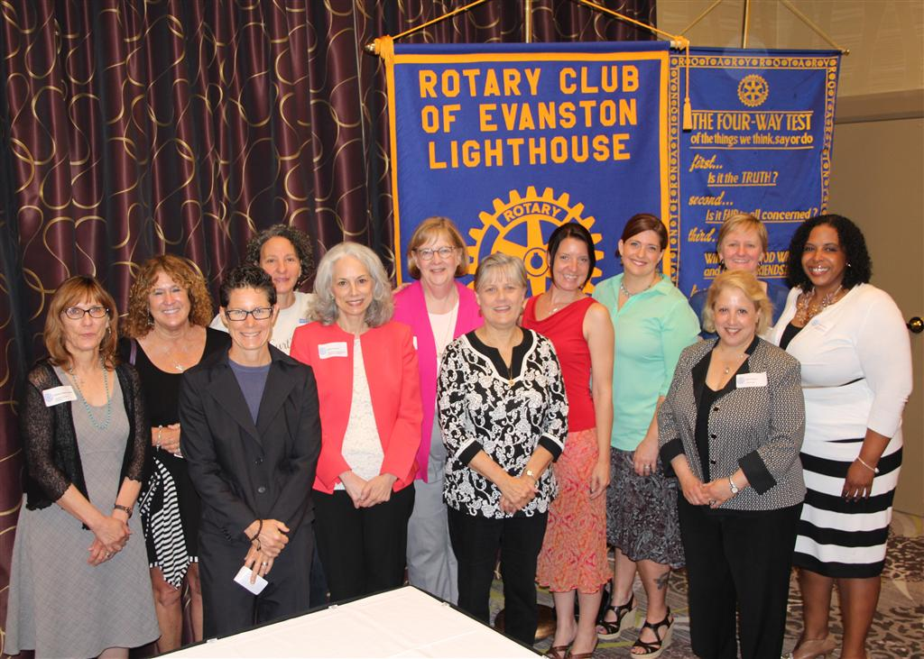
Evanston Lighthouse Rotary Club 2014 Community Service grantees. From left to right: Kathleen Watson Nadler and Sue Murphy, Interfaith Action of Evanston; Andrea Densham, Childcare Network of Evanston; Lori Dube, Curt’s Café; Jeanie Ramsey, Services for Adults Staying in Their Homes; Mary Fulton, Hillside Food Pantry; Elaine Clemens, Justin Wynn Fund; Sabrina Clark and Cari O’Donnell, Evanston School Children’s Clothing Association; Patti Anderson, Curt’s Café; Julianne Dieterich, Evanston Lighthouse Rotary Club; Andrea Horton, Youth Organization Umbrella.

- Childcare Network of Evanston for on-site support for children with behavioral, social/emotional, and learning challenges at eight childcare centers.
- Connections for the Homeless for funding clients who live in supporting housing to participate in workshops on parenting, financial planning, and other cultural and educational programs.
- Curt’s Café for providing basic needs such as glasses, coats, bicycles, and bus cards to at-risk youth.
- Dental Access Days for providing a free one-day dental clinic serving 120 needy patients.
- Evanston School Children’s Clothing Association (ESCCA) for purchasing new gym shoes and winter boots for needy children in Evanston/Skokie District 65.
- Hillside Food Pantry for new chairs and a chair dolly to be used in the waiting area where up to 300 people wait during a 2-hour period.
- Interfaith Action of Evanston to support an emergency “cold” shelter when the temperature reaches 5 degrees. Funds will be used to replace worn sheets and blankets, purchase hot drinks and other supplies, and to cover heating costs.
- Justin Wynn Fund to feed up to 450 dinner guests at area soup kitchens. Youth volunteers cook and serve dinner, developing leadership skills as they take responsibility for improving their communities.
- Services for Adults Staying in their Homes to train 39 caregivers in Senior Nutrition and Meal Preparation.
- Youth Organization Umbrella (Y.O.U.) to expand the Street Outreach Program to provide food, personal hygiene products, baby care items, clothing and transit passes to runaway, homeless/housing-insecure, and street youth.

