
2025 Holiday Food Baskets
When your finances are challenged, trying to put Joy on the Table at the holidays can become even more stressful.
The Rotary Club of Antioch helps individuals overcome challenges with our annual Holiday Food Basket donations.
The Antioch Rotary started the Holiday Basket Program in 1987 after noting that many families in the area were struggling to make ends meet and put food on the table. The club worked with the Township Office to obtain name and addresses of those in need in the Antioch Area and deliver a Holiday Food Basket that provides for up to 16 meals.
For the 2025 Holidays, we were able to distribute 2400 meals in the form of holiday baskets at Thanksgiving and again at the Christmas time to families in need within the Antioch area.
This assistance to our neighbors is not accomplished alone. We were assisted by Dave Karzvewski, former Antioch Piggly Wiggly owner, Uline that donated the "basket" boxes, Auction attendees that purchased 22 of the Holiday Baskets at our Annual Pork Chop Dinner & Auction fundraiser, the Antioch Township Center that provided the facility for assembly of the baskets and the truck for bringing the food to the site, and the delivery crew made up of 20 Rotarians, their families, 15 Friends of Rotary, and others. A huge thank you also goes to Penny’s Purpose that donated blankets for the Christmas Baskets to Rotary, Antioch Township and Lion’s Club baskets.
Thank you for helping to continue this tradition and putting Joy on the Table.

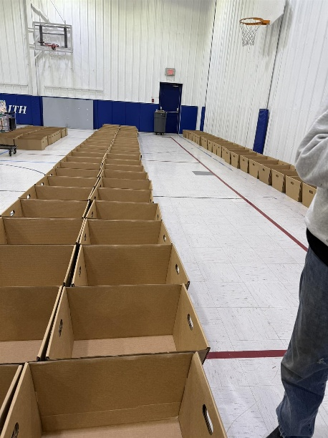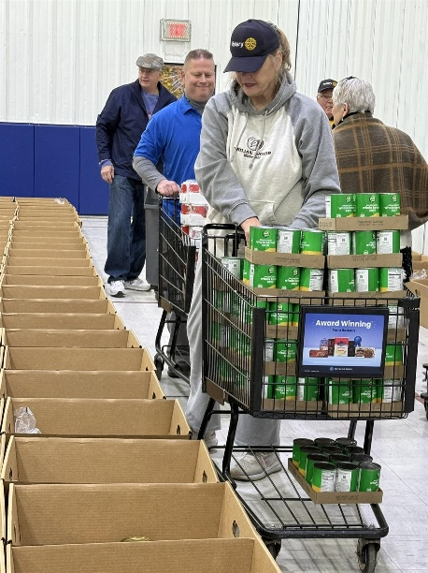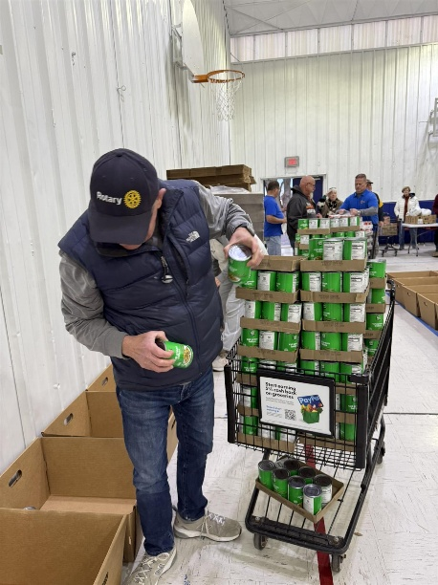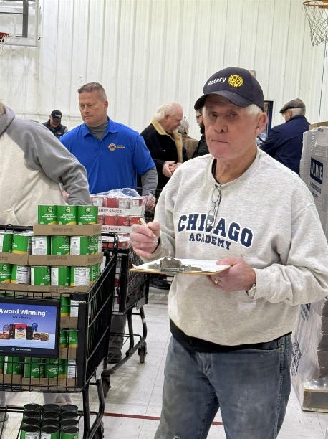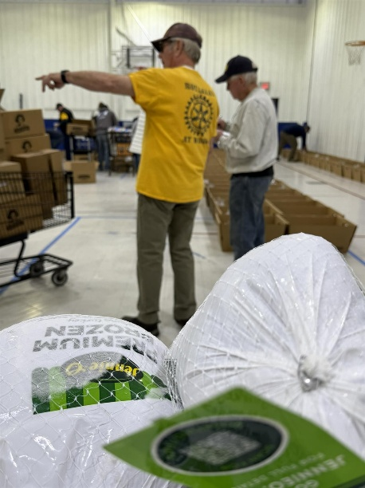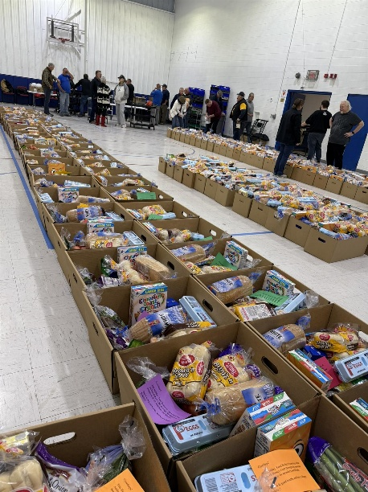
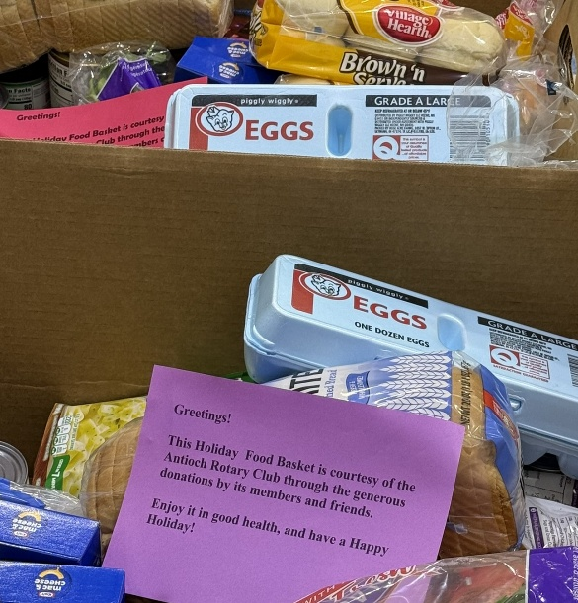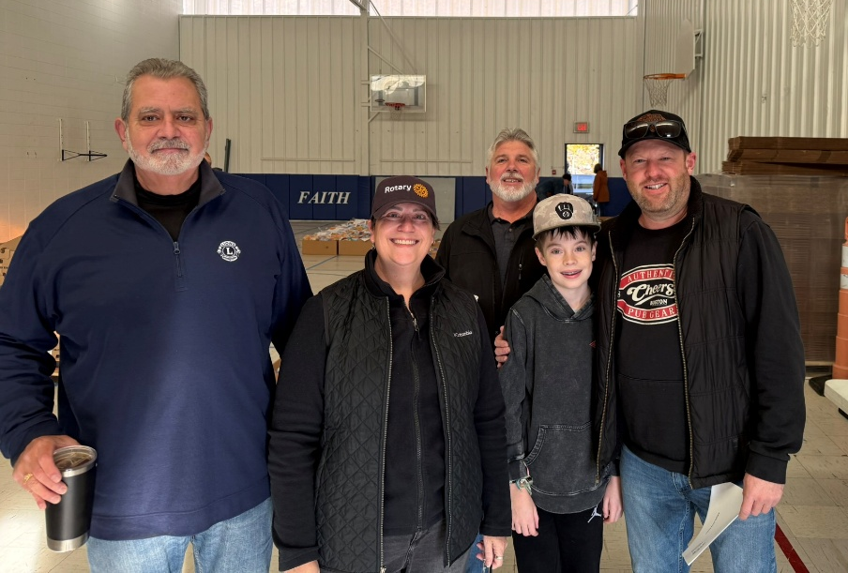
Representatives of Lions Club and Rotary with the Antioch Town Mayor – Scott Gartner

