INSTRUCTIONS FOR COMPLETING THE 2023 AUCTION DONATION GOOGLE FORM (same as prior year):

GO TO GOOGLE LINK TO ENTER 2023 AUCTION DONATIONS: https://forms.gle/wSstQPKBmCKfCBrh8
USE NEXT (OR BACK) BUTTONS TO MOVE THROUGH THE FORM SECTIONS AND ENTER CONTENT.
REQUIRED CONTENT MARKED BY RED ASTERIK. SOME ANSWERS REQUIRE SPECIFIC FORMAT (DATE AS MM/DD/YYYY, OR VALUE IN NUMBERS – IGNORE THE DOLLAR SIGN).SELECT ANSWER WHERE MULTUPLE CHOICE,
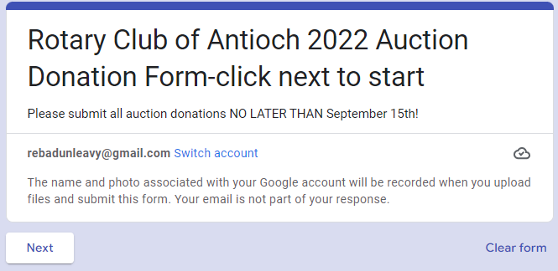

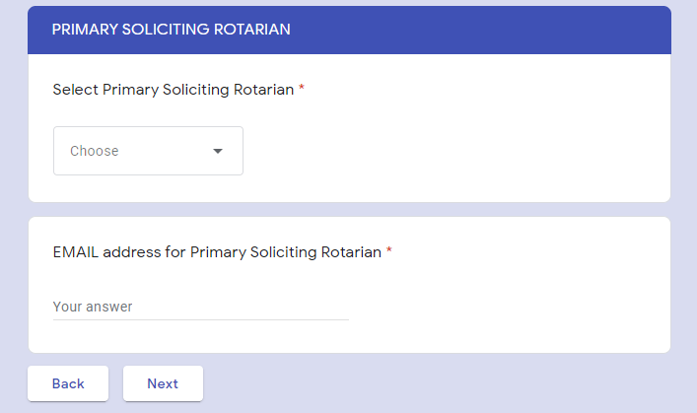

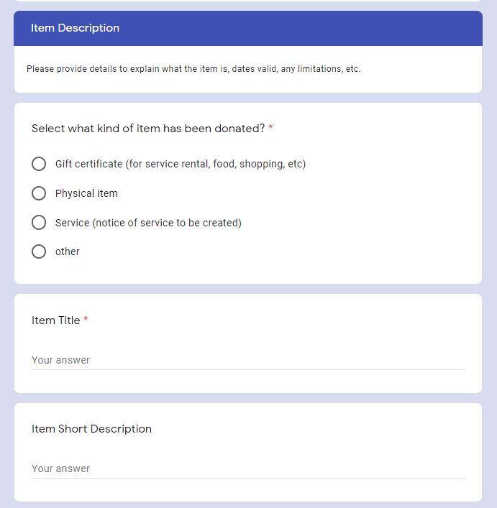

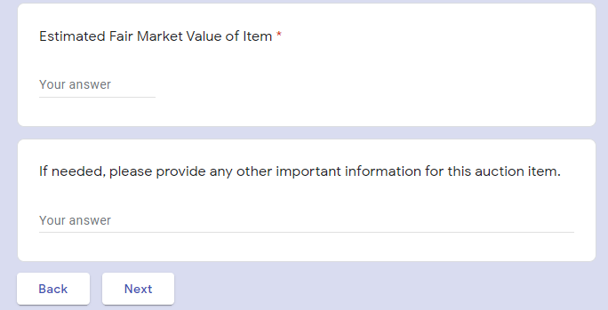
Only display dollars (no cents required). Round to the nearest full dollar.

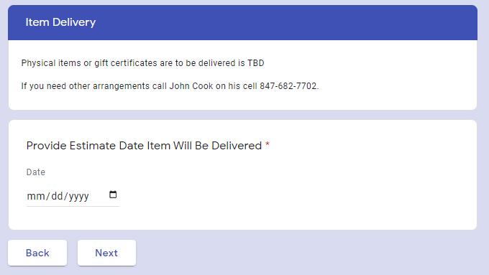

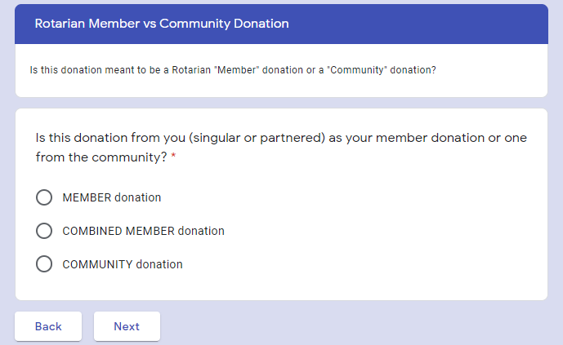

DEPENDING ON ANSWER YOURE FINISHED OR ROUTED TO ONE OF TWO SECTIONS BEFORE FINISHED
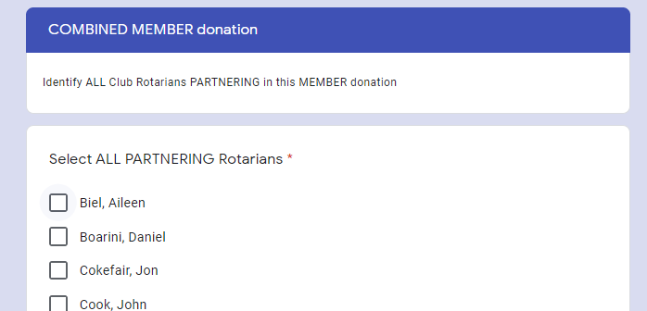

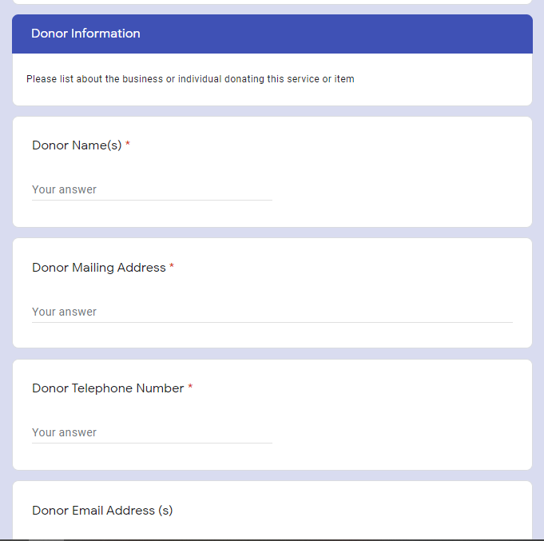

OR

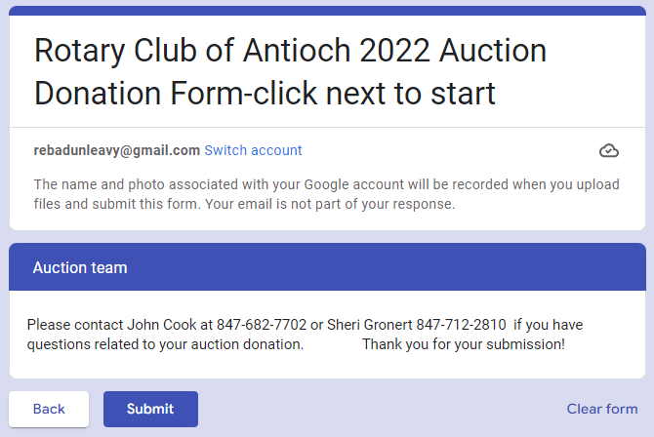

YOU CAN QUICKLY COMPLETE ADDITIONAL FORMS DURING THE SAME SESSION

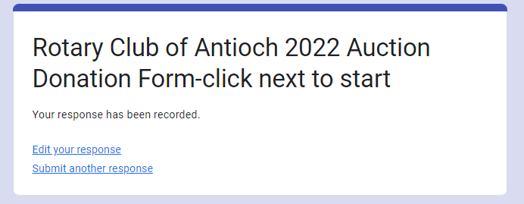

AUCTION RELATED QUESTIONS GO TO JOHN COOK AND SHERI GRONERT.
QUESTIONS ON COMPLETING THE FORM: Rebecca Dunleavy 847-997-3603

