

The Wall That Heals Volunteer project.

The Rotary Club of Antioch is proud to have been part of the local community volunteers assisting at The Wall That Heals exhibit July 16-20th. The wall exhibit and Education Center was open 24 hours during its stay at the Tim Osmond Sports Complex in Antioch, IL.
Antioch was the ONLY location in Illinois in 2025 for this traveling Vietnam Veterans Memorial exhibit.
Hopefully you made it with your family, friends and/or neighbors that had been directly impacted or involved in Vietnam War or were interested about this special opportunity to experience the exhibit.
Learn more about this programs objectives and funding at their website: Click on: The Wall That Heals - Antioch, IL - Vietnam Veterans Memorial Fund Or type: https://www.vvmf.org/event/The-Wall-That-Heals-Antioch-IL/
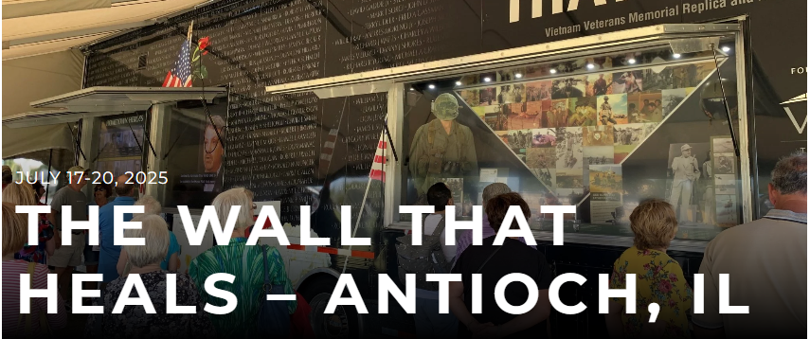
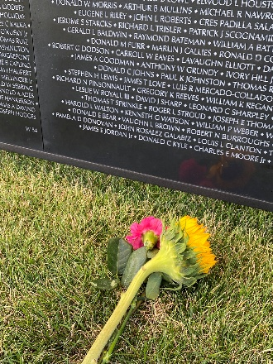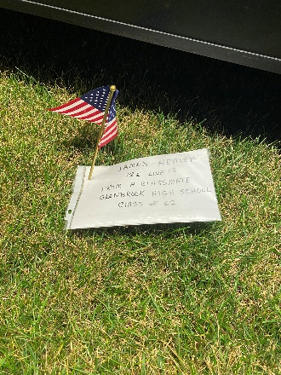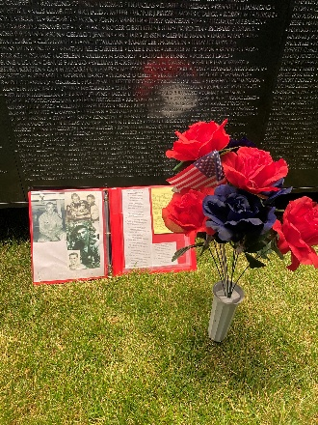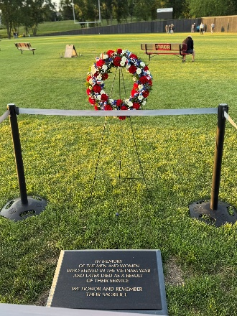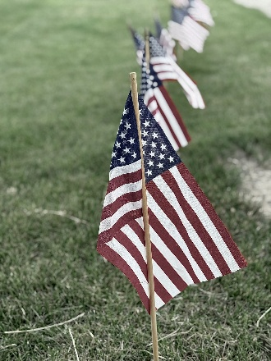
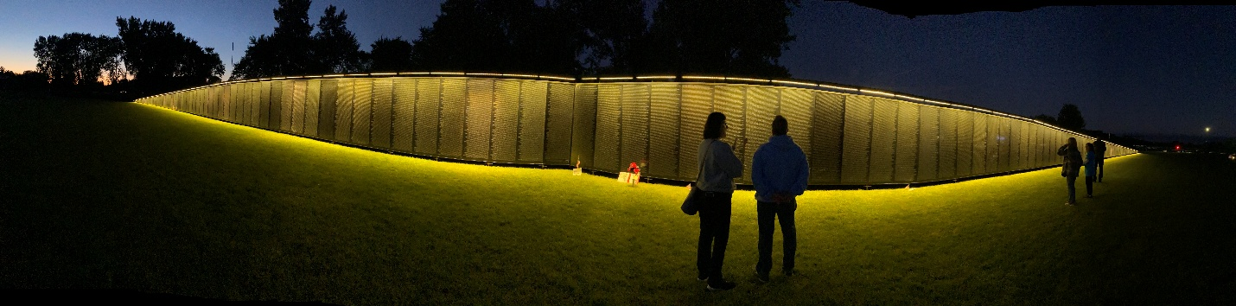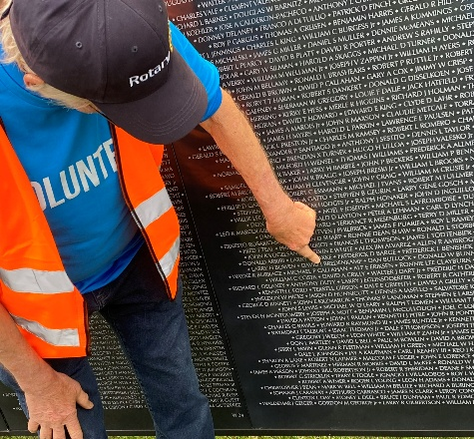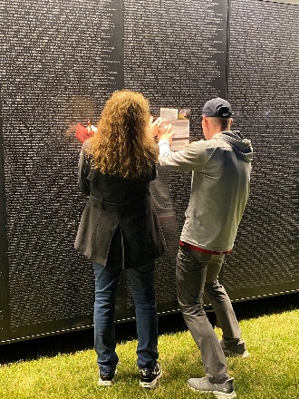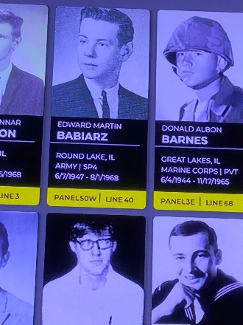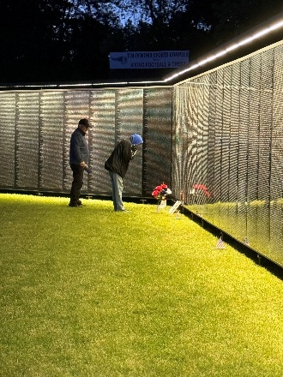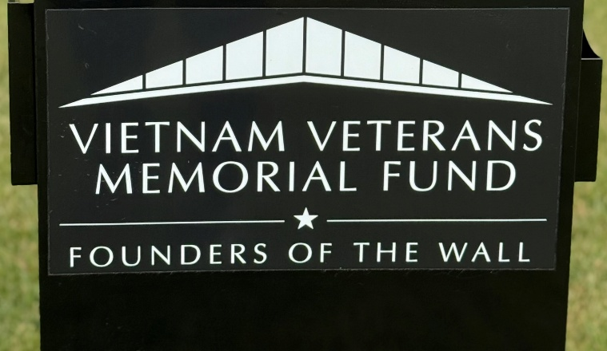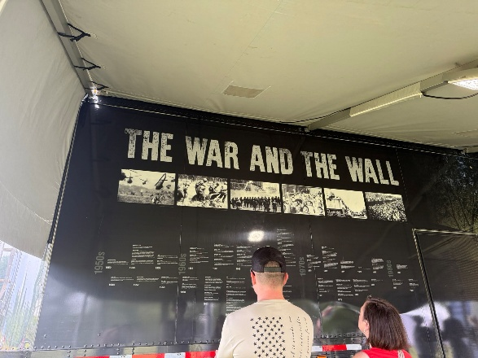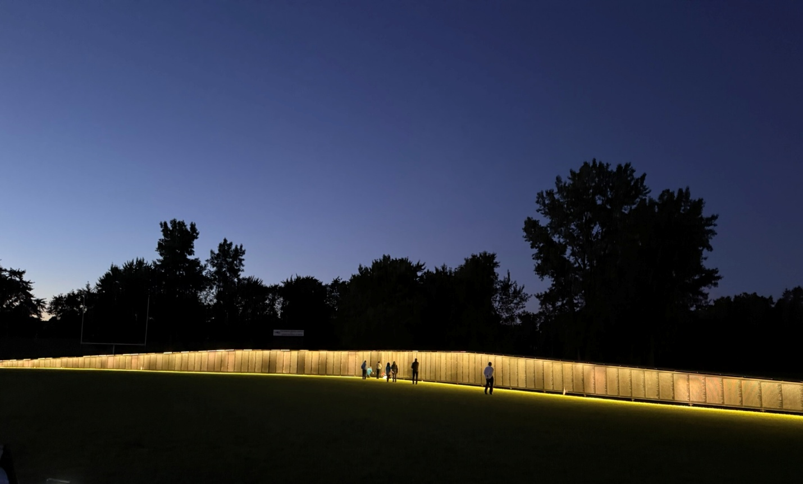
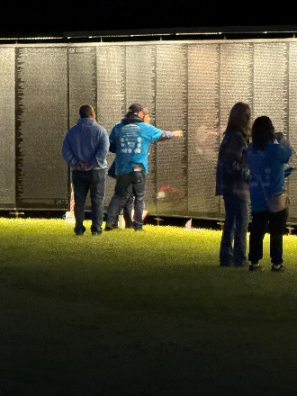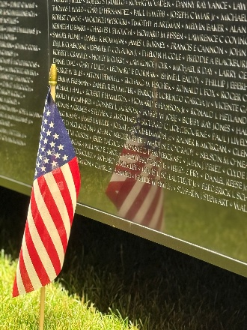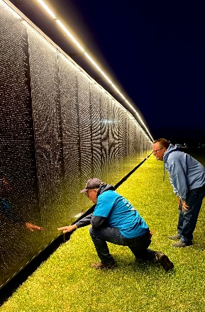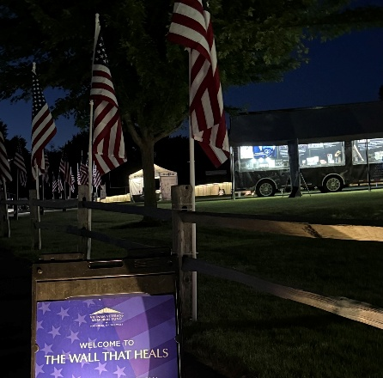
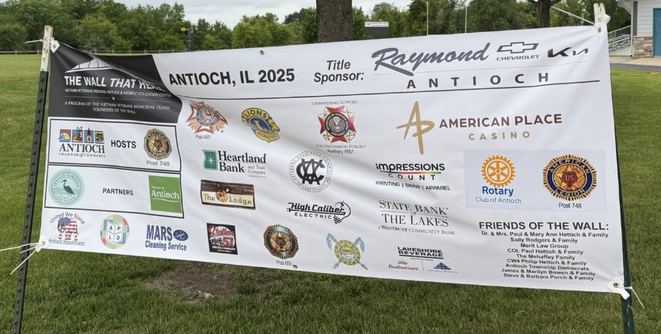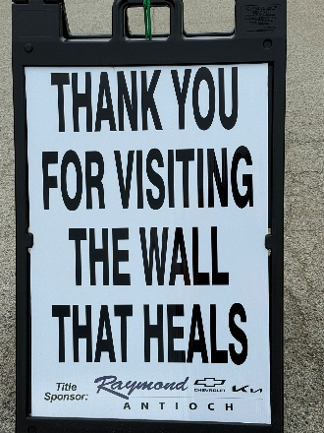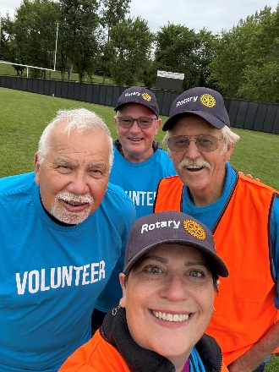

Compiled by Rotarian Rebecca Dunleavy

