2025 Winter Gear Collection.

Yet, again our club members take extra steps to make a difference. This year, as part of our own social gathering, we asked Rotarians to consider bringing a new pair of socks or gloves for us to donate.
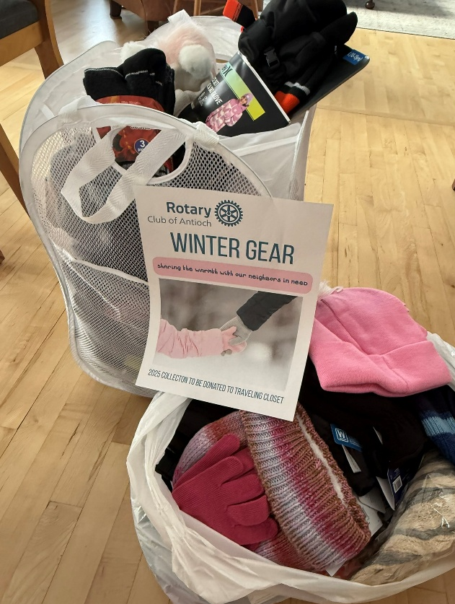
And they did!
- 122 pairs of socks
- 47 pairs of gloves
- 17 hats
- And 1 scarf

The collection was donated to The Antioch Traveling Closet to help those needing extra items.

Learn more about the Antioch Traveling Closet mission and how you can help directly at https://antiochtravelingcloset.org/

Interested in being a part of a group that continually gives back? Contact us
RotaryclubAntioch@gmail.com

