Sponsorship Agreement
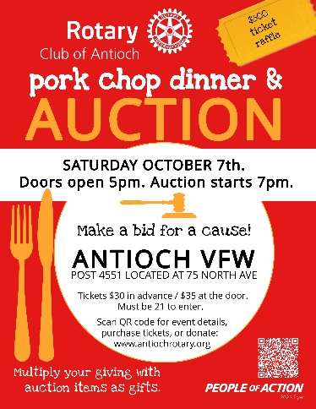
Thank you for supporting the Rotary Club of Antioch. Sponsoring the October 7th Pork Chop Dinner & Auction fundraiser will assist in providing: Community outreach locally and internationally; High School programs in expanding cultural awareness through Rotary Youth Exchange and leadership training in the 4-day Rotary Youth Leadership Award; College Scholarships for Antioch & Lakes Community High School; and technical grants for people entering the a trade profession.
- By sponsoring the event, your logo will be in the Auction booklet which is viewed by on average 400 attendees.
- An small electronic banner will be on the event website with advance information about the event. This site link is on all the flyers posted around Antioch and Lake Villa.
- An electronic version of your ad will also be posted on our main Club website page (www.antiochrotary.org) through the end of this year.
- Deadline for your ad to be included is September 23, 2023.
- Artwork in event signage will be adjusted based on the sponsorship levels:

Select | Size | Dimensions in inches (width by height) | Proportion Price
 | Small | 4.0 by 2.5 | $50
 | Banner | 8.0 by 2.5 | $125
 | Half Page | 8.0 by 5.0. | $250
 | Full page | 8.0 by 10.0 | $500

- Provide your contact information below:
Business Name _________________________________________
Address ___________________________________________________________________________
Phone ________________________________
Contact Name _________________________________________
Phone ________________________________
Email _________________________________________
- Sign agreement: ____________________________________________ Date: ______________________
- Provide payment to your local Rotarian that has requested this support. Please make your checks to Antioch Rotary Scholarship Inc. a 501c3 entity.
- Send electronic file of artwork to include both a jpg and pdf format so the best quality can be used. Rebadunleavy@gmail.com.
DEADLINE FOR ARTWORK AND PAYMENT IS: SEPTEMBER 23rd NOON.

